

TABLE OF CONTENTS

**INTRODUCTION** **4**

**LAB#1 : REGISTRATION** **7**

**LAB#2: AZURE PREREQUISITES** **10**

Create a Virtual Network 11

Create a Network Security Group 12

Create your Availability Sets for Master, Worker and Edge 17

Create a SSH Key Pair 19

**LAB#4: DEPLOY CLOUDERA DIRECTOR** **23**

Deploy Cloudera Director Virtual Machine 23

Install BIND Server 26

Install Java 8 31

Install Cloudera Director 6.1 32

Access to Cloudera Director 6.1 Web Application 32

**LAB#5: DEPLOYING YOUR CLOUDERA ENTERPRISE CLUSTER** **34**

Creating your Azure Environment 34

Creating Template Node template 35

Deploying Cloudera Data Warehouse 39

**LAB#6: CONNECTING TO CLOUDERA MANAGER & HUE** **43**

Connect to Cloudera Manager Web UI. 43

Connect to HUE Web UI 45

Import Customer.csv from Hive Metastore 48

**LAB#7: CONNECTING TO AZURE DATA LAKE STORE** **53**

Create your personal ADLS 53

Update the ADLS permissions 54

Updating Cloudera Manager to connect with Azure Data Lake Storage 58

Upload the DataSet on ADLS 64

Impala Query on ADLS storage 67

**LAB#8: INTEGRATING WITH POWER BI DESKTOP** **69**

Deploying the PowerBI Desktop Virtual Machine 69

Update the Power BI Virtual Machine DNS name 71

Install Power BI Desktop on the Virtual Machine 71

Update the ODBC driver 73

**LAB#9: AZURE ACTIVE DIRECTORY APPLICATION & SERVICE PRINCIPLE** **77**

Identify your AZURE-AD-TENANT-ID 77

Create your AD Application and retrieve your AZURE-AD-CLIENT-ID 79

Create the AZURE-AD-CLIENT-SECRET 81

Identify your AZURE-AD-SUBSCRIPTION-ID 84

Grant Permissions to the AD Application 85

**LAB#10: CREATE YOUR RESOURCE GROUP** **87**

**LAB#11: ENABLE PROGRAMMATIC DEPLOYMENT FOR CLOUDERA IMAGES** **90**

**TROUBLESHOOTING** **93**

Cannot access to Cloudera Director Web UI 93

Deploying Cloudera Manager - Cluster in a private network. 93

# INTRODUCTION

Organizations are no longer constrained in choosing how and where they deploy their workloads based on the ability they have to manually manage the data context between them. Any combination of workloads can now take advantage of the most appropriate infrastructure. The benefits are realized as soon as more than one workload is deployed.

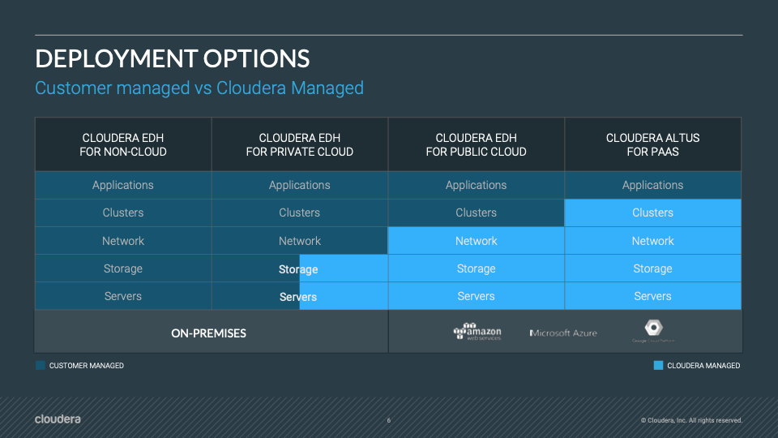

Indeed, there a multiple ways to deploy Cloudera in a hybrid (On-Prem / Private Cloud / Public Cloud) and multi-cloud (AWS, Azure, GCP, Oracle, IBM) cloud environments.

The aim of this Hands-On Lab is to understand how to deploy a Cloudera Cluster on Microsoft Azure. The 4 options on Azure:

* Infrastructure-as-a-Service mode (Cloudera Altus Director)
* Platform-as-a-Service mode (Cloudera Altus Services)
* Azure Marketplace Cloudera Director
* Azure Marketplace Cloudera Enterprise Data Hub

These options are ranked by decremental skill sets required (IaaS mode is the most difficult one). And we have chosen the latter, IaaS mode, to run today. The aim is for you partners to understand best the entire process to manage yourself the platform.

We will base most of our labs on the Cloudera Reference Architecture deployment on Microsoft Azure cloud:

<https://www.cloudera.com/documentation/other/reference-architecture/topics/ra_azure_deployment.html>

Cloudera Reference Architecture documents illustrate example cluster configurations and certified partner products. The Cloud RAs are not replacements for official statements of supportability, rather they’re guides to assist with deployment and sizing options. Statements regarding supported configurations in the RA are informational and should be cross-referenced with the latest documentation.

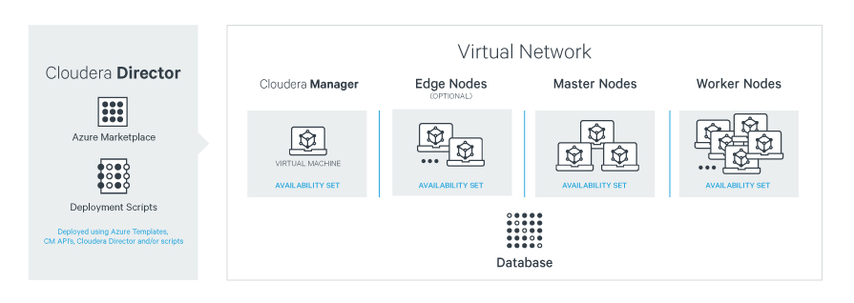

The steps required:

* Lab#1: Registration. Get registered through our partner Spektra System to an Azure environment and free Azure credits. It will be a 4 hours limited resources session.
* Lab#2: Azure Active Directory Application & Service Principal. To avoid providing too large permissions on Azure, this step has been fulfilled by Spektra Systems team. You still have the instructions, despite the fact that we will skip.
* Lab#3: Azure Prerequisites. Create a Resource Group (to be skipped), Availability Sets, Enable Programmatic Deployment and create SSH Key Pair.
* Lab#4: Deploy Cloudera Director.
* Lab#5: Deploy Cloudera Enterprise Cluster.
* Lab#6: Connecting to Cloudera Manager and HUE
* Lab#7: Connecting to Azure Data Lake Store Gen 1.
* Lab#8: Integrating with Power BI.

We will not cover in this lab, and maybe could be future updates for this documents will be:

* connecting to Microsoft Azure Active Directory Domain Services (AADDS).
* connecting to a MySQL type of DataBase (instead of PostGre).

# LAB#1 : REGISTRATION

If you don’t have an Azure account with credits please use the following registration process.

Here is the URL for the registration page <http://bit.ly/2UZMugM>. Your instructor will give you the **Activation Code** (if requested)

Only corporate emails can be used to register (no gmail, yahoo, outlook or hotmail)

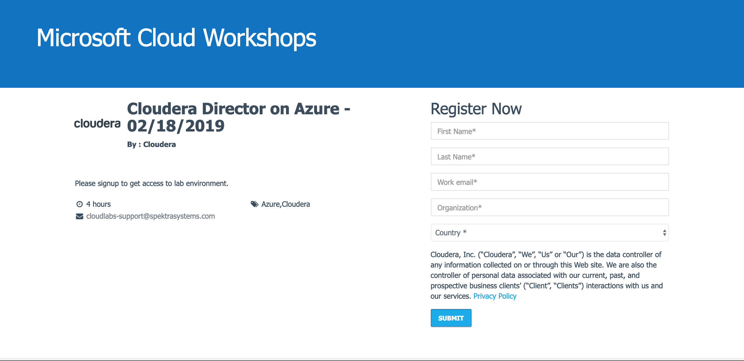

Please complete the registration process.

Then click on Launch Lab



You will then receive an Azure Logon credentials 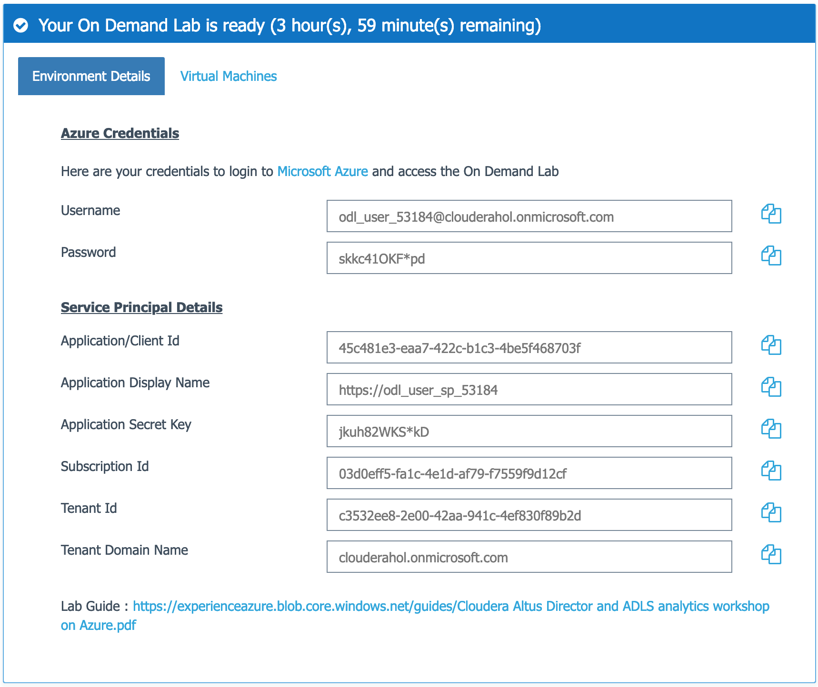

## 

Logon to Azure with YOUR OWN above generated credentials

You can use the copy icon to the right of the user id and password and URL ([https://azure.microsoft.com/en-us/).](https://azure.microsoft.com/en-us/)

Click on Sign In 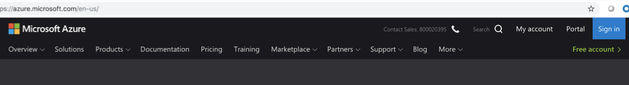

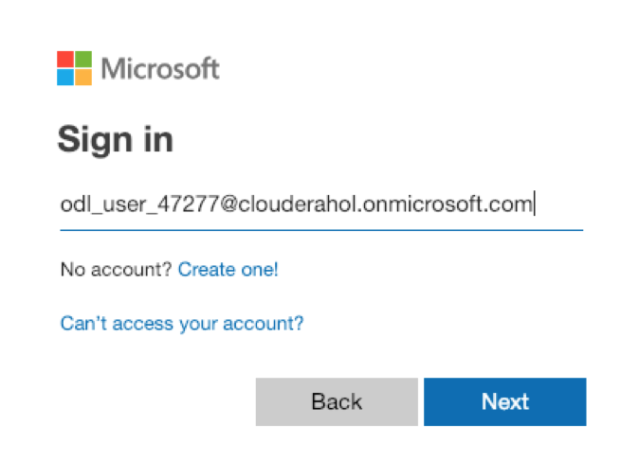

Click on Next

Enter your password from the above **Azure Credentials** page

Then you will see the Azure in the top right hand corner Portal and ODL_User

Click on Portal



Then the Azure Portal Appears

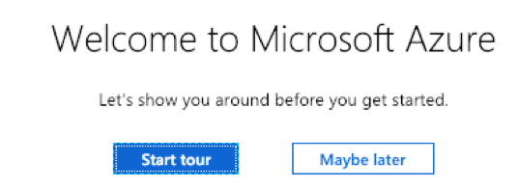

Then click on **Maybe later**

You will then click on Home for default view



# LAB#2: AZURE PREREQUISITES

These steps has been provided and managed by Spektra Systems. Still is notified here in the document to keep a chronological order of steps to be performed.

Spektra Systems has pre-provisioned a Service Principle, with the permissions to deploy Cloud Resources on Cloudera Director’s behalf. You will have been provided through a separate email / web page with these informations

* Subscription ID
* Tenant ID
* Application / Client ID
* Client Secret Key

For more details on how to perform these steps, see Lab#9: AZURE ACTIVE DIRECTORY APPLICATION & SERVICE PRINCIPLE.

Spektra Systems has also pre-created 3 ressources groups (adls, director and marketplace):

* ODL-cldr-<USERID>-adls
* ODL-cldr-<USERID>-director
* ODL-cldr-<USERID>-marketplace

For more details on how to perform these steps, see Lab#10: CREATE YOUR RESOURCE GROUP.

Spektra System has, at last, activated the programmatic deployment of images. Indeed, without accepting the Azure T&C, you will not be successful in deploying Virtual Machine by Cloudera Director.

For more details on how to perform these steps, see LAB#11: ENABLE PROGRAMMATIC DEPLOYMENT FOR CLOUDERA IMAGES

## **Create a Virtual Network**

Altus Director requires a virtual network and subnet to implement its networking environment. The networking environment must be set up for forward and reverse hostname resolution. For a basic example for setting up forward and reverse hostname resolution, see [Setting Up Dynamic DNS on Azure](https://www.cloudera.com/documentation/director/latest/topics/director_get_started_azure_ddns.html#setting_up_ddns).

For an overview of virtual networks on Azure, see [Virtual networks](https://azure.microsoft.com/en-us/documentation/articles/virtual-networks-overview/).

To set up a new virtual network and its subnets, follow the steps below. Skip these steps if you are using an existing virtual network and subnet.

* In the left pane, click **New**.
* Type Virtual Network in the search box.
* Click **Virtual Network** in the search result.
* Click **Create**.

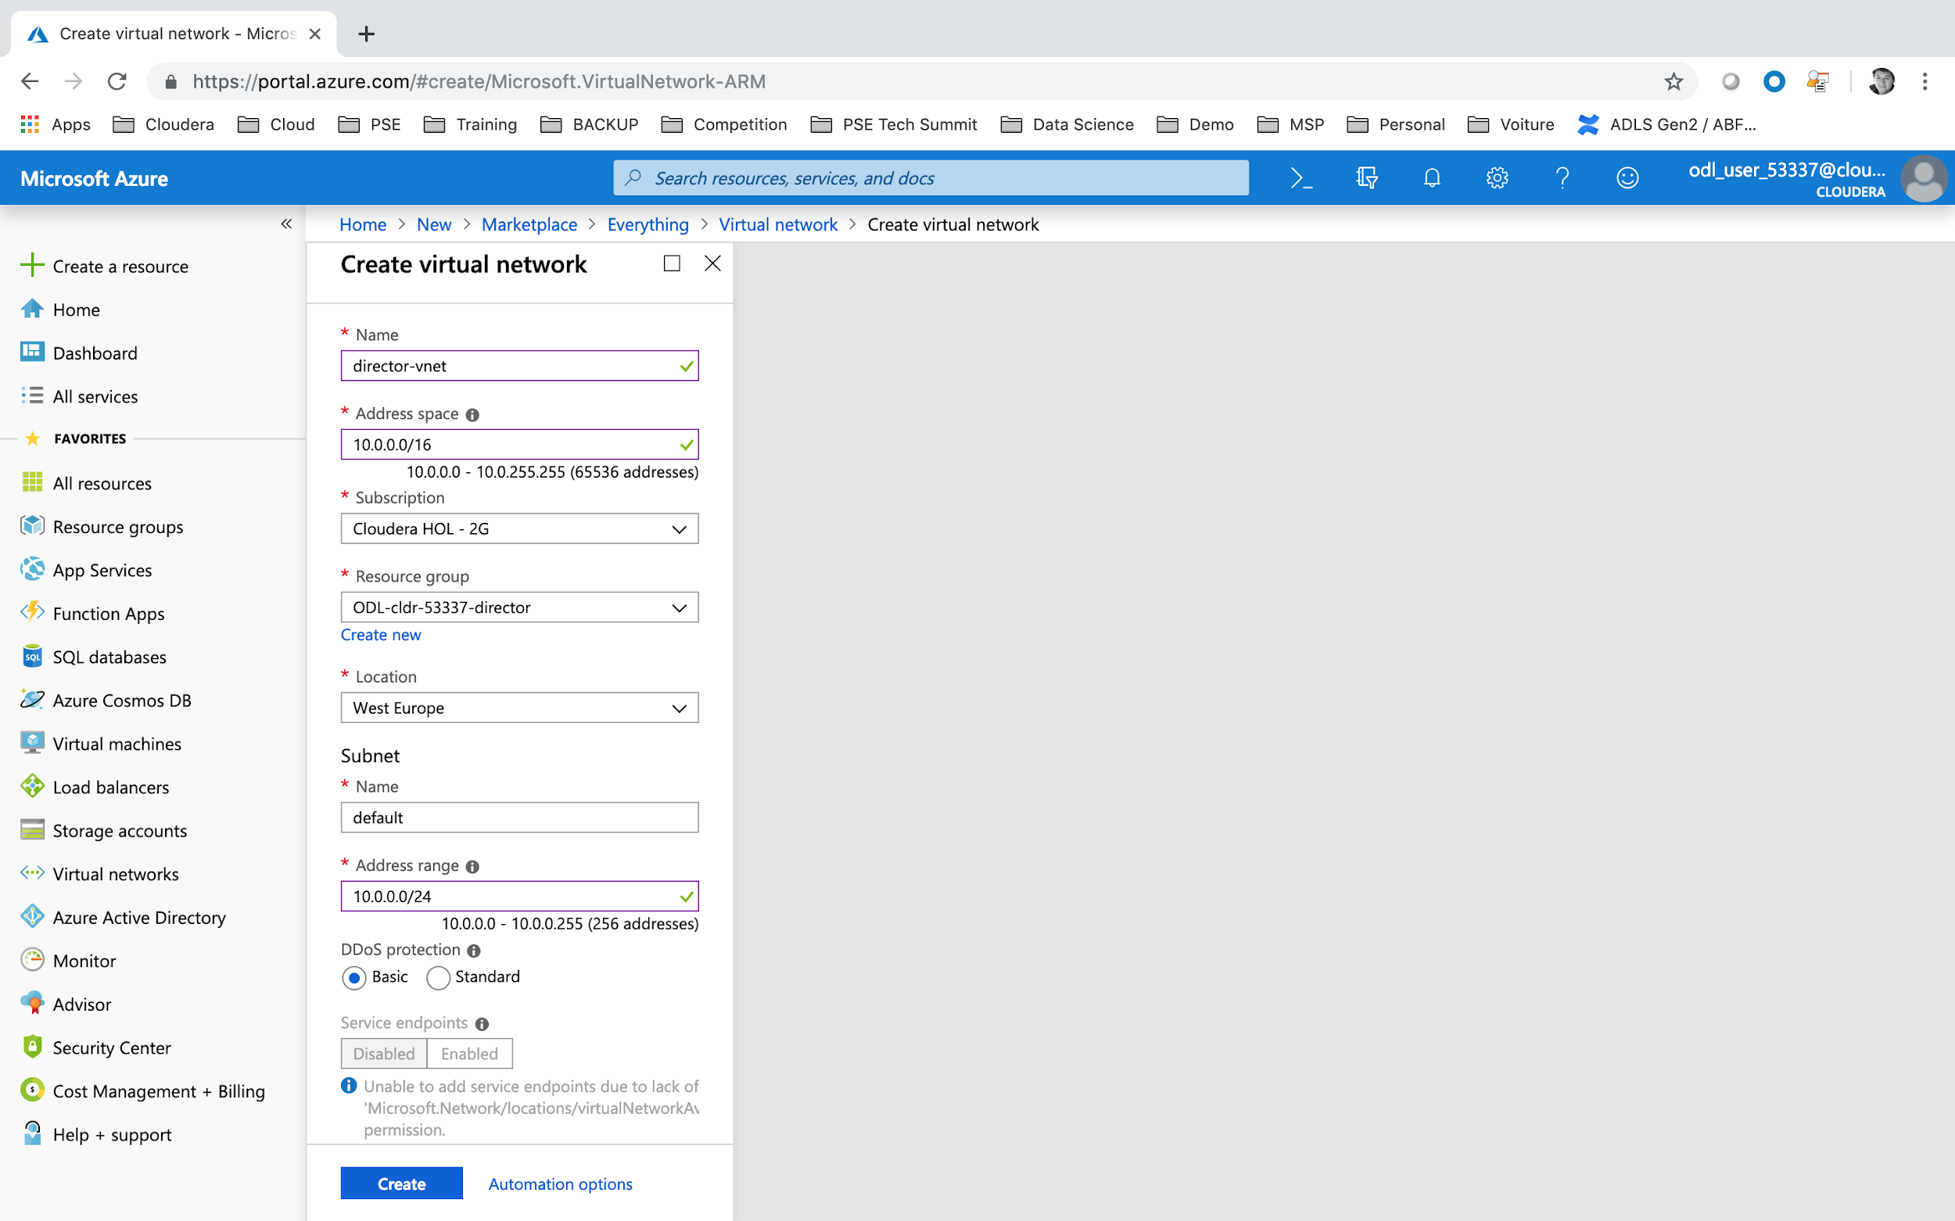

* Name = **director-vnet**
* Address Space = **10.0.0.0/16**
* Resource Group = **ODL-cldr-<USERID>-director**
* Location = Select the Data Center which is close to your current location. For example **West Europe**
* Subnet Name = **default**
* Subnet Range Address = **10.0.0.0/24**
* Click **Create**.

## **Create a Network Security Group**

To create a new network security group:

* In the left pane, click **New**.
* Type Network security group in the search box.
* Click **Network security group** in the search result.
* Click **Create**.

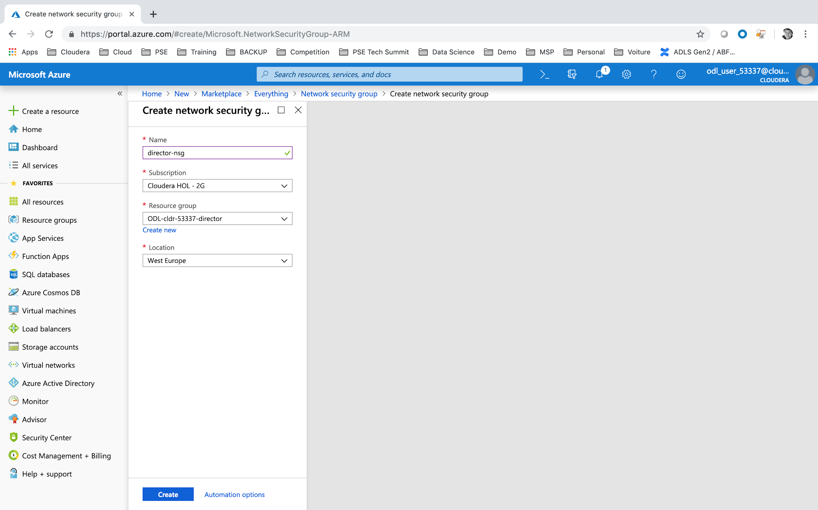

* Name = **director-nsg**
* Resource Group = **ODL-cldr-<USERID>-director**
* Location = Select the same Data Center as previously. For example **West Europe.**
* Click **Create**.

Once created, see [How to manage NSGs using the Azure portal](https://azure.microsoft.com/en-us/documentation/articles/virtual-networks-create-nsg-arm-pportal/#create-rules-in-an-existing-nsg) in the Microsoft Azure documentation for instructions on creating the rules in the network security group.

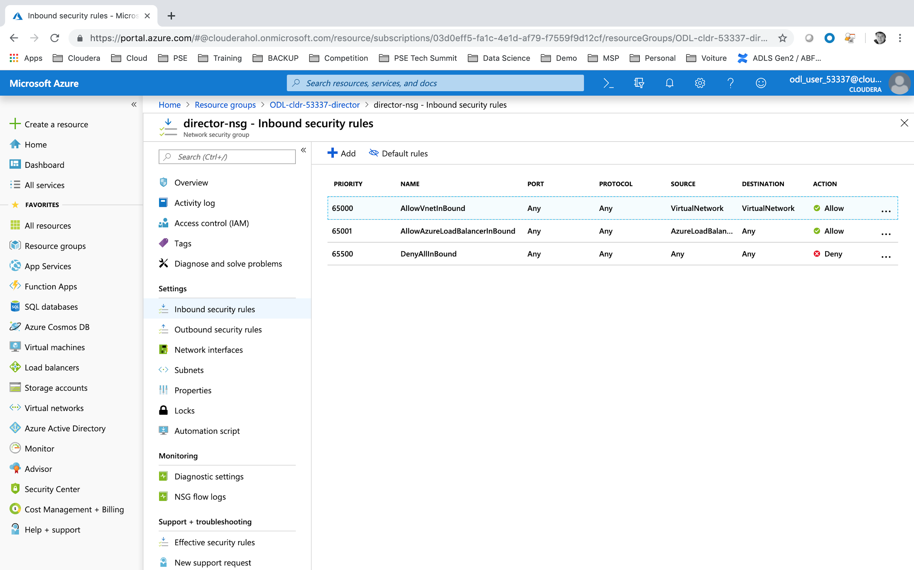

* Navigate to your **Home > Resource groups > ODL-cldr-<USERID>-director > director-nsg** network security group.
* Click on Inbound security rules.

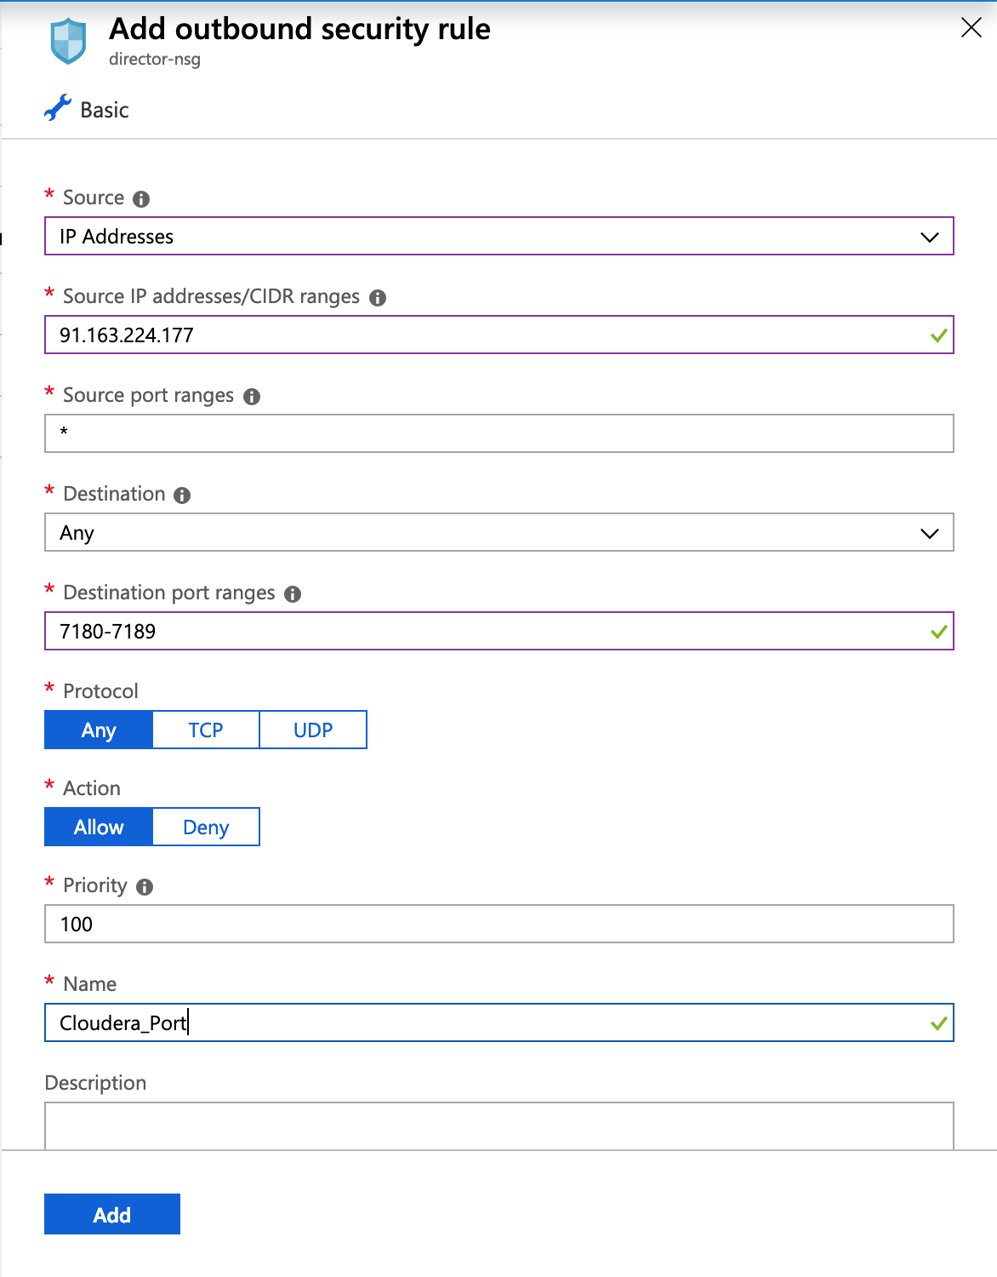

Click on **Inbound Security Rules** and then **Add** rules.

* Source = **IP Addresses**
* Source IP addresses/CIDR ranges = your laptop IP address (could be found on this website <https://www.myip.com/>)
* Source Port Range = *
* Destination = **Any**
* Destination Port Range = **7180-7189** (opening port from 7180 to 7189)
* Name = **Cloudera_Port**

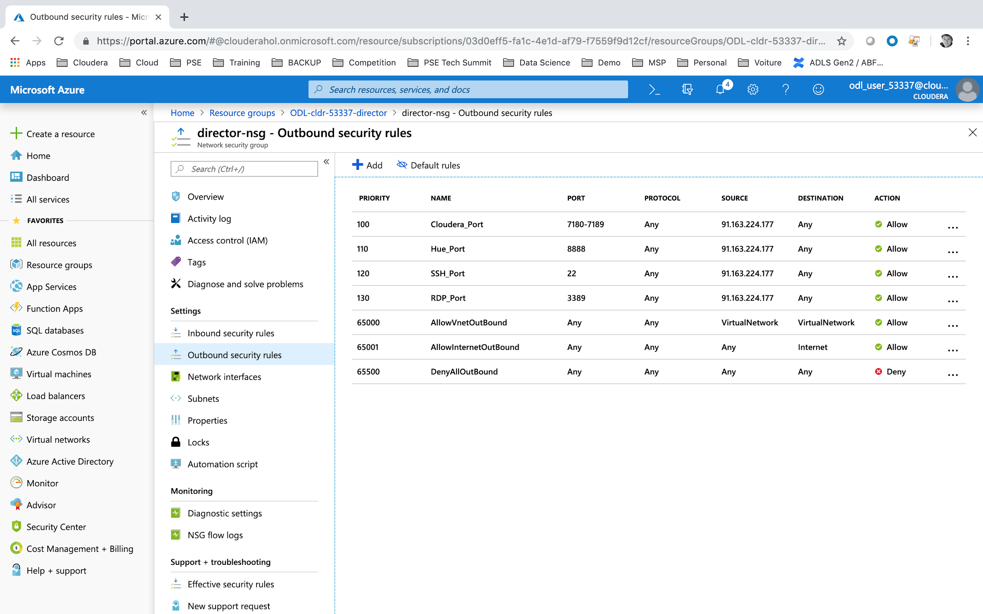

Repeat the operation for:

* Name = Hue_Port / Destination Port Range = 8888
* Name = SSH / Destination Port Range = 22
* Name = RDP / Destination Port Range = 3389

## **Create your Availability Sets for Master, Worker and Edge**

Azure uses Availability Sets to manage the availability of virtual machines. For best practices, in a CDH cluster, Cloudera recommends using one Availability Set for the master nodes and one Availability Set for the worker nodes. An Availability Set should not be shared by more than one CDH cluster.

Read this [Azure document](https://azure.microsoft.com/en-us/documentation/articles/virtual-machines-linux-manage-availability/) for an overview of Availability Sets on Azure.

To create an Availability Set:

* In the left pane, click **Create New Resource**.
* Type Availability Set in the search box.
* Click **Availability Set** in the search result.
* Click **Create**.

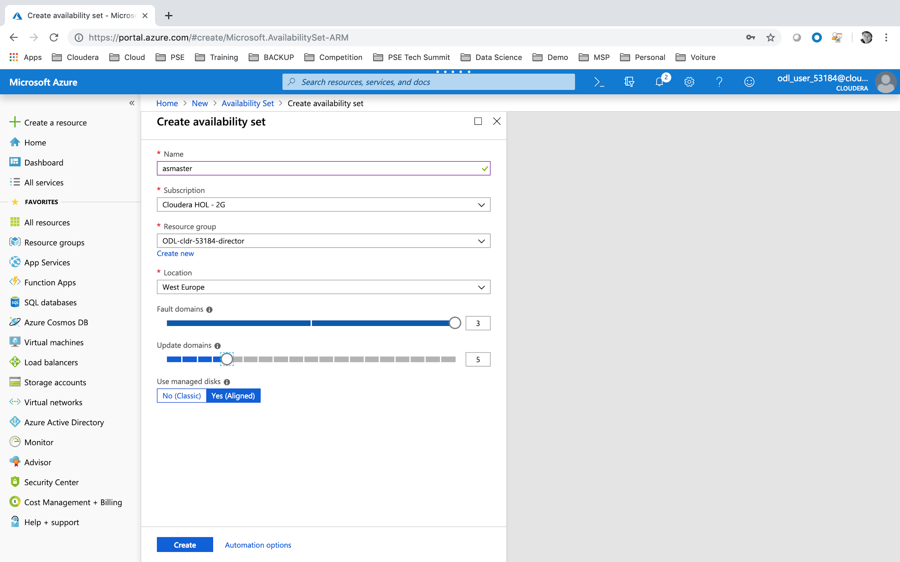

* Name = asmaster
* Resource Group = ODL-cldr-xxxxx-director
* Location = Select the same Data Center as previously. For example **West Europe**
* Fault Domain = 3 (except in some Data Centers, there are only 2 fault domains - like Data Center in France).
* Update Domain = 5
* Click **Create**.

After creating the Availability Set for master nodes, repeat the steps to create an Availability Set for **asworker** and **asedge** nodes.

## **Create a SSH Key Pair**

You should create a ssh key pair:

* id_rsa private key
* id_rsa.pub, public key

You could go through specific platform commands:

**MAC USERS**

Instructions are here: <https://docs.microsoft.com/en-us/azure/virtual-machines/linux/mac-create-ssh-keys>

/!\ IMPORTANT: Some recent changes in OpenSSH library makes SSH Key not compatible with PEM format on Linux/Mac. We need specific retro compatibility mode. See below /!\

|  |
| --- |
| > ssh-keygen -m PEM -t rsa -b 4096  Generating public/private rsa key pair.  Enter file in which to save the key (/Users/heibalvin/.ssh/id_rsa):  Enter passphrase (empty for no passphrase):  Enter same passphrase again:  Your identification has been saved in /Users/heibalvin/.ssh/id_rsa.  Your public key has been saved in /Users/heibalvin/.ssh/id_rsa.pub. |

* SSH filename = Press enter to keep **id_rsa** filename.
* Passphrase = None (click on enter)

Then you need to secure the access (read/write/update) to the files:

|  |
| --- |
| > chmod 400 /Users/heibalvin/.ssh/id_rsa* |

**WINDOWS USERS**

The creation of a SSH Private / Public key will be performed in 2 steps:

* creation of a SSH Public / Private Key in PPK file format (<https://docs.microsoft.com/en-us/azure/virtual-machines/linux/ssh-from-windows> )
* conversion of Private Key PPK to PEM format

For key creation, you will need a tool call Putty ([PuTTY download](http://www.chiark.greenend.org.uk/~sgtatham/putty/download.html)).

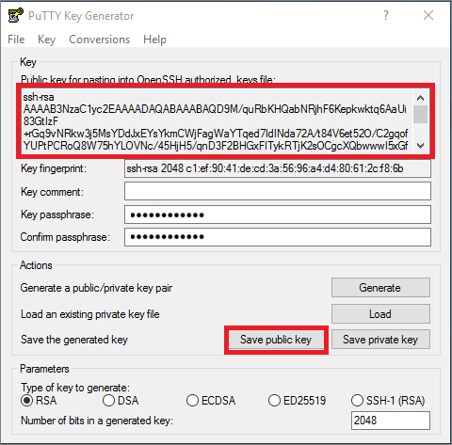

* Start PuTTYgen.
* Click Generate. By default PuTTYgen generates a 2048-bit SSH-2 RSA key
* Move the mouse around in the blank area to provide randomness for the key.
* After the public key is generated, optionally enter and confirm a passphrase. You will be prompted for the passphrase when you authenticate to the VM with your private SSH key. Without a passphrase, if someone obtains your private key, they can sign in to any VM or service that uses that key. We recommend you create a passphrase. However, if you forgot the passphrase, there is no way to recover it.
* The public key is displayed at the top of the window. You can copy this entire public key and then paste it into the Azure portal or an Azure Resource Manager template when you create a Linux VM. You can also select Save public key to save a copy to your computer, **name it id_rsa.pub.**

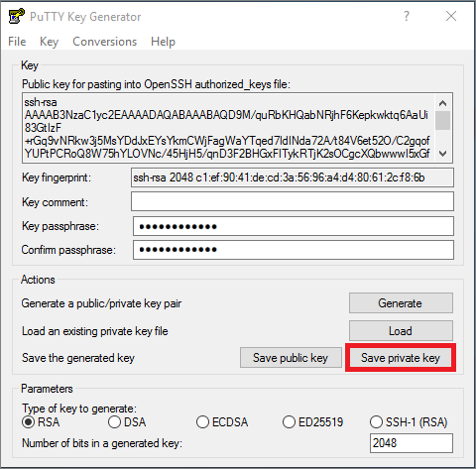

* to save the private key in PuTTy private key format (.ppk file), select Save private key, and **name it id_rsa.ppk**. You will need the .ppk file later to use PuTTY to make an SSH connection to the VM.
* to save the private key in the OpenSSH format, the private key format used by many SSH clients, select Conversions > Export OpenSSH key, and **name it id_rsa**.

# LAB#4: DEPLOY CLOUDERA DIRECTOR

## 

## **Deploy Cloudera Director Virtual Machine**

Altus Director server is used to provision CDH clusters. See [Create a Linux VM on Azure using the Portal](https://azure.microsoft.com/en-us/documentation/articles/virtual-machines-linux-quick-create-portal/) in the Azure documentation for an overview of creating a Linux VM on Azure. We recommend using the CentOS image published by Cloudera on Microsoft Azure Marketplace.

Consider the following when creating a Linux VM:

* Instance size should be D3 or larger.
* Typically, install Altus Director in the same virtual network and subnet of the cluster.
* Typically, specify the same network security group.
* Typically, set the same availability as you set on the master nodes.
* A public IP address is optional, depending on the access pattern you use.

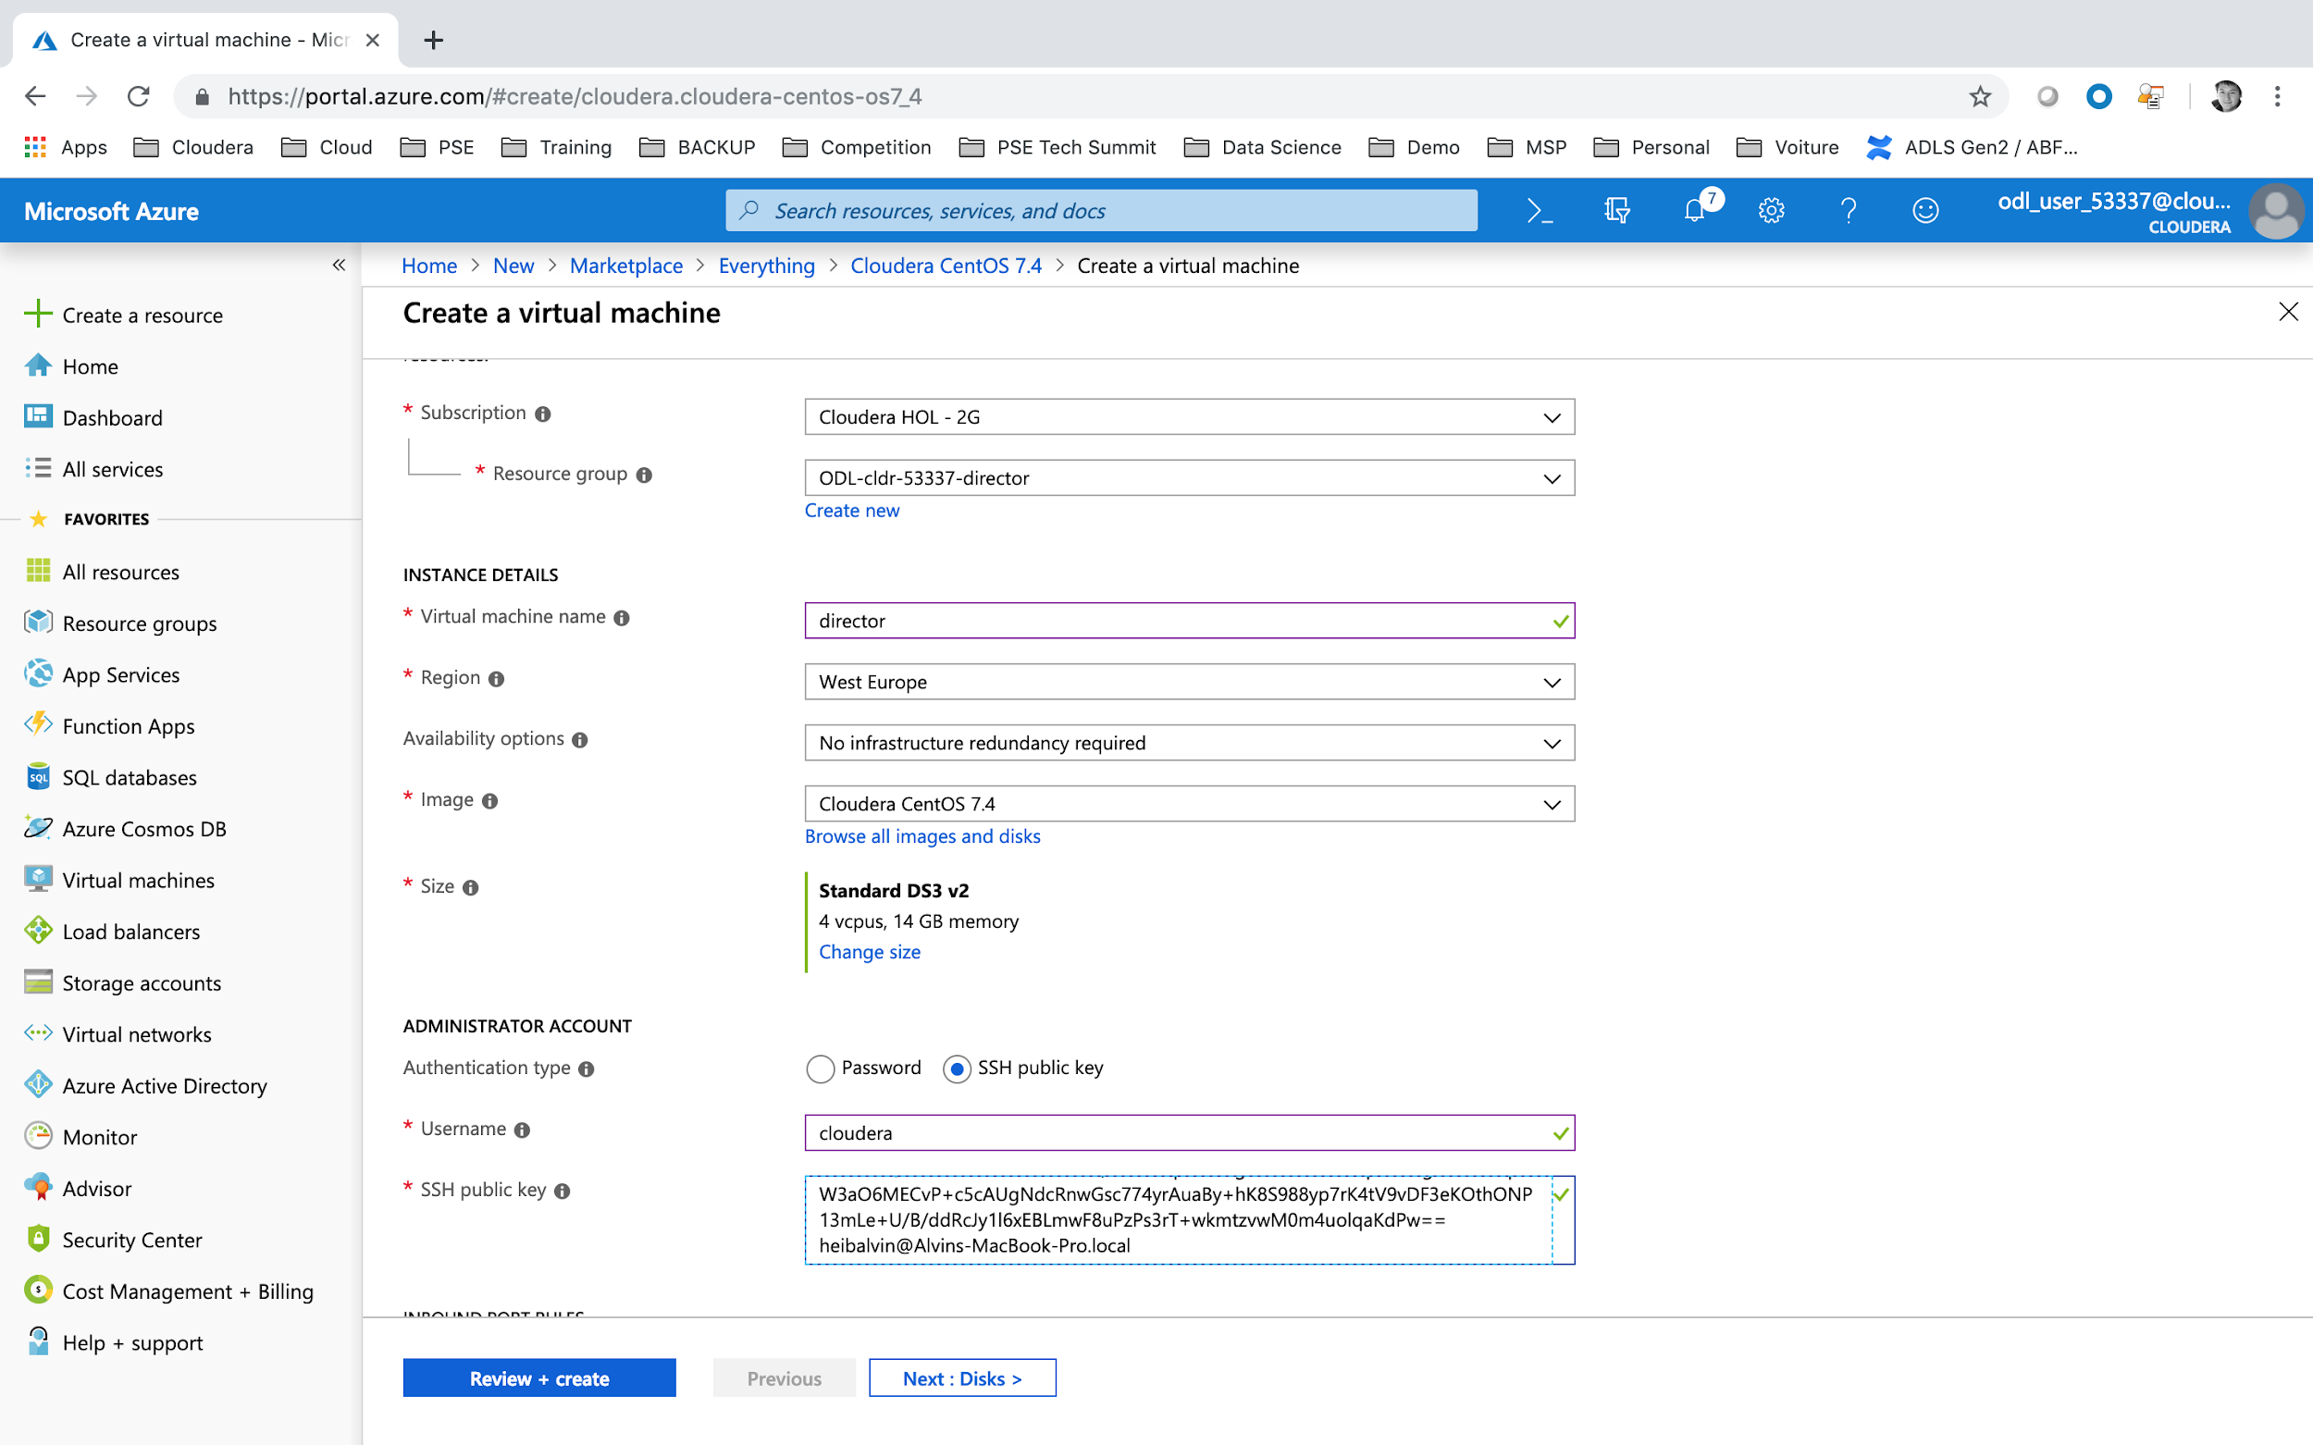

To create a Virtual Machine:

* In the left pane, click **Create New Resource**.
* Type Cloudera CentOS in the search box.
* Select **Cloudera CentOS 7.4** in the search result.
* Click **Create**.
* Resource Group = ODL-cldr-<USERID>-director
* Virtual Machine Name = director
* Region = Select the same Data Center as previously. For example **West Europe**
* Size = D3_v2
* Username = **cloudera**
* SSH public key = copy/paste content of the **id_rsa.pub** content.
* Click on **Networking Tab**

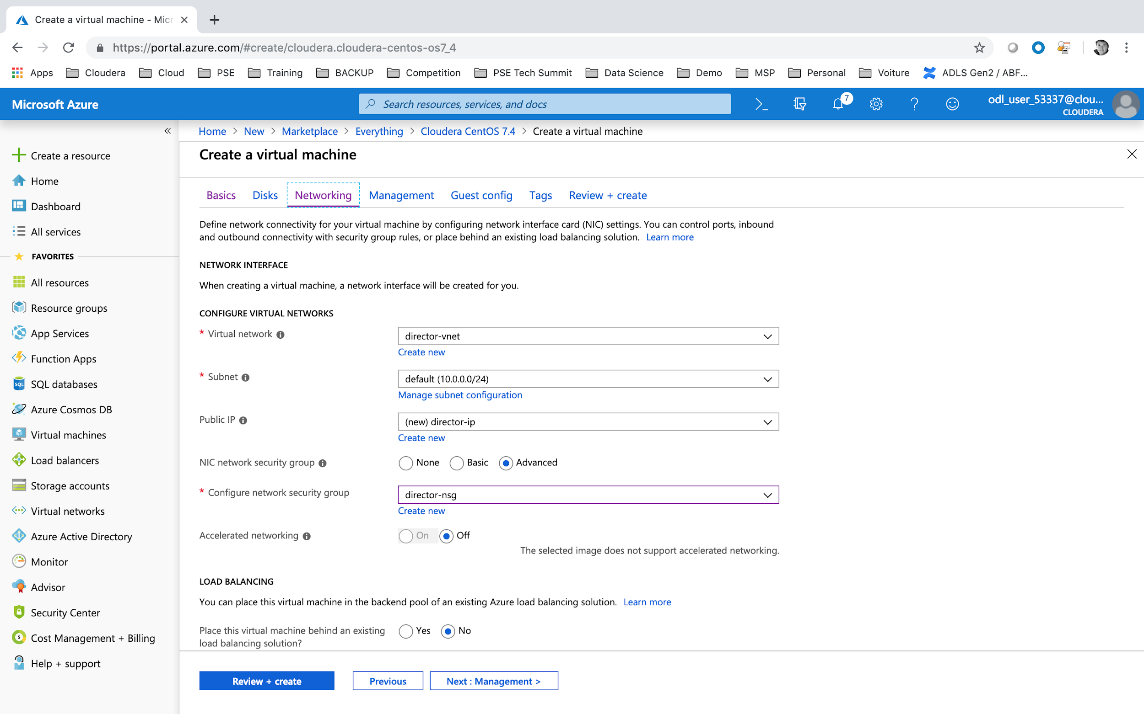

* Virtual Network = **ODL-cldr-<USERID>-director-vnet**
* Subnet = **default (10.0.0.0/24)**
* Configure network security group = **director-nsg**
* Click on **Review + create**
* Click on **Create**

## **Install BIND Server**

Microsoft azure does not natively propose a reverse DNS service. We will create a manual DNS server on the Cloudera Director Virtual Machine. And update the Azure Network.

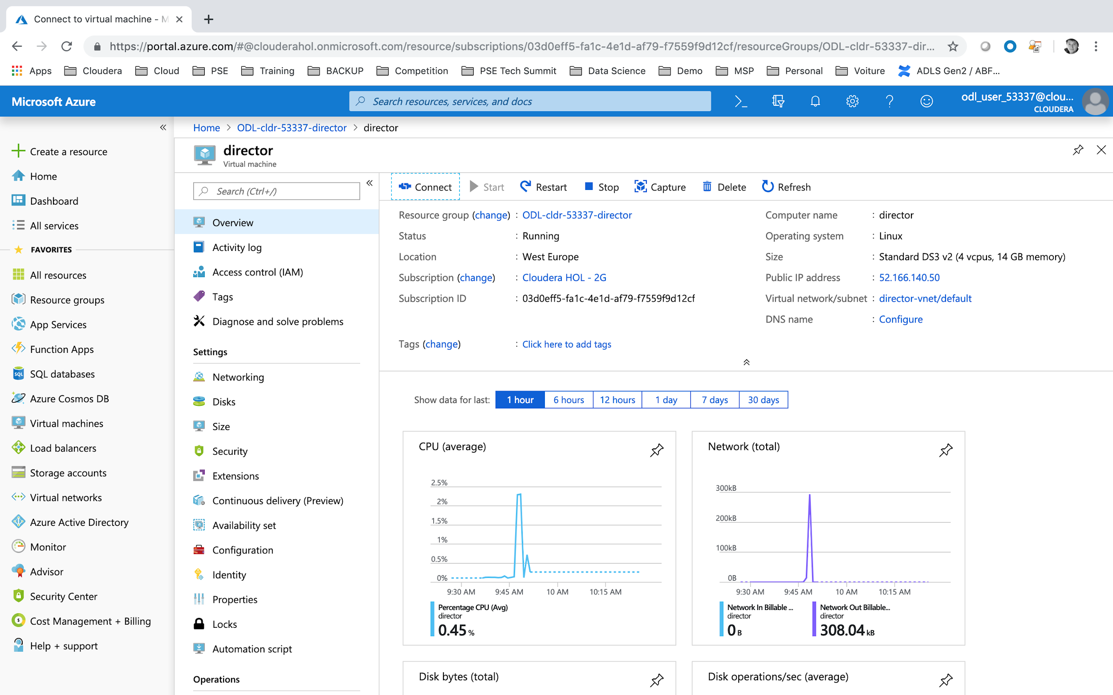

* Navigate to **Home > Resource groups > ODL-cldr-<USERID>-director > director**  virtual machine.
* Click on DNS Name **Configure**.

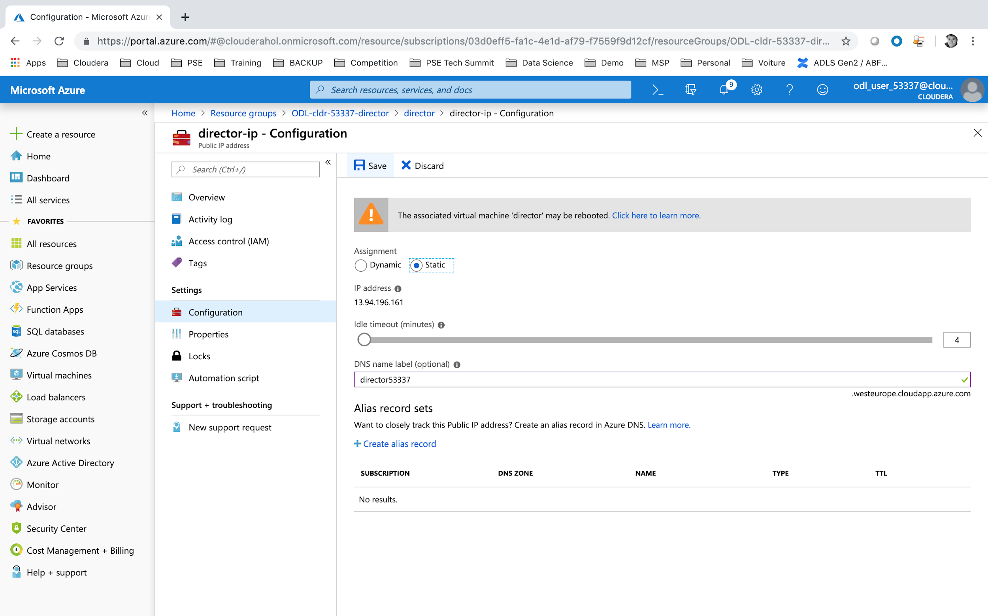

* DNS name label = **director<USERID>**. Please take into account that this name should be unique within the Data Center deployment. For example **.westeurope.cloudapp.azure.com**.

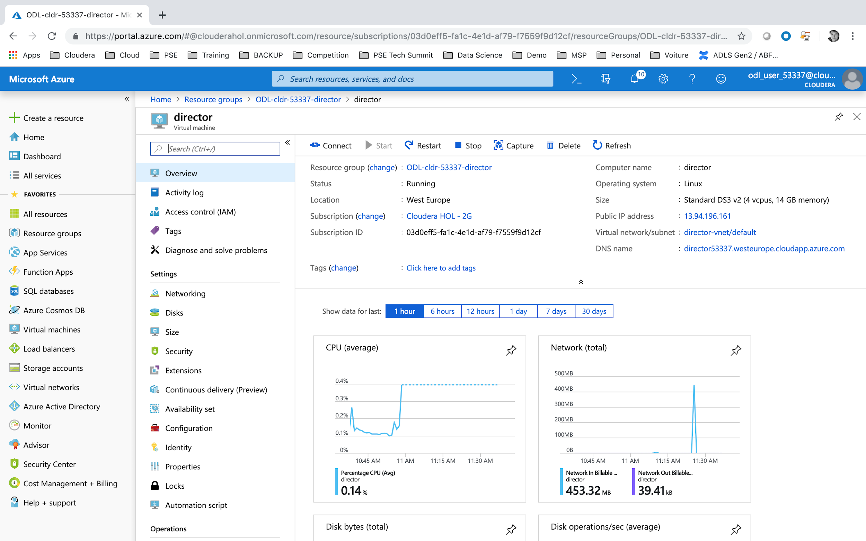

To connect to your newly created Virtual Machine, please press **Connect** button. You will have all the information to connect by **SSH**.

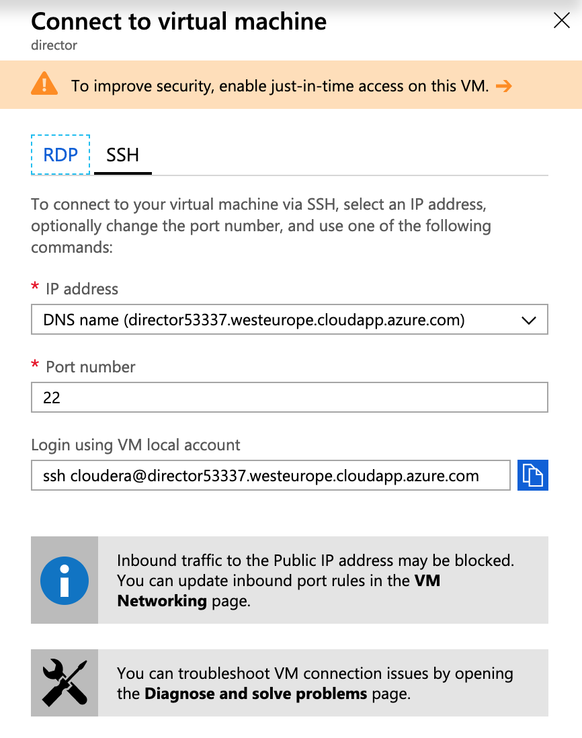

Connect to your newly created virtual machine using terminal on mac (<https://docs.microsoft.com/en-us/azure/virtual-machines/linux/mac-create-ssh-keys#ssh-into-your-vm>) or putty for windows (<https://docs.microsoft.com/en-us/azure/virtual-machines/linux/ssh-from-windows#connect-with-putty>)

|  |
| --- |
| sudo yum install -y git  git clone <https://github.com/cloudera/director-scripts>  chmod uog+x director-scripts/azure-dns-scripts/*  sudo director-scripts/azure-dns-scripts/bind-dns-setup.sh |

* When requested for the network prefix keep proposal **cdh-cluster.internal**.
* And once the script will end, do not hit enter at this point !!! You will be provided instructions to use the local DNS with a private IP (for ex: **10.0.0.4**)

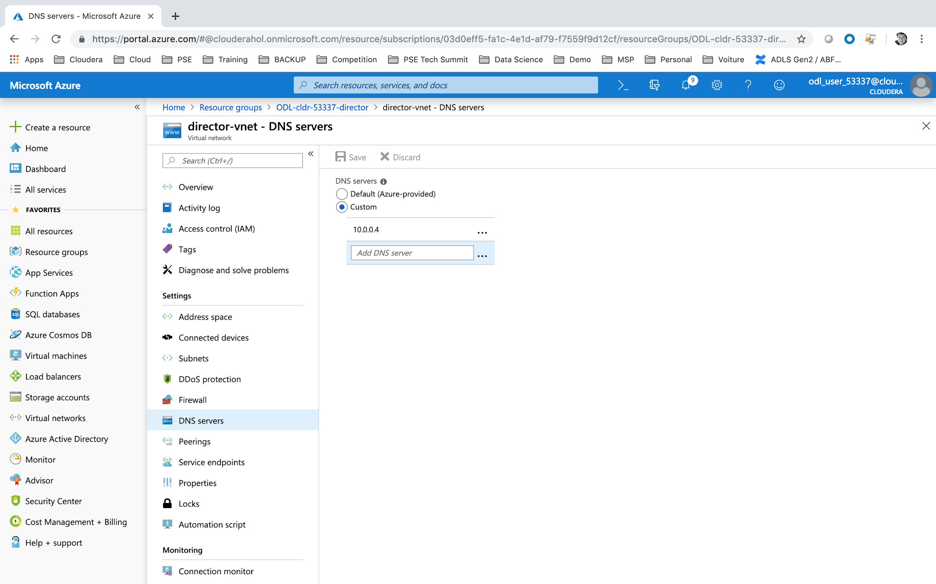

* Navigate to your Home > Resource groups > ODL-cldr-<USERID>-director > **ODL-cldr-<USERID>-director-vnet** resource.
* Click on **DNS servers**
* We first need to update the Azure DNS configuration from default to **Custom** and update the private IP provided by the script (for ex: 10.0.0.4).
* Click on **Save**.

Once the DNS servers has been updated on Azure network, you could complete your script on director virtual machine image.

|  |
| --- |
| Go to -- portal.azure.com -- and change Azure DNS to point to the private IP of this host: 10.0.0.4  Press [Enter] once you have gone to portal.azure.com and this is completed. |

* Click on **Enter**.

You now have installed a local DNS and Reverse DNS managed by the Cloudera Director Virtual Machine. Any new Virtual Machine deployed in this Resource Group / Virtual Network will have as local resolution name **cdh-cluster.internal.**

You now could test your reverse DNS is fully functional.

|  |
| --- |
| # hostname -f  director.cdh-cluster.internal  # hostname -i  10.0.0.4  # host `hostname -i`  4.0.0.10.in-addr.arpa domain name pointer director.cdh-cluster.internal.  # host `hostname -f`  director.cdh-cluster.internal has address 10.0.0.4 |

Sometimes it happens that the named service is not correctly started. And a manual restart could be required.

|  |
| --- |
| # sudo service named restart  Redirecting to /bin/systemctl restart named.service |

## **Install Java 8**

We will now proceed to install java version suitable for Cloudera Director.

|  |
| --- |
| cd /etc/yum.repos.d/  sudo wget "<http://archive.cloudera.com/director6/6.1/redhat7/cloudera-director.repo>"  sudo yum install -y oracle-j2sdk1.8.x86_64 |

## **Install Cloudera Director 6.1**

Once Java 8 is correctly installed we will now install and start Cloudera Director services.

|  |
| --- |
| # Install cloudera Director / Client  sudo yum install -y cloudera-director-server cloudera-director-client  # Start Cloudera Director service  sudo service cloudera-director-server start  # Shutting down firewalling on the virtual machine if relevant  sudo service iptables save  sudo chkconfig iptables off  sudo service iptables stop |

## **Access to Cloudera Director 6.1 Web Application**

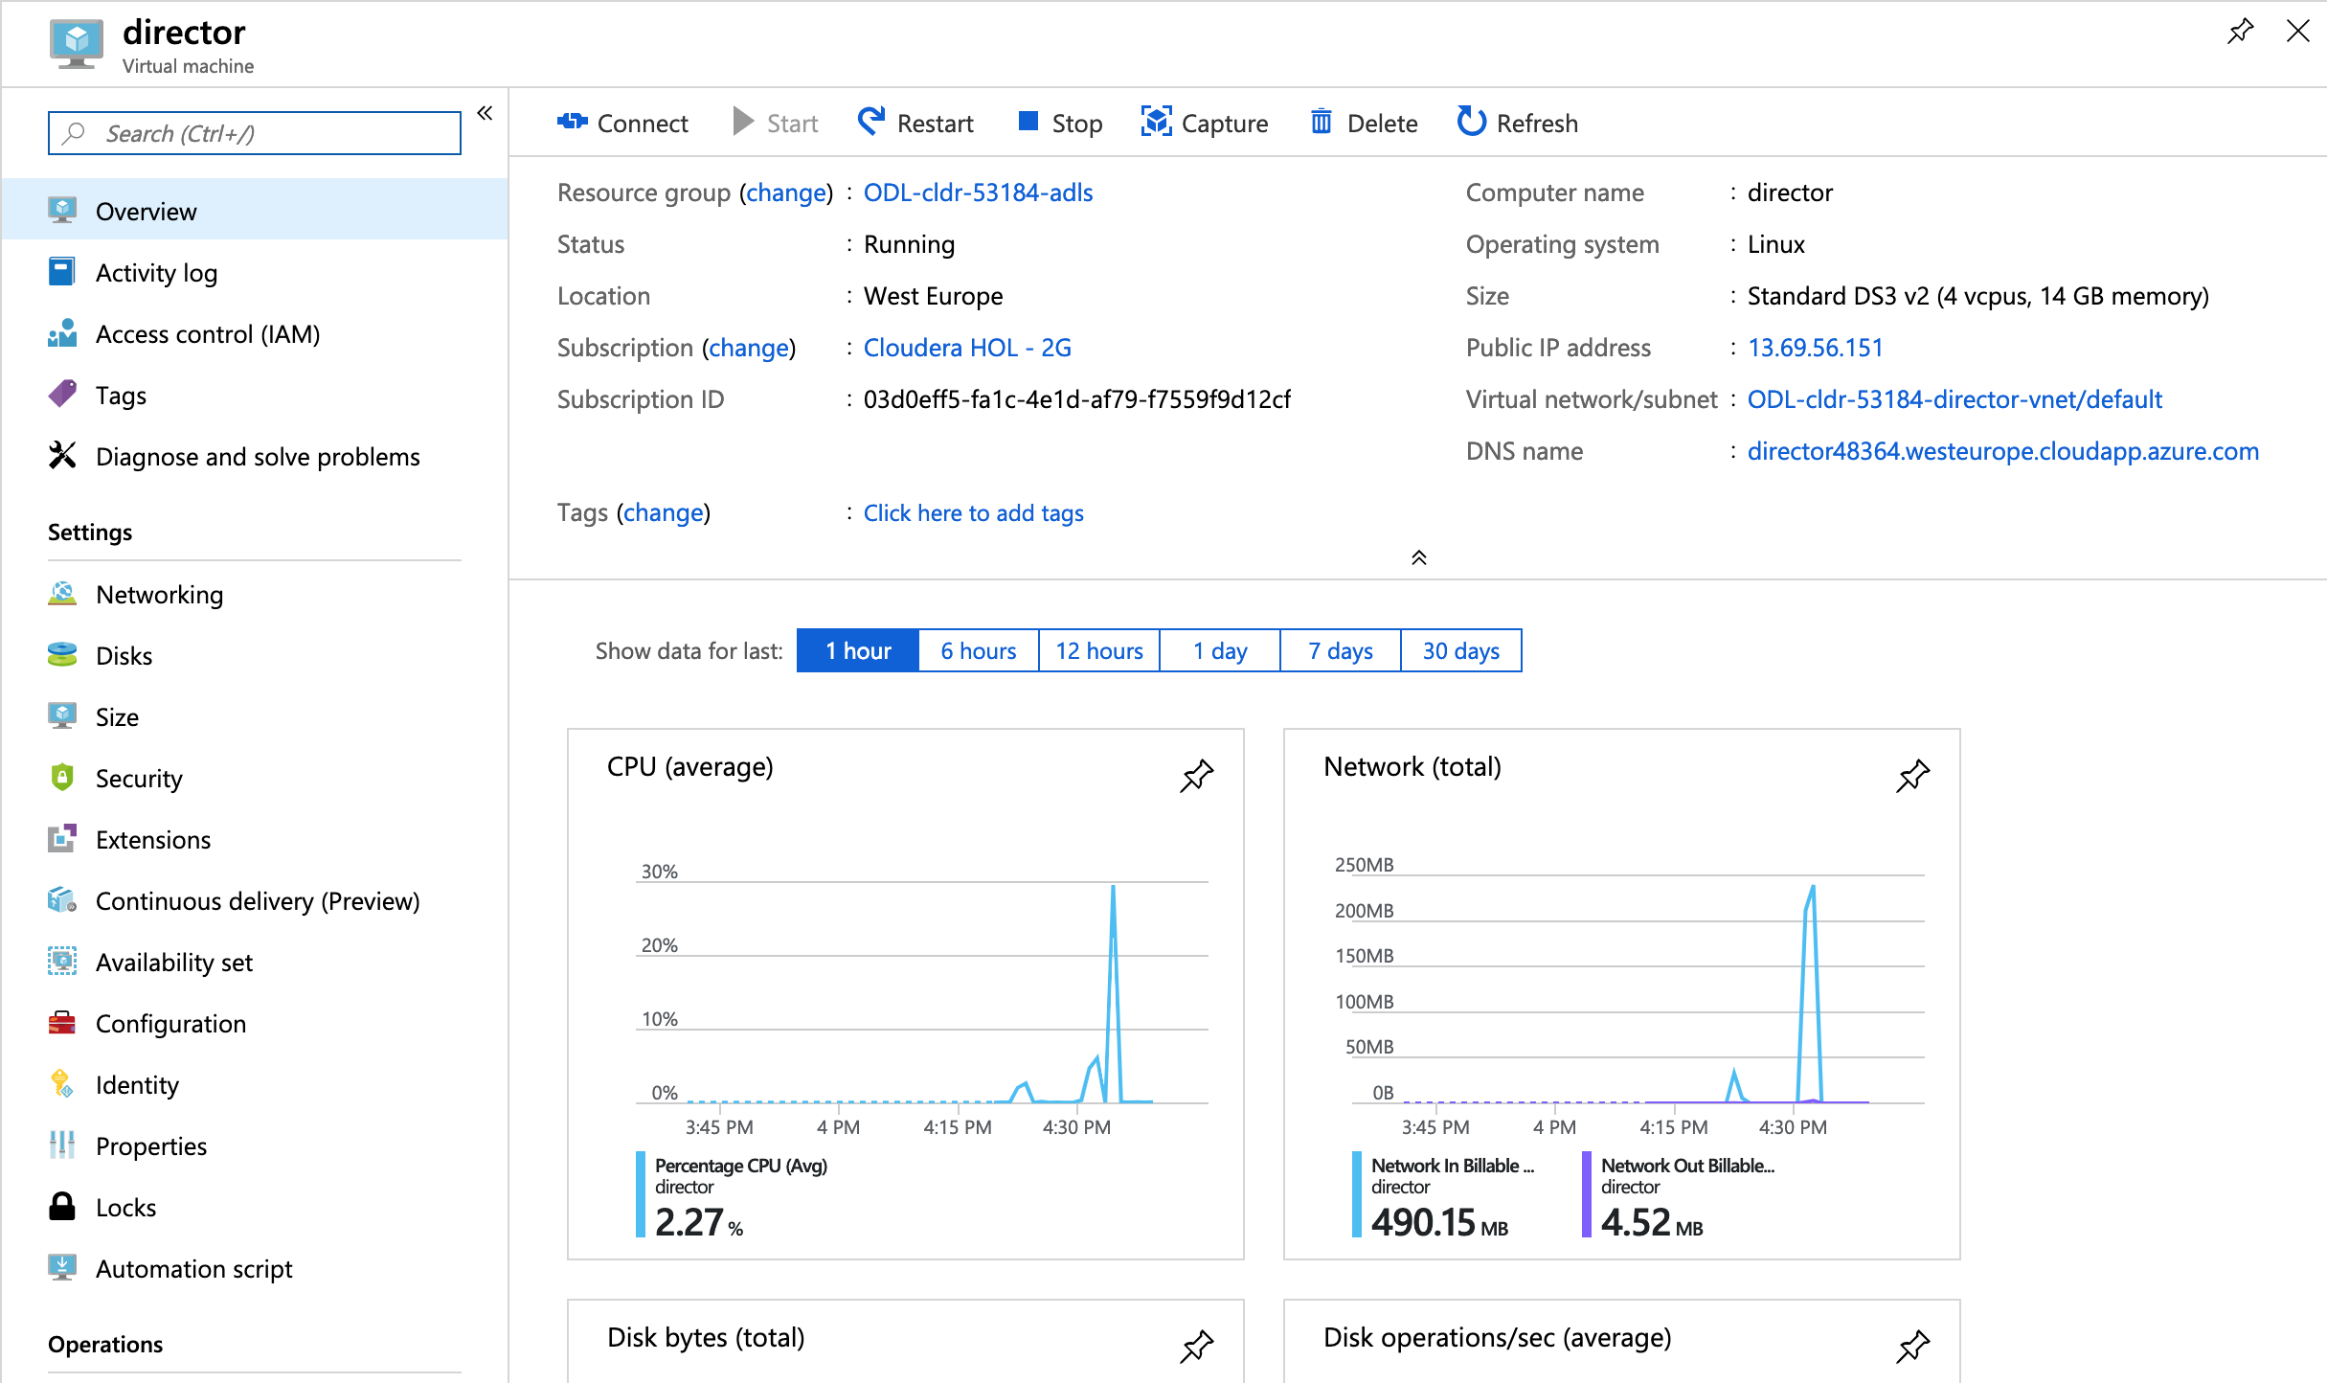

* Navigate to **Home > Resource groups > ODL-cldr-<USERID>-director > director** virtual machine.
* Copy the DNS name = **director<USERID>.westeurope.cloudapp.azure.com**.

You now should be able to reach your Cloudera Director Web Service through your prefered web browser at the director DNS name (for ex: [http://director48364.westeurope.cloudapp.azure.com**:7189**](http://director48364.westeurope.cloudapp.azure.com:7189)).

When requested to log into the web application, the default username/password is **admin**/**admin**.

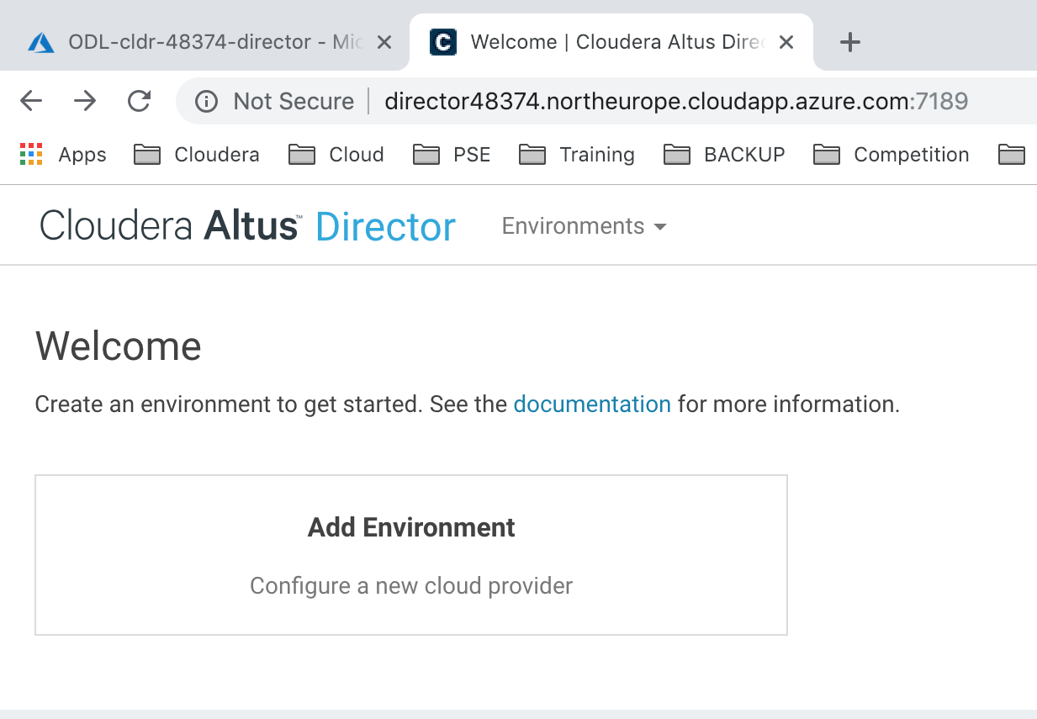

/!\ Good practice is to change your admin password, in top right menu. Change the password to **Cloudera_123** /!\

# LAB#5: DEPLOYING YOUR CLOUDERA ENTERPRISE CLUSTER

## **Creating your Azure Environment**

To deploy Cloudera Manager and CDH on an Azure VM instance, begin by creating an environment. The environment defines common settings, like region and key pair, that Altus Director uses with Azure. While creating an environment, you are also prompted to deploy its first cluster.

In the **Add Environment** screen:

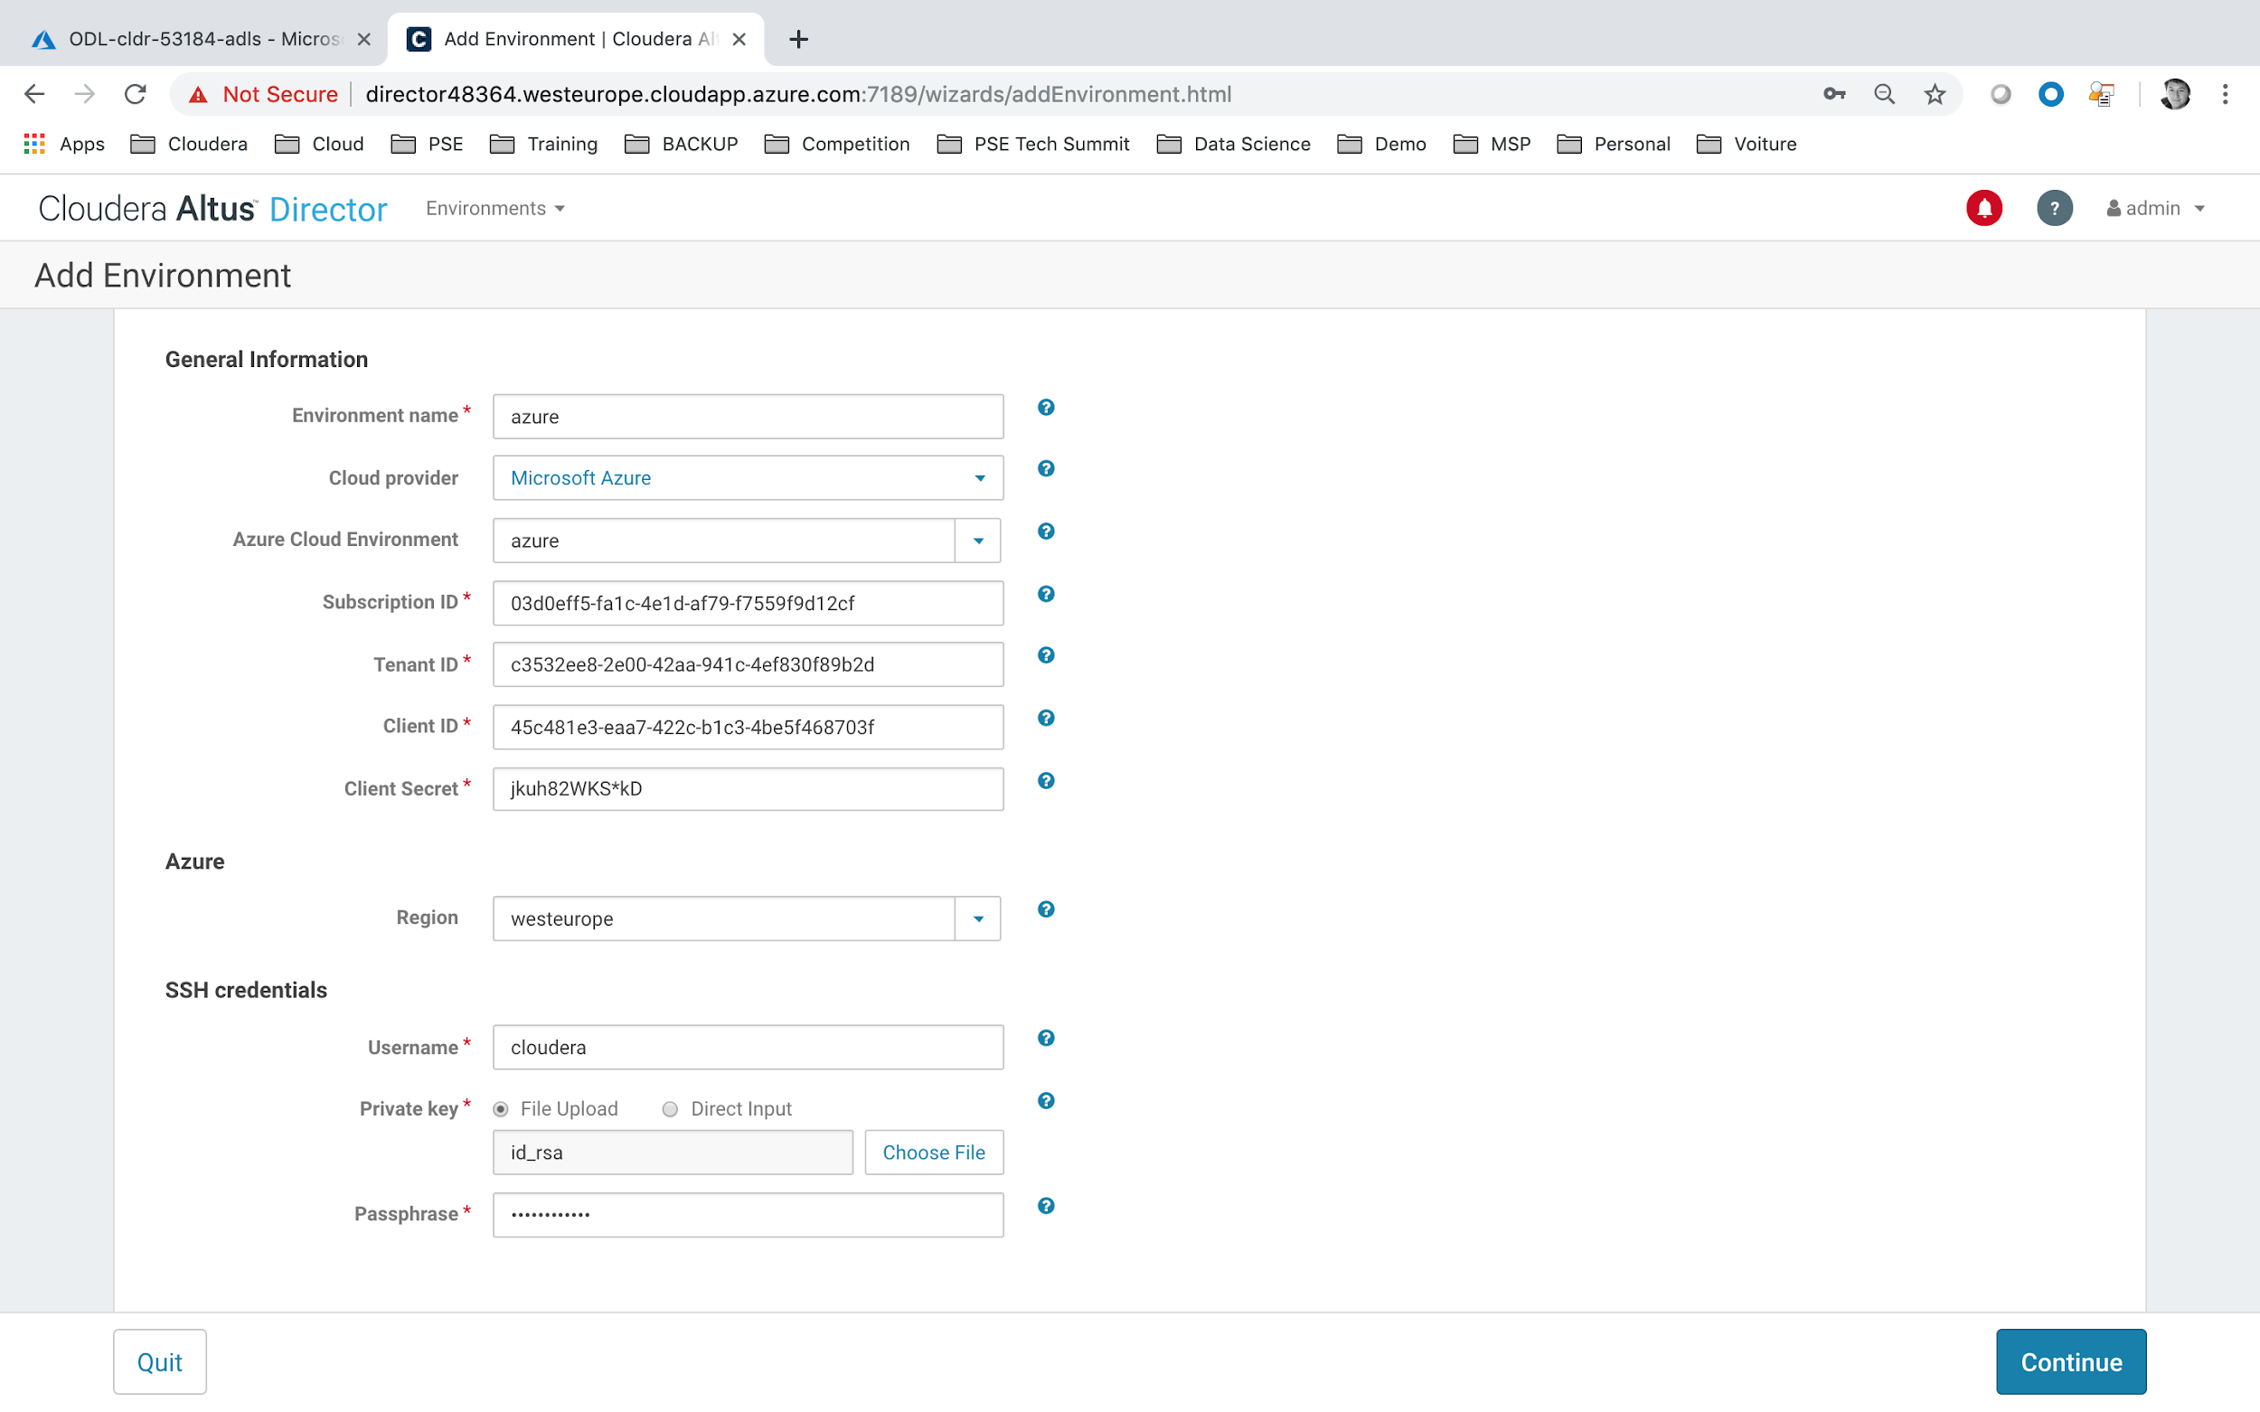

Update the current informations:

* Environment Name = Azure
* Cloud Provider = Microsoft Azure
* Azure Cloud Environment = azure
* Subscription ID, Tenant ID, Client ID (or Application ID) and Client Secret = are provided by Spektra Systems through an email.
* Region = Please make sure to choose the same region as the Resource Group that have been chosen by Spektra Systems. For example **westeurope**.
* Username = cloudera
* private key = please point to the **id_rsa** private key file.

## **Creating Template Node template**

On the next screen, we will select the newly created environment **Azure**.

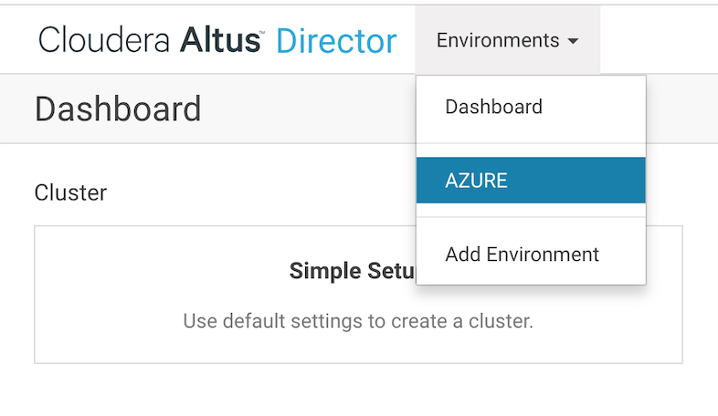

You will be able to select the **Templates** tab.

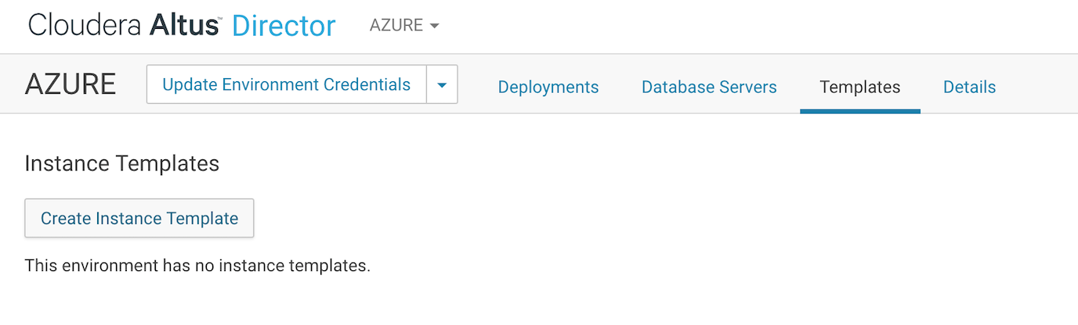

We will create a first template for **Cloudera Manager - CM** node.

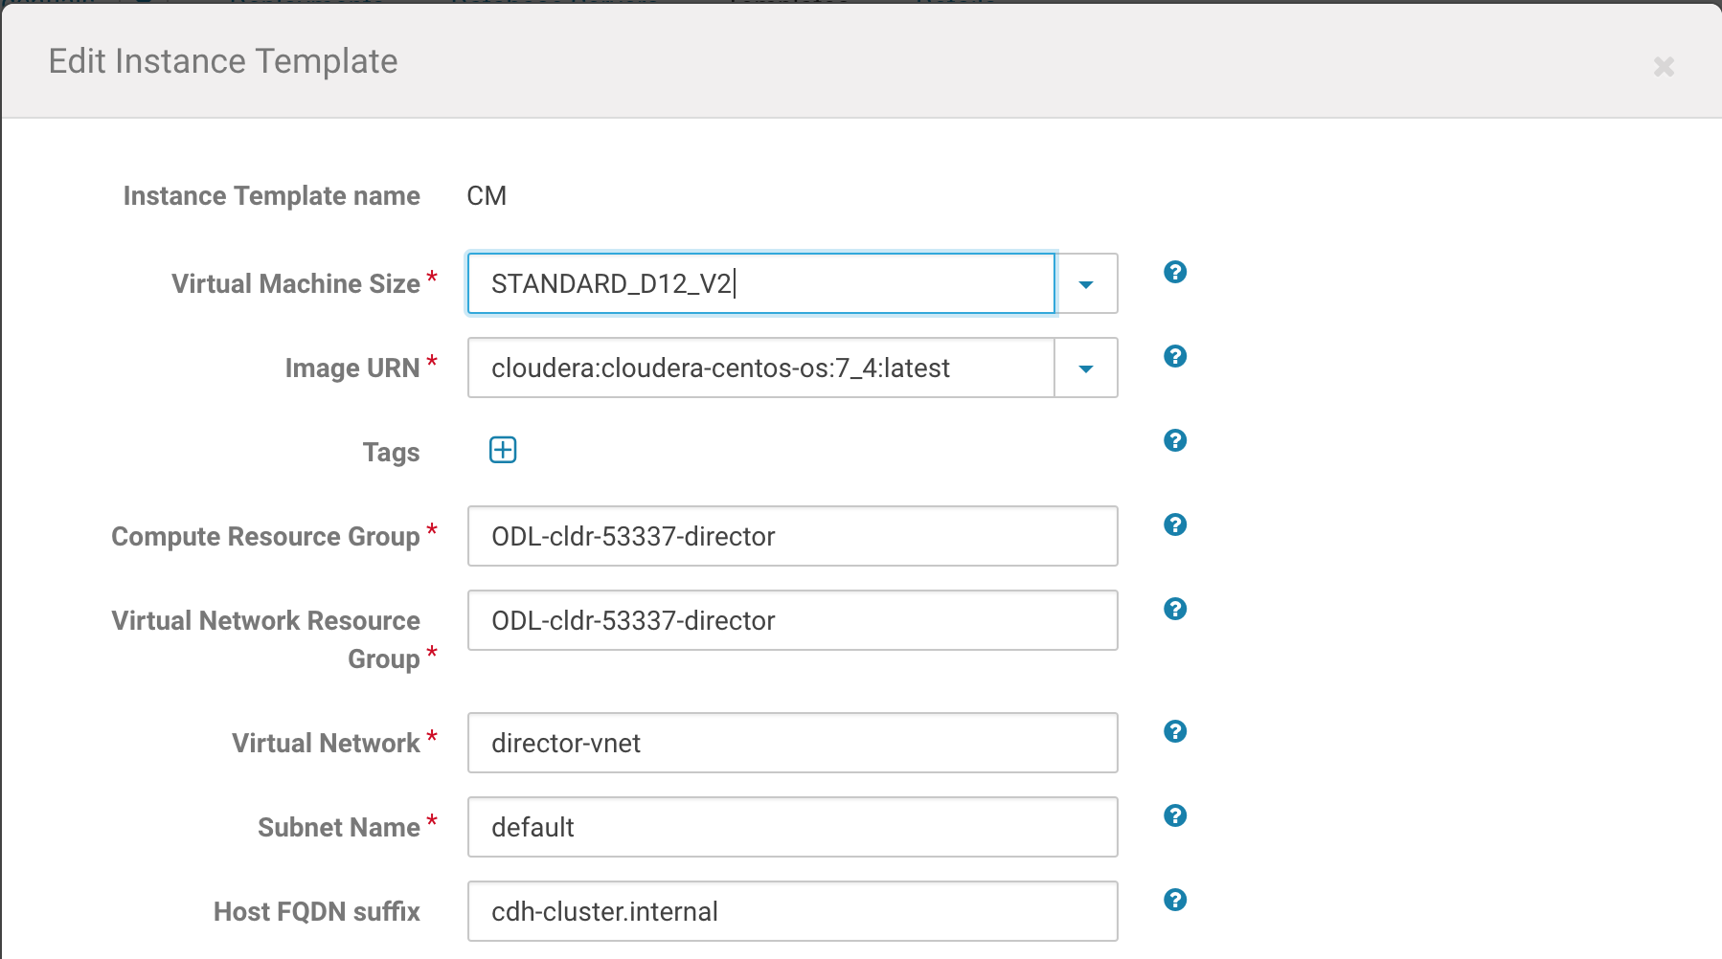

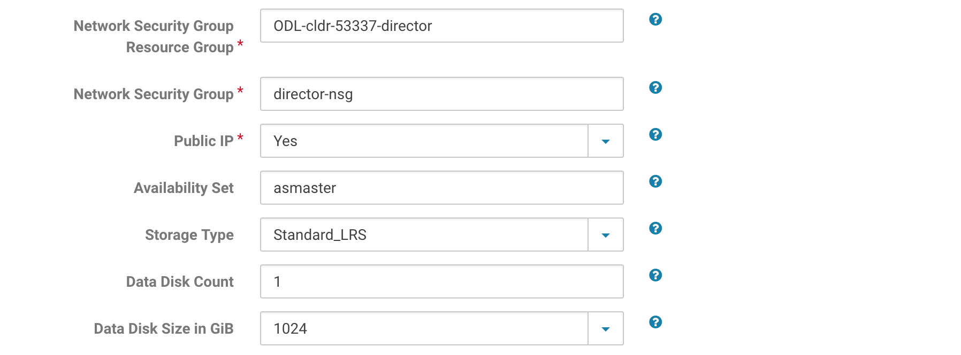

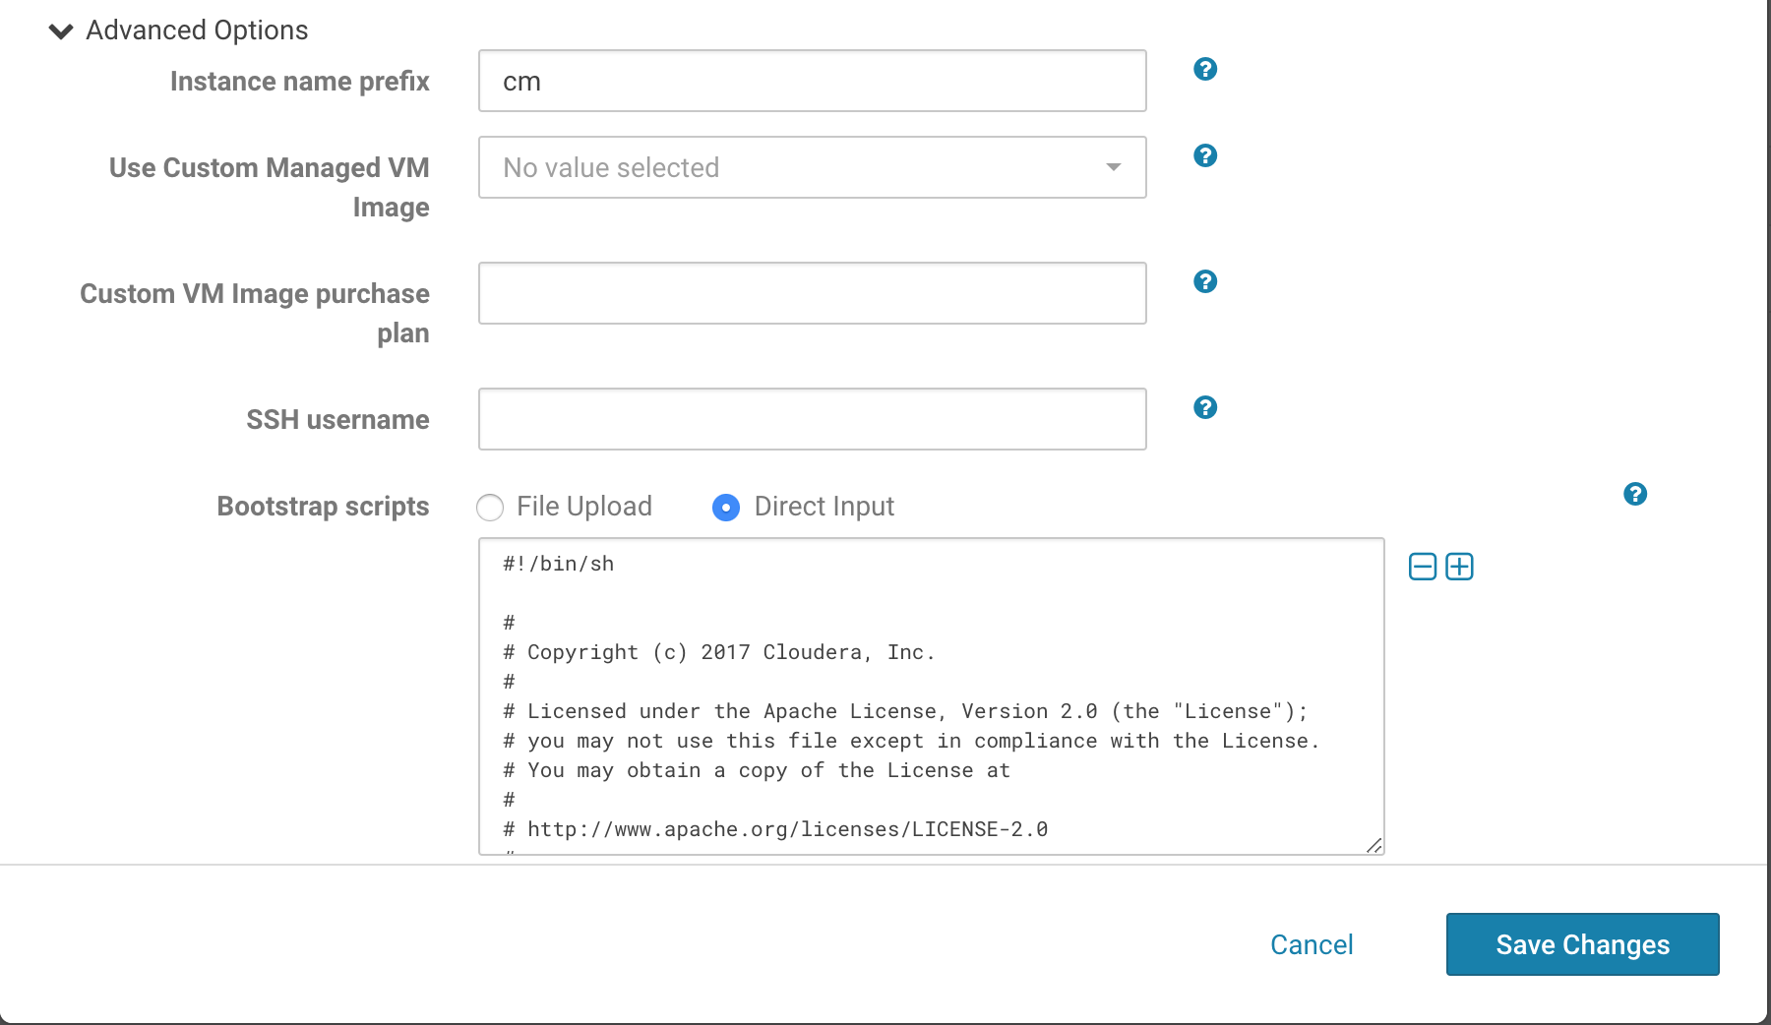

Update the configuration as indicated below:

* Template name = **CM**
* VM name = **STANDARD_DS13_V2**
* Image URN = **cloudera-centos-os:7_4:latest**
* Compute RG = **ODL-cldr-<USERID>-director**
* Virtual Network RG = **ODL-cldr-<USERID>-director**
* Network Security Group RG = **ODL-cldr-<USERID>-director**
* Virtual Network = **director-vnet**
* Subnet Name = **default**
* Host FQDN = **cdh-cluster.internal**
* Network Security Group = **director-nsg**
* Public IP = **yes**
* Availability Set = **asmaster**
* Storage Type = **Standard_LRS**
* Data Disk Count = **1**
* Data Disk Size in GiB = 1024
* Advanced > Instance prefix name = **CM**
* Advanced > Bootstrap script = copy/paste code from this link <https://raw.githubusercontent.com/cloudera/director-scripts/master/azure-bootstrap-scripts/os-generic-bootstrap.sh>
* Click on **Save**.

You should a freshly created new template for CM Node Template.

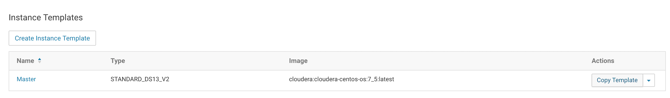

You now could use the Copy Template functionality to create Worker, Edge and Cloudera Manager nodes. Please make sure you have updated the Template Name / Availability Set / Instance prefix name accordingly

* Master Node: Master / asmaster / master
* Worker Node: Worker / asworker / worker
* Edge Node: Edge / asedge / edge

## **Deploying Cloudera Data Warehouse**

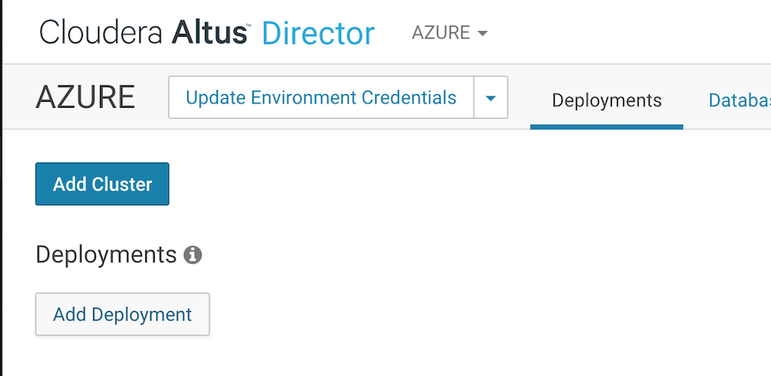

Click on **Deployments** tab and then on **Add Deployment**.

You will have another option screen, where you will be able to define the Cloudera Manager options.

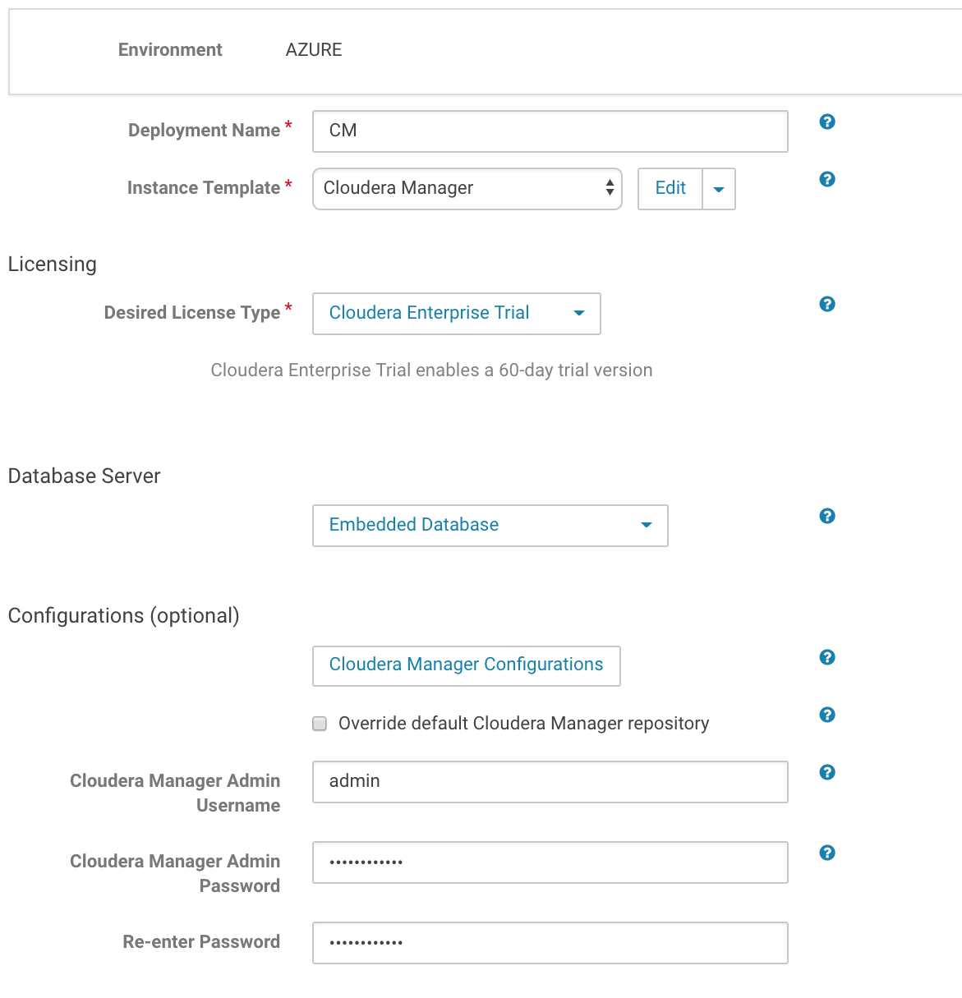

Update the parameters as follow:

* Deployment Name = **CM**
* Instance Type = **CM**
* Desired License Type = **Cloudera Enterprise Trial**
* Database Server = **Embedded Database**
* CM Admin Username = **cloudera**
* CM Admin Password = **Cloudera_123**

On the next screen you will be able to select information regarding the cluster itself.

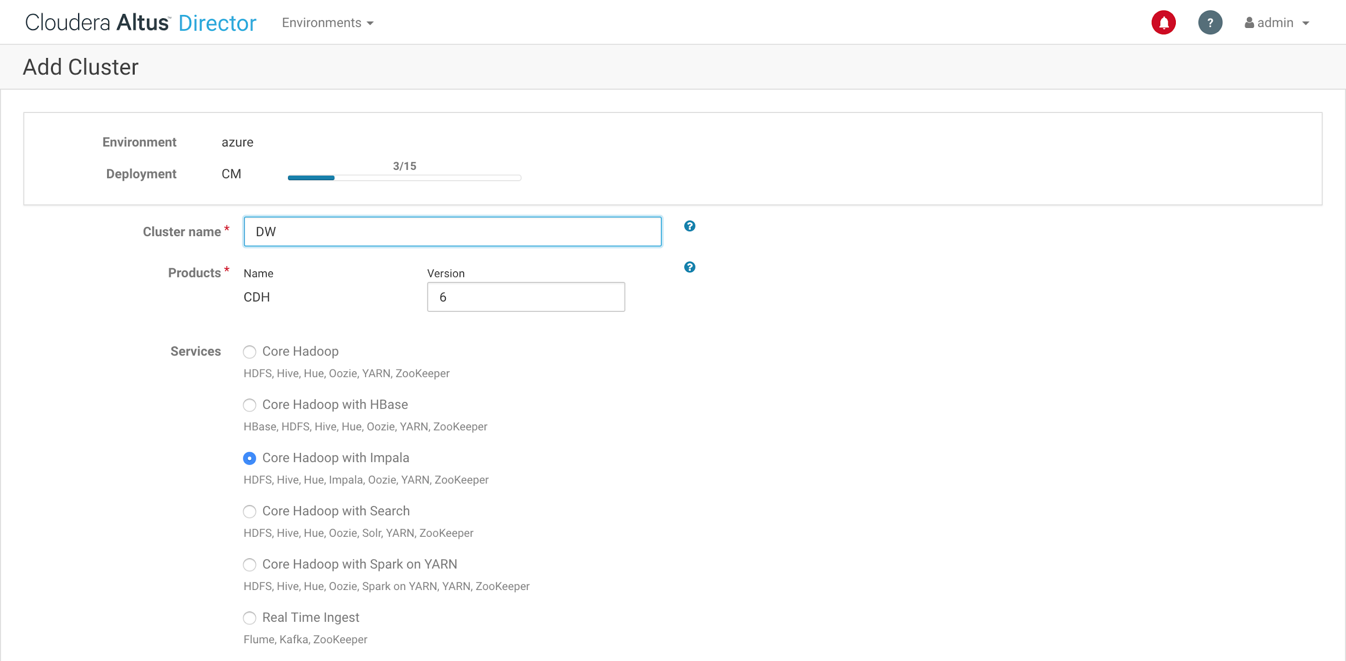

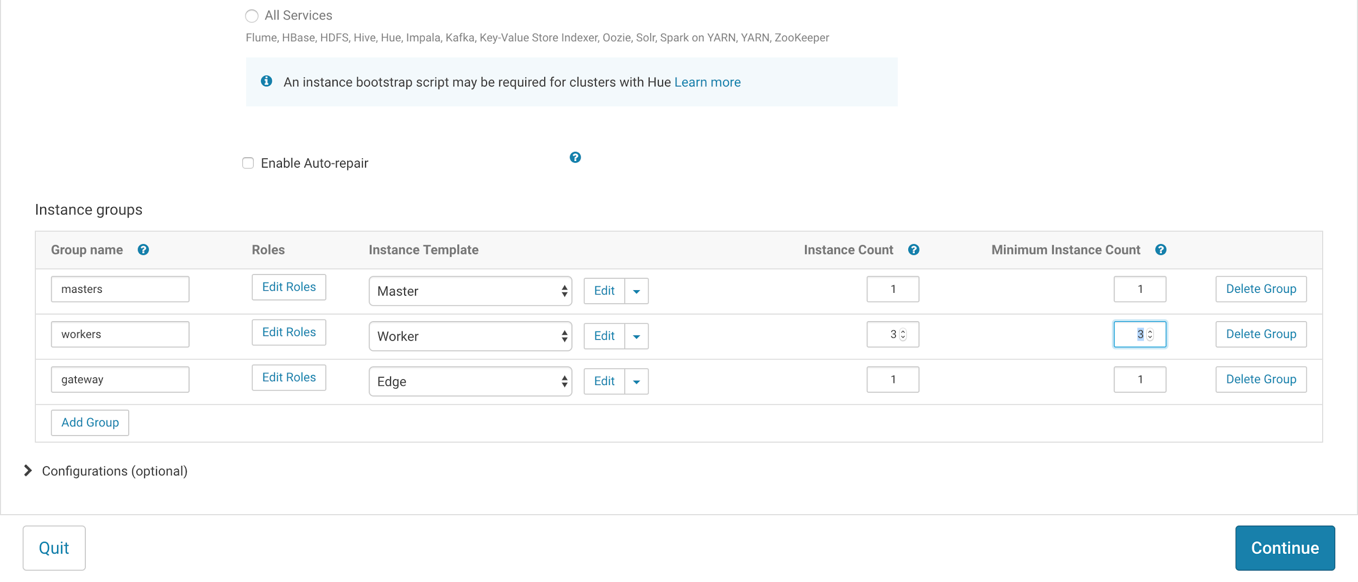

Select Options as follow:

* Cluster Name = **DW**
* Services = **Core Hadoop with Impala**
* Instance Groups:
  + group name = **masters | Instance Template = Master | Instance Count = 1 | Minimum Instance Count = 1**
  + group name = **workers | Instance Template = Worker | Instance Count = 3 | Minimum Instance Count = 3**
  + group name = **gateway | Instance Template = Edge | Instance Count = 1 | Minimum Instance Count = 1**

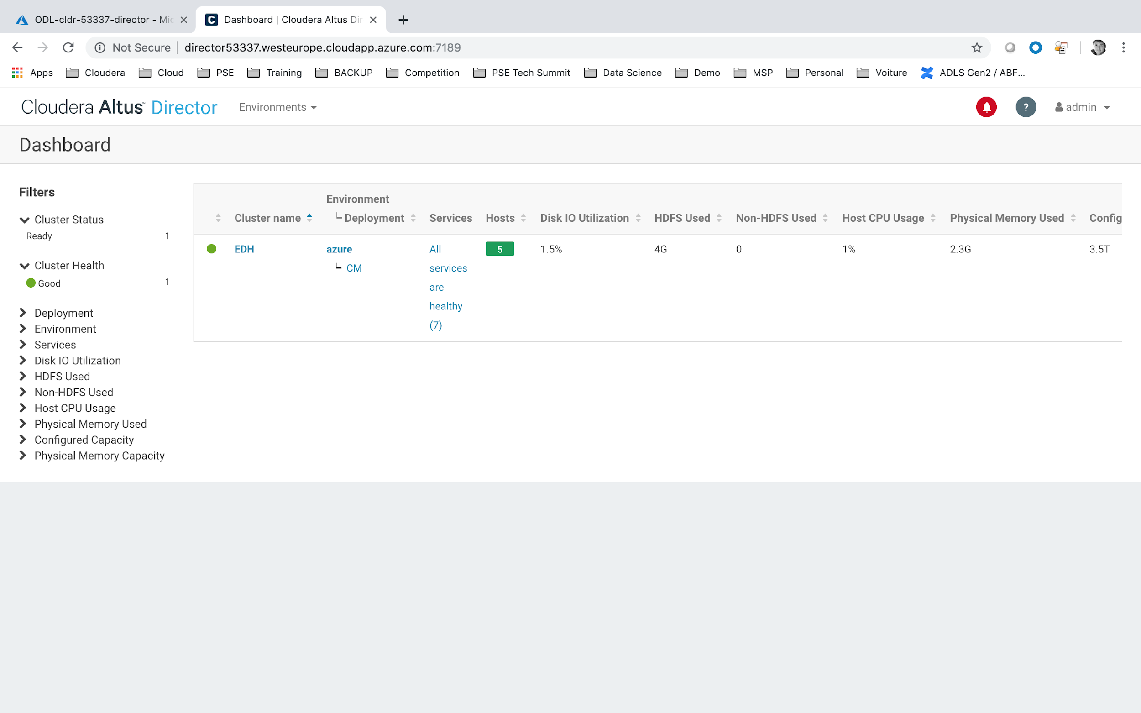

# LAB#6: CONNECTING TO CLOUDERA MANAGER & HUE

## **Connect to Cloudera Manager Web UI.**

You should be able to connect to Cloudera Manager through Cloudera Director.

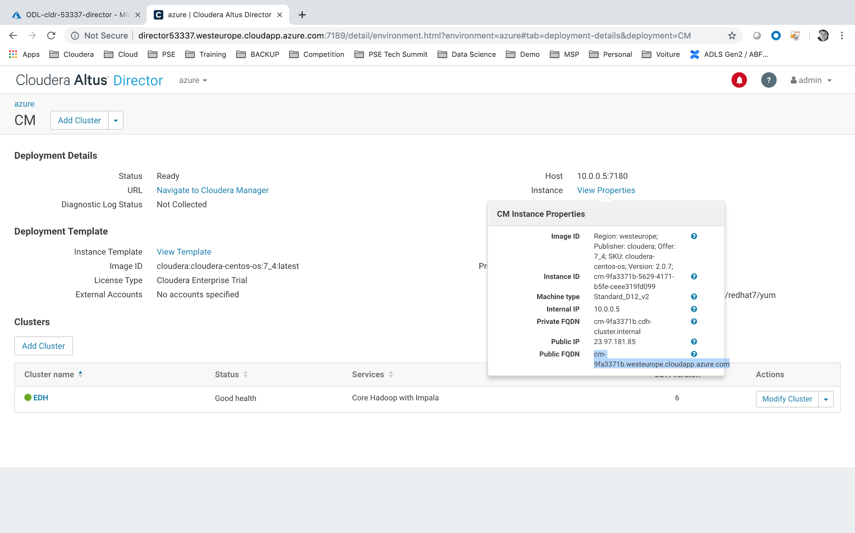

* Click on **CM**
* Click on **View Properties.**
* Copy the Public FQDN (for ex: cm-9fa3371b.westeurope.cloudapp.azure.com)

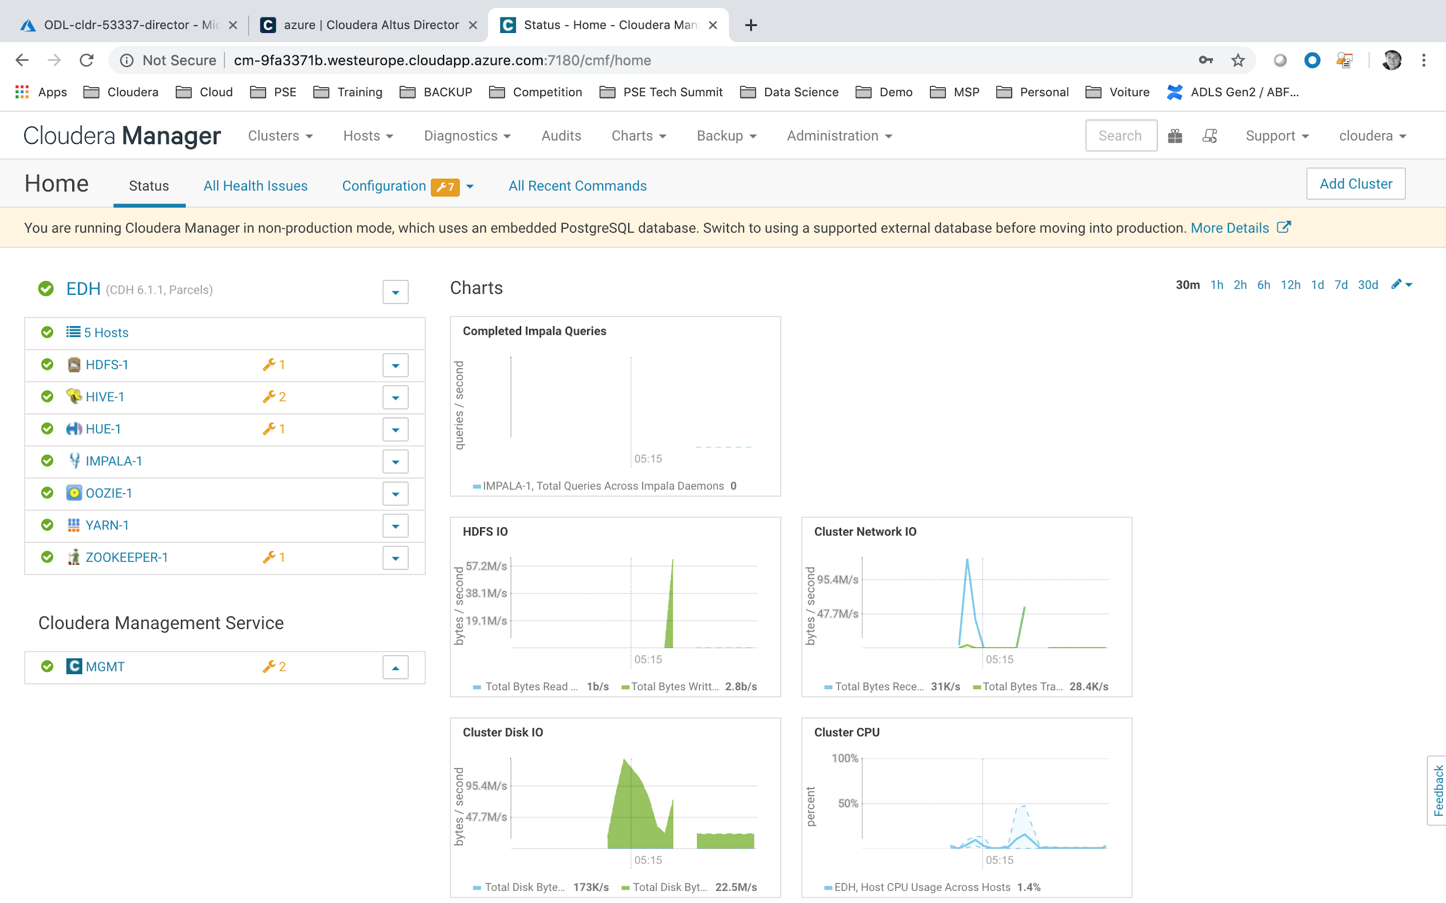

Fire your favorite web browser and open link [http://FQDN:7180/](http://fqdn:7180/) (for ex: <http://cm-9fa3371b.westeurope.cloudapp.azure.com:7180/cmf/login>)

* login = **cloudera**
* password = **Cloudera_123**

## **Connect to HUE Web UI**

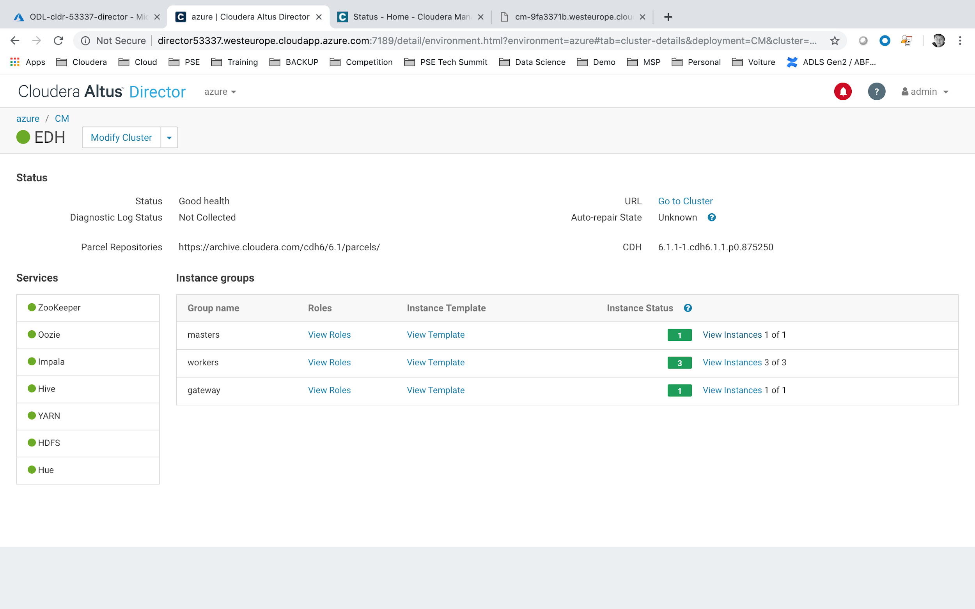

On Cloudera Director, click on **EDH** cluster.

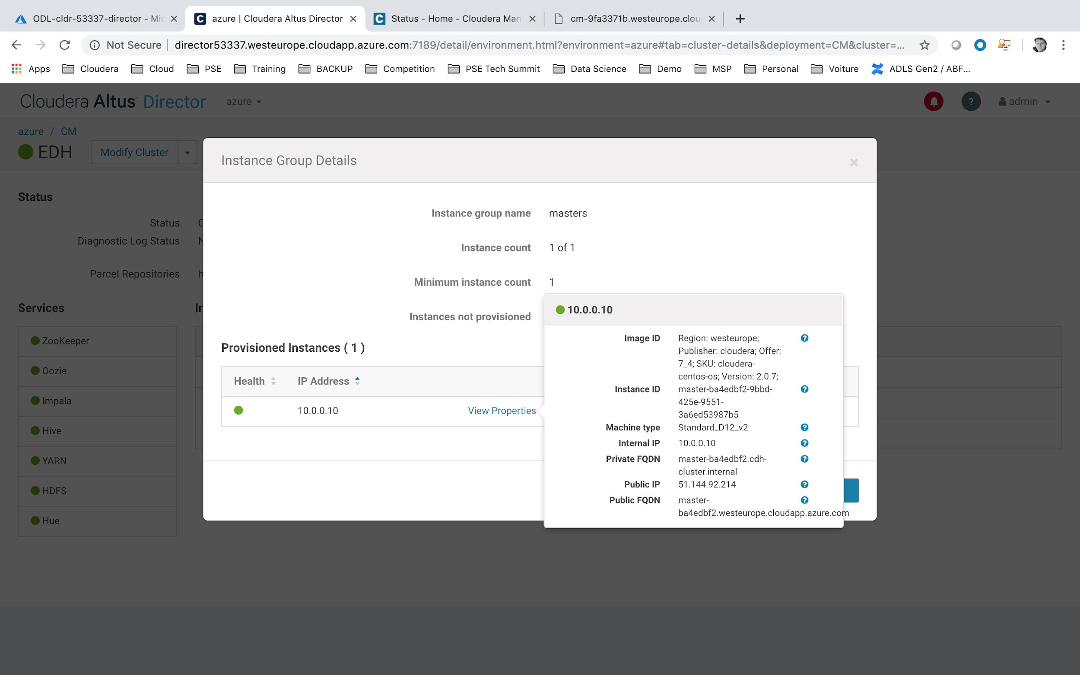

* Click on Masters -> View Instances
* Click on View Properties
* Copy the Public FQDN (for ex: master-ba4edbf2.westeurope.cloudapp.azure.com)

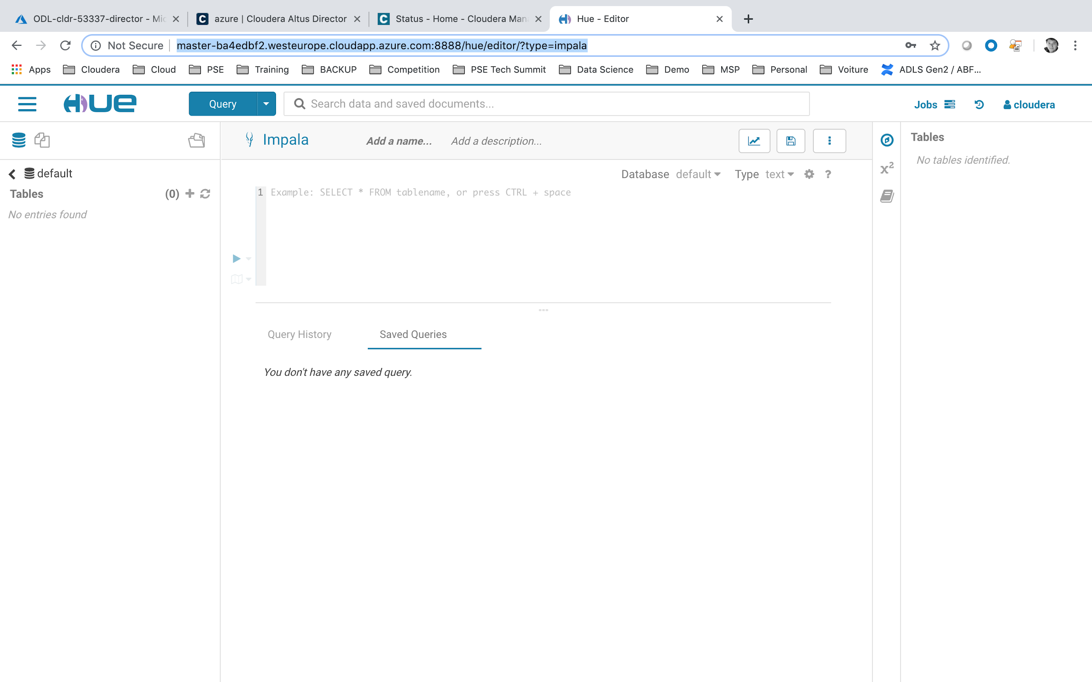

Fire your favorite web browser and open link [http://FQDN:8888/](http://fqdn:7180/) (for ex: http://master-ba4edbf2.westeurope.cloudapp.azure.com:8888)

* login = **cloudera**
* password = **Cloudera_123**

## **Import Customer.csv from Hive Metastore**

Download file **crm_customers.txt** from<https://cloudera.box.com/s/vkd8rit7ainmetaqur9yo85jh16cy7qb>.

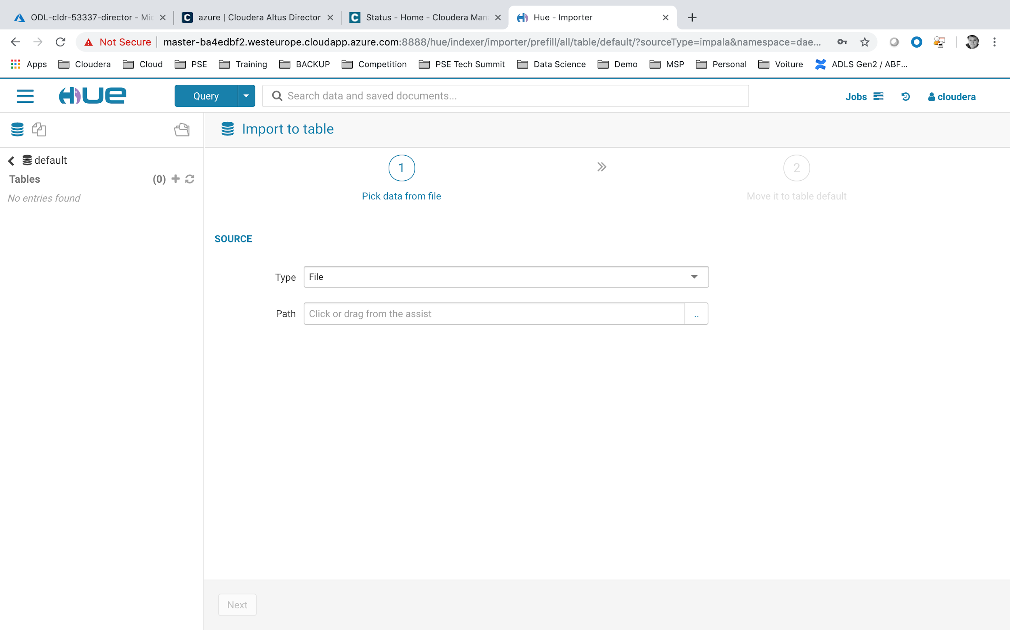

We will now import the **crm_customers.txt** to HDFS and build a **crm_customers** table.

* Click on ‘**+**’ button next to the **Default > Tables.**
* In path we will upload the **crm_customers.txt** file, click on the ‘**..**’ icon.

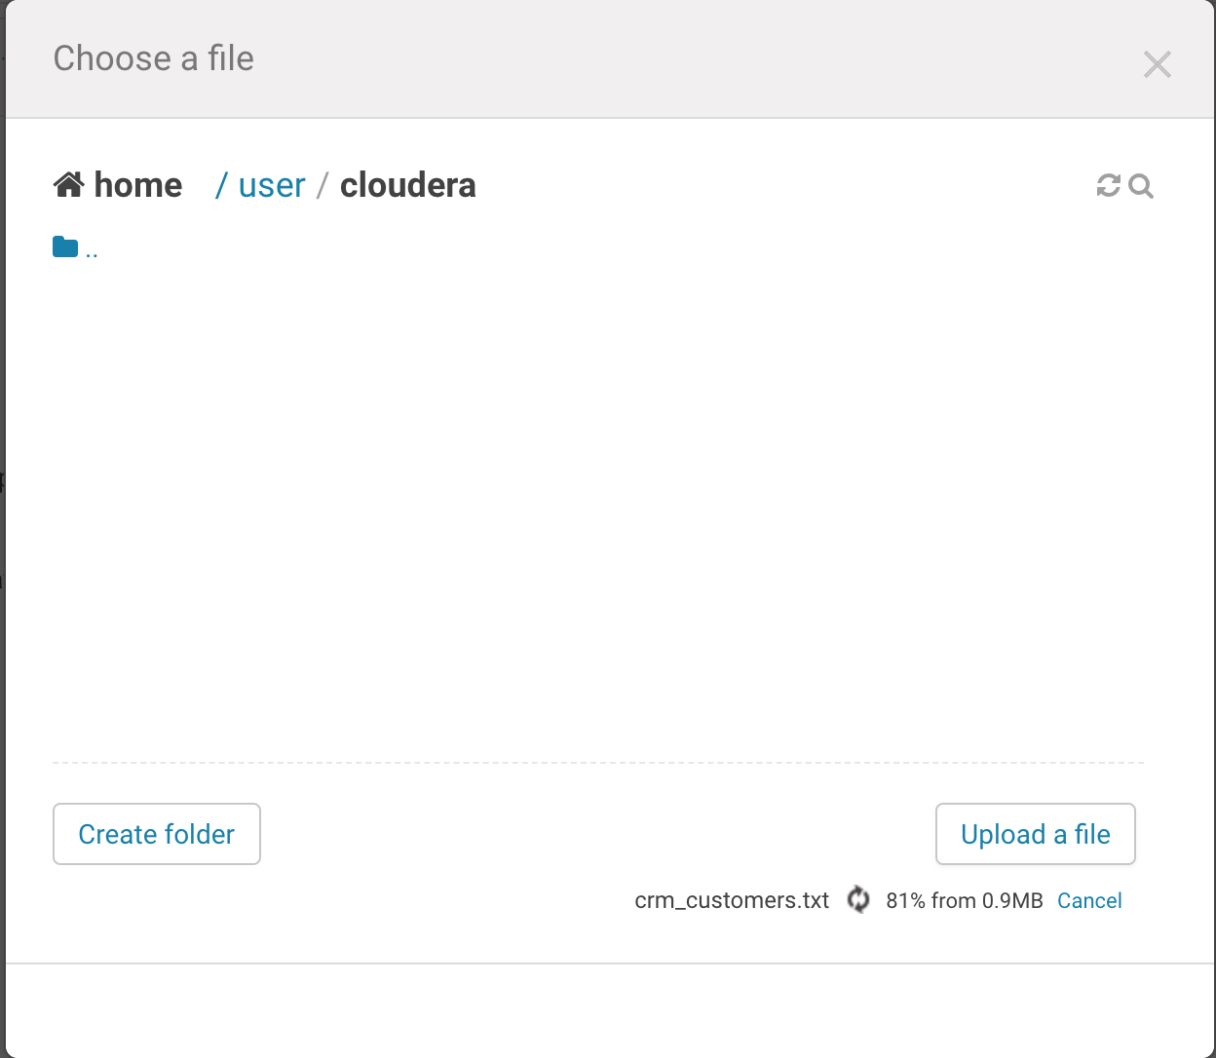

A dialog will open so that you can upload a file.

* Click on **Upload a File**
* And point it to the newly download **crm_customers.txt** file.
* Then select the HDFS file.

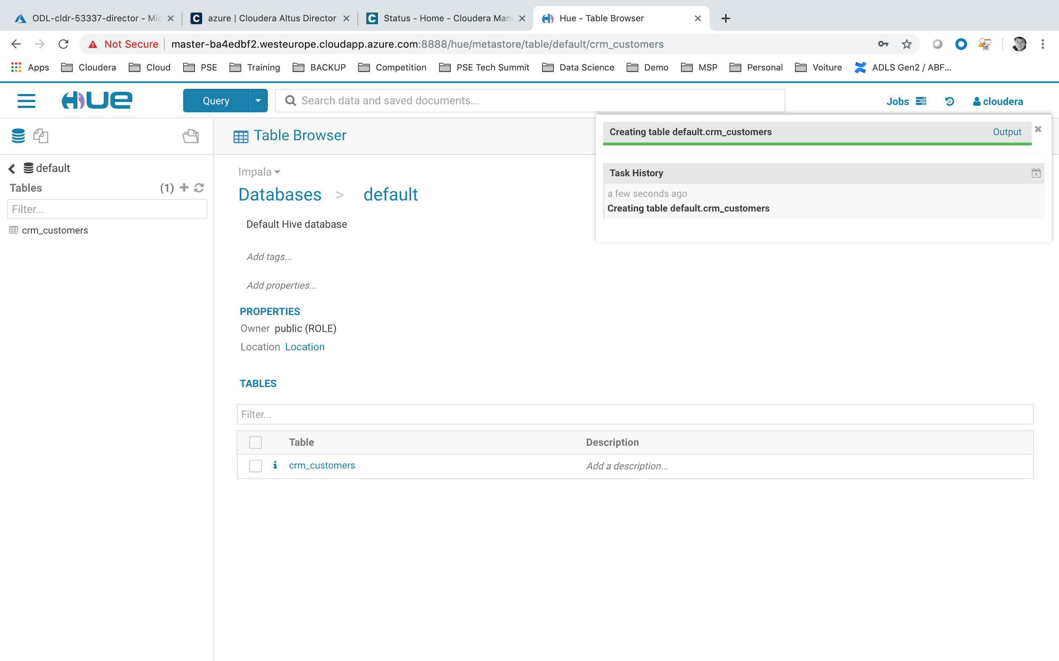

* Click on Next
* then Submit.

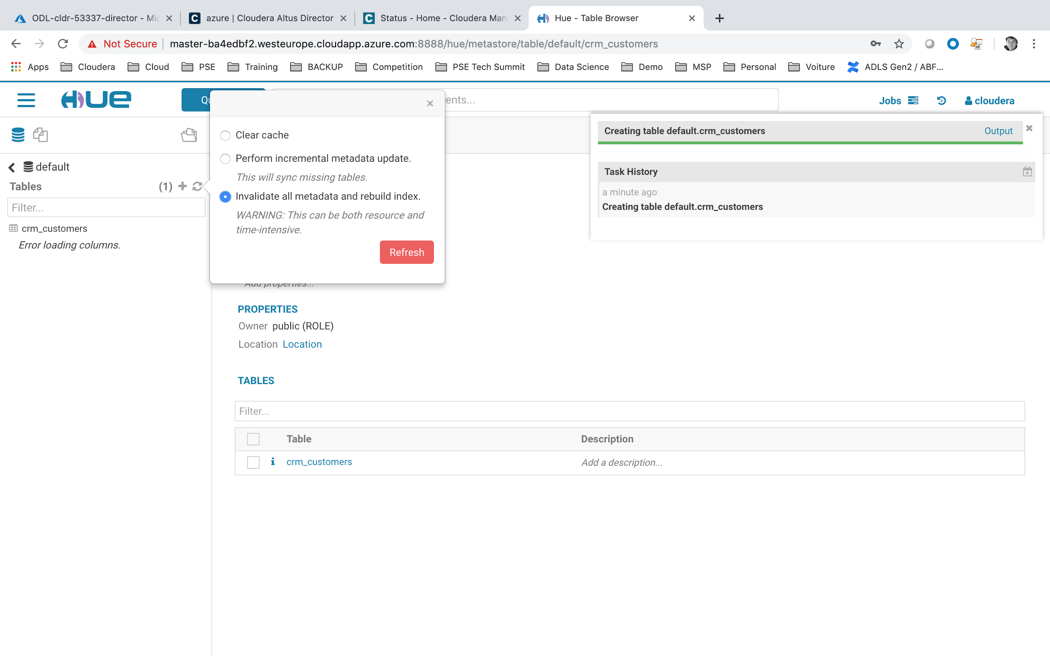

Remember to refresh your Metadata to update the newly created table.

* Click on the Refresh icon (next to Default > Table)
* Select **Invalidate All Metadata**.
* Click on **Refresh**

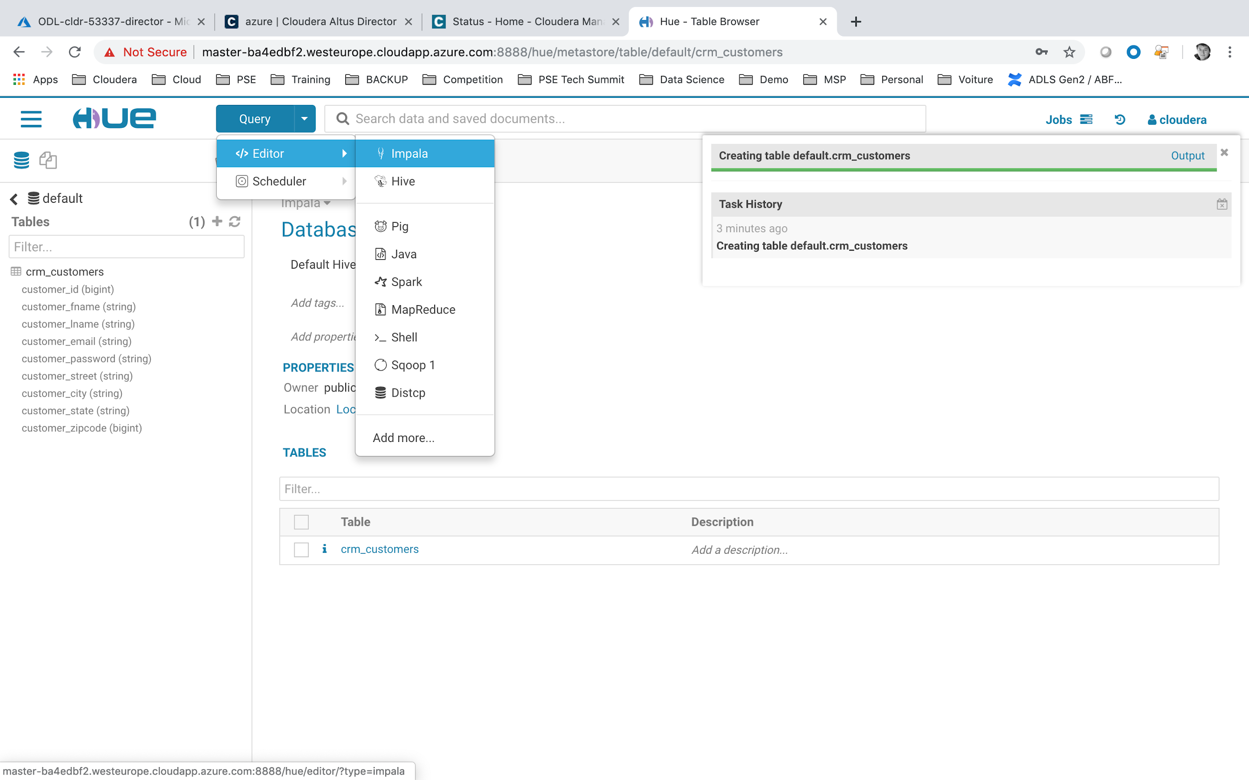

We now will launch some SQL statements based on this newly created table.

* Select **Query**
* Choose **Editor**
* Choose **Impala**

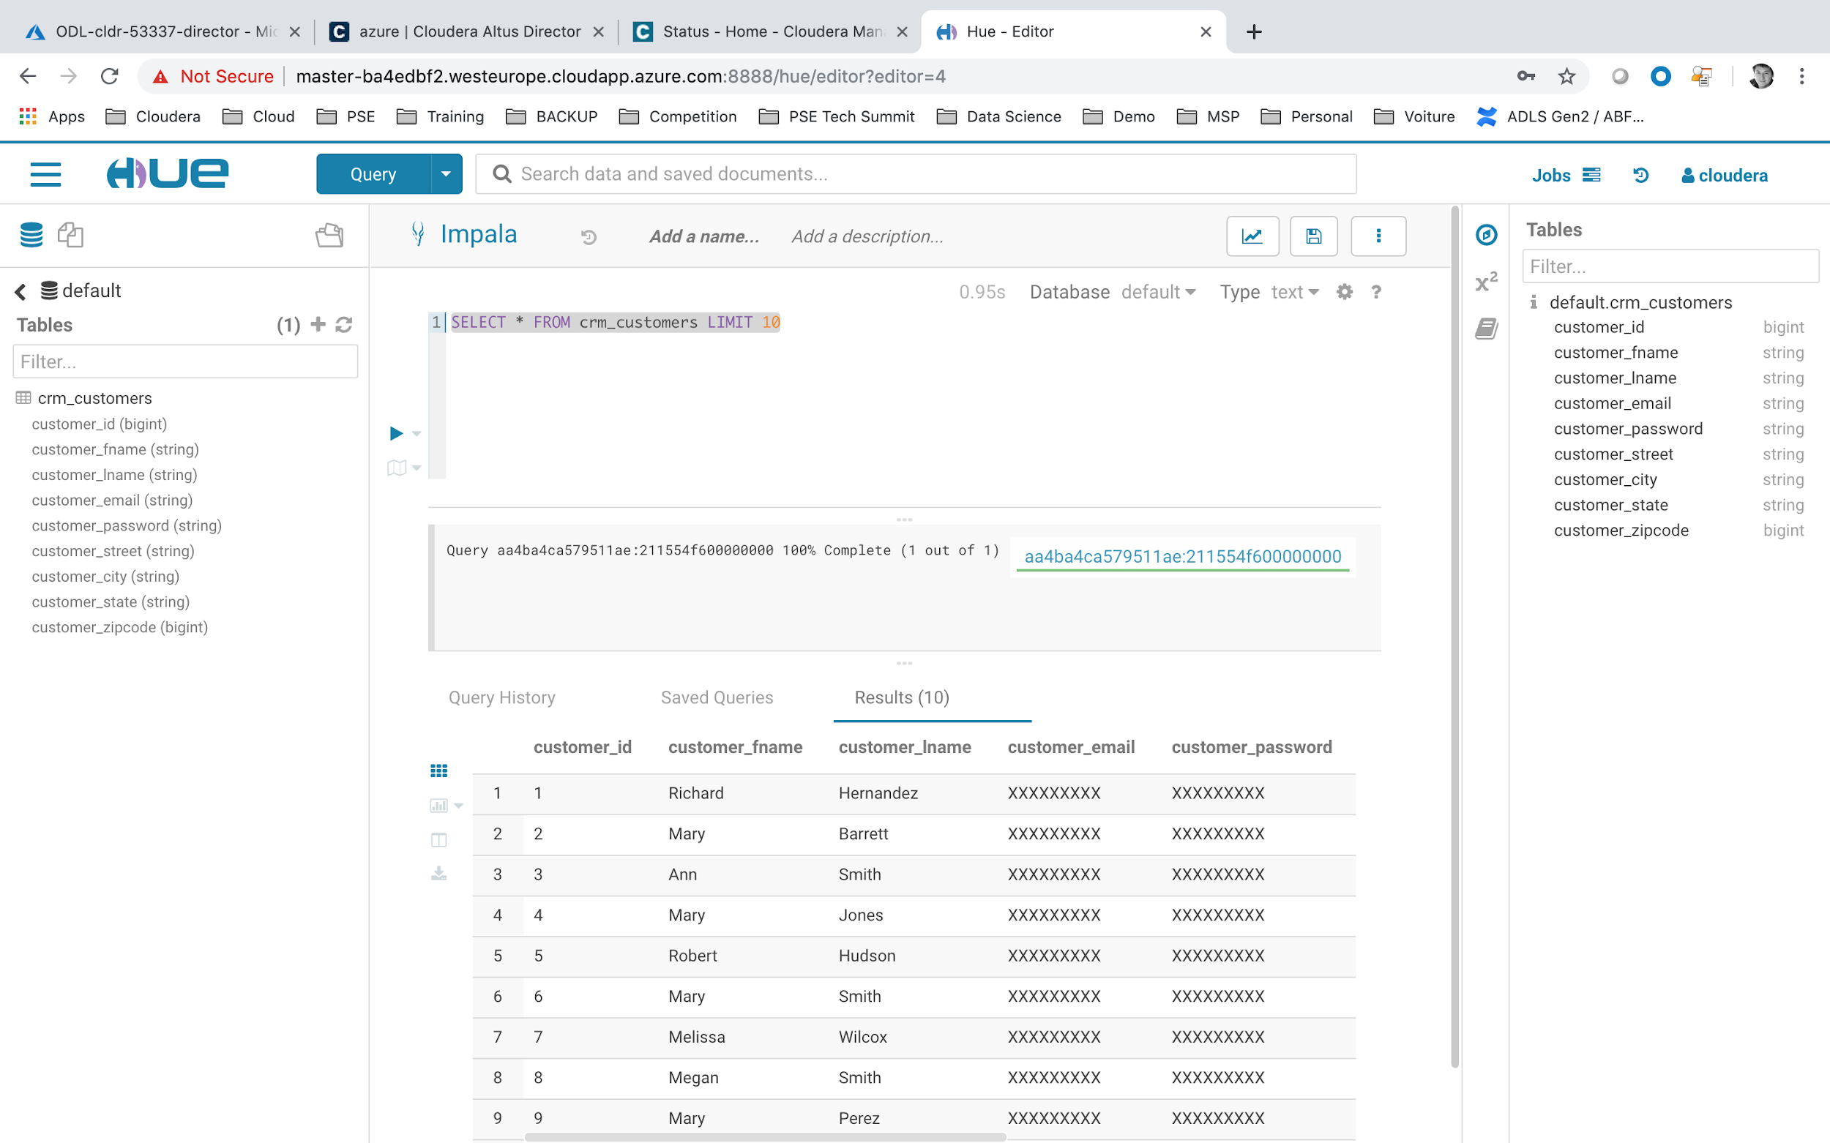

When you launch SQL statement you will see the output directly on HUE screen

* Type SELECT * FROM crm_customers LIMIT 10
* Click on Play icon

# LAB#7: CONNECTING TO AZURE DATA LAKE STORE

## **Create your personal ADLS**

On the **Services** menu, select **Data Lake Storage**.

## 

Update the informations as follow, and click on **Create** button:

* Name = **adls<USERID>**
* Subscription = **provided by Spektra Systems**
* Resource Group = **ODL-cldr-<USERID>-adls (note it is a different Resource Group than previously with Director)**
* Location = **West Europe**

## **Update the ADLS permissions**

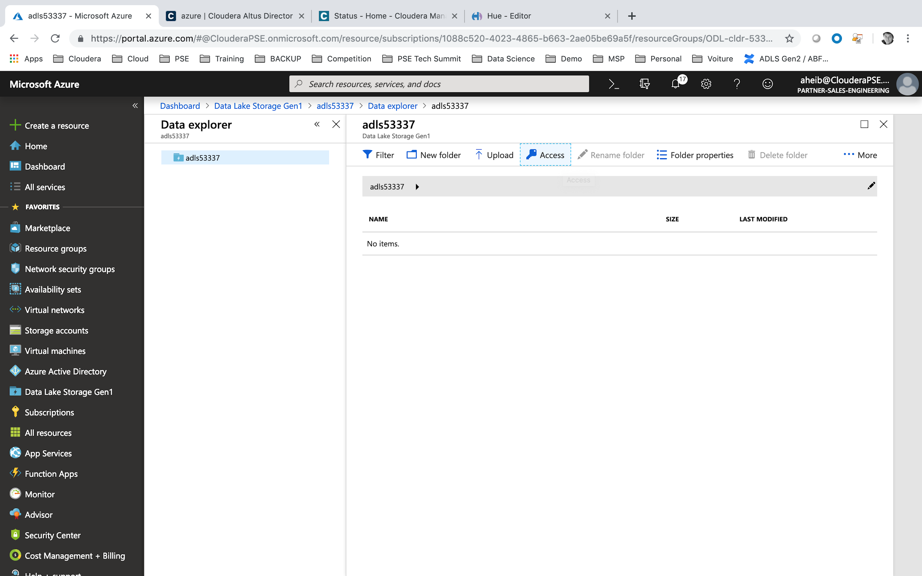

Once you have clicked on the newly created ADLS storage, you could click on **Data explorer**. And then we will select **Access** tab, to add the Service Principal to the ADLS permissions.

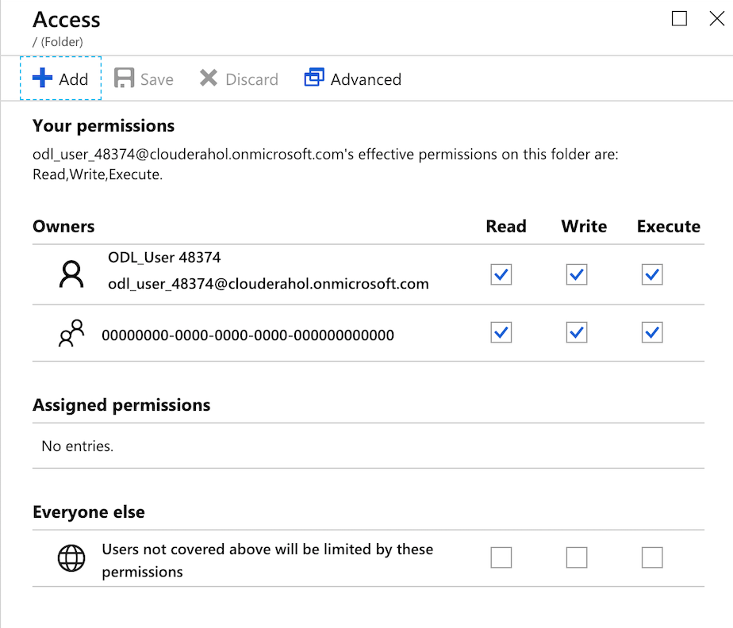

We could notice that the current user has already full permission to access the ADLS store. We will now grant permission to the Cloudera Cluster (through the service principal) to access to the same storage. Click on **Add** access.

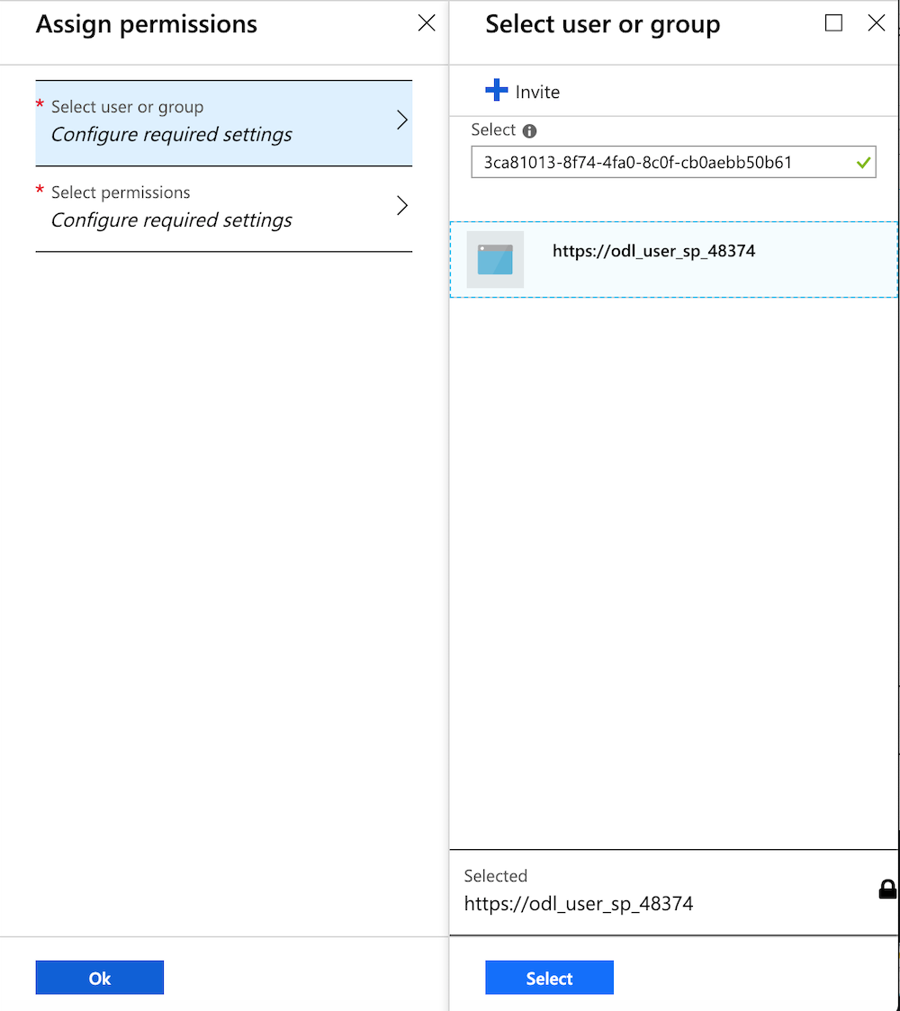

Search for the Service Principal by adding information like the **Client ID** (also called Application ID).

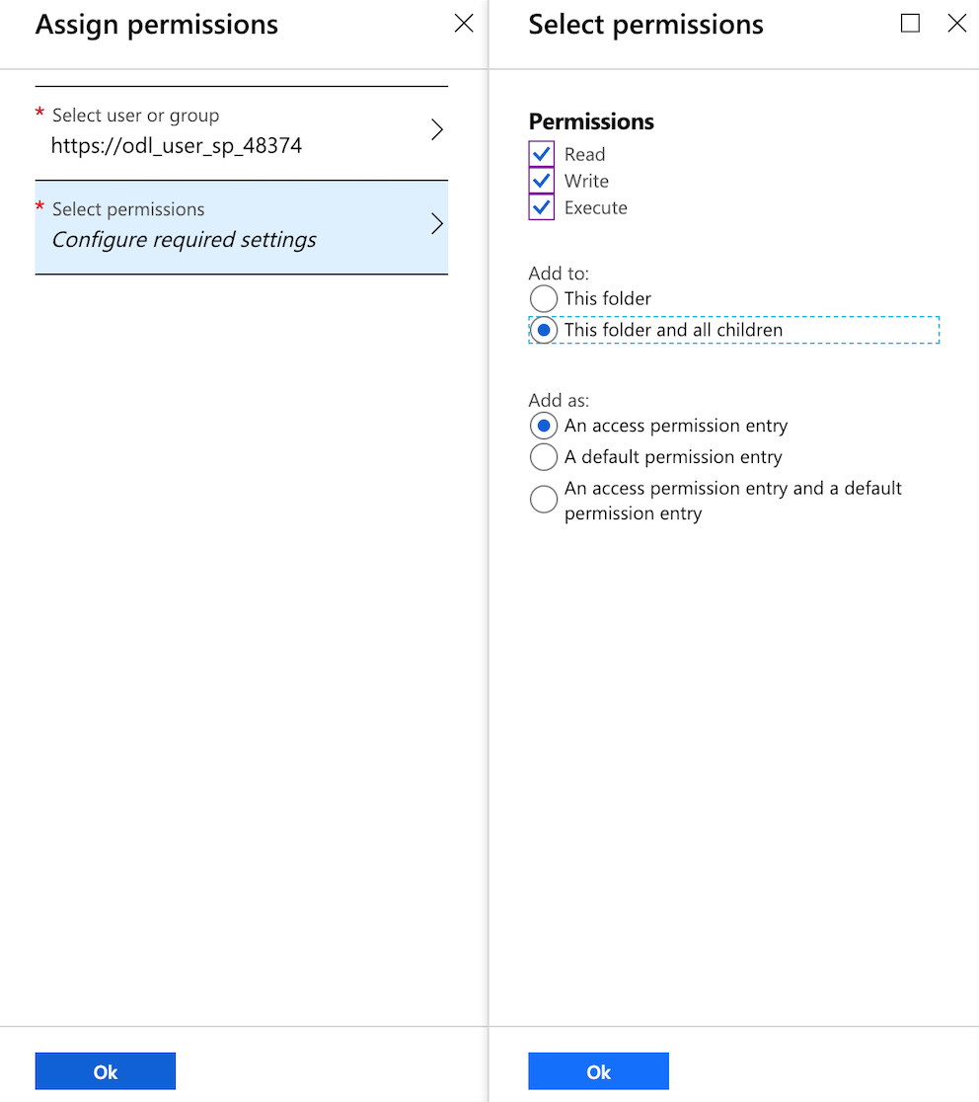

Grant full permissions for **Read / Write / Execute** and on **all folders and all children**.

## **Updating Cloudera Manager to connect with Azure Data Lake Storage**

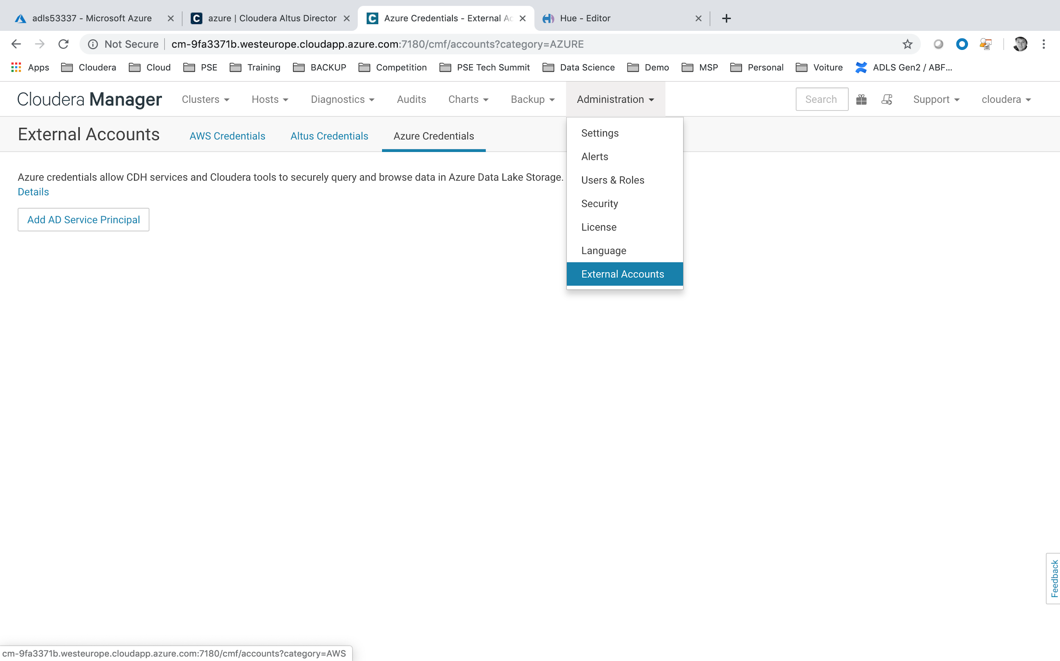

* Connect to Cloudera Manager web interface.
* Go to Administration > External Accounts.
* Select the **Azure Credentials** tab.
* Click **Add AD Service Principal**.

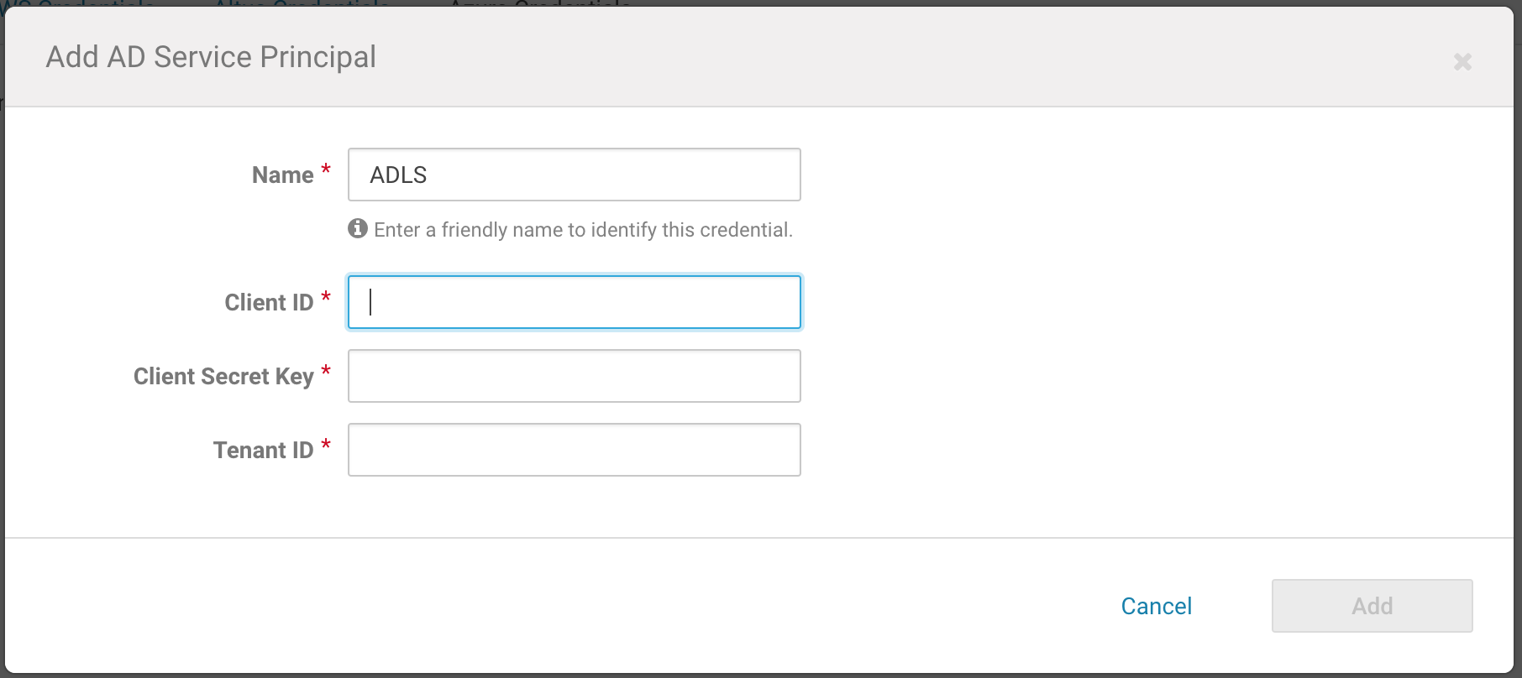

* In the Name field, enter a unique name to identify the credentials in your cluster (for ex: ADLS).
* Enter the Client ID, Client Secret Key, and Tenant ID that you obtained when creating the ADLS account and service principal.
* Click **Save**.

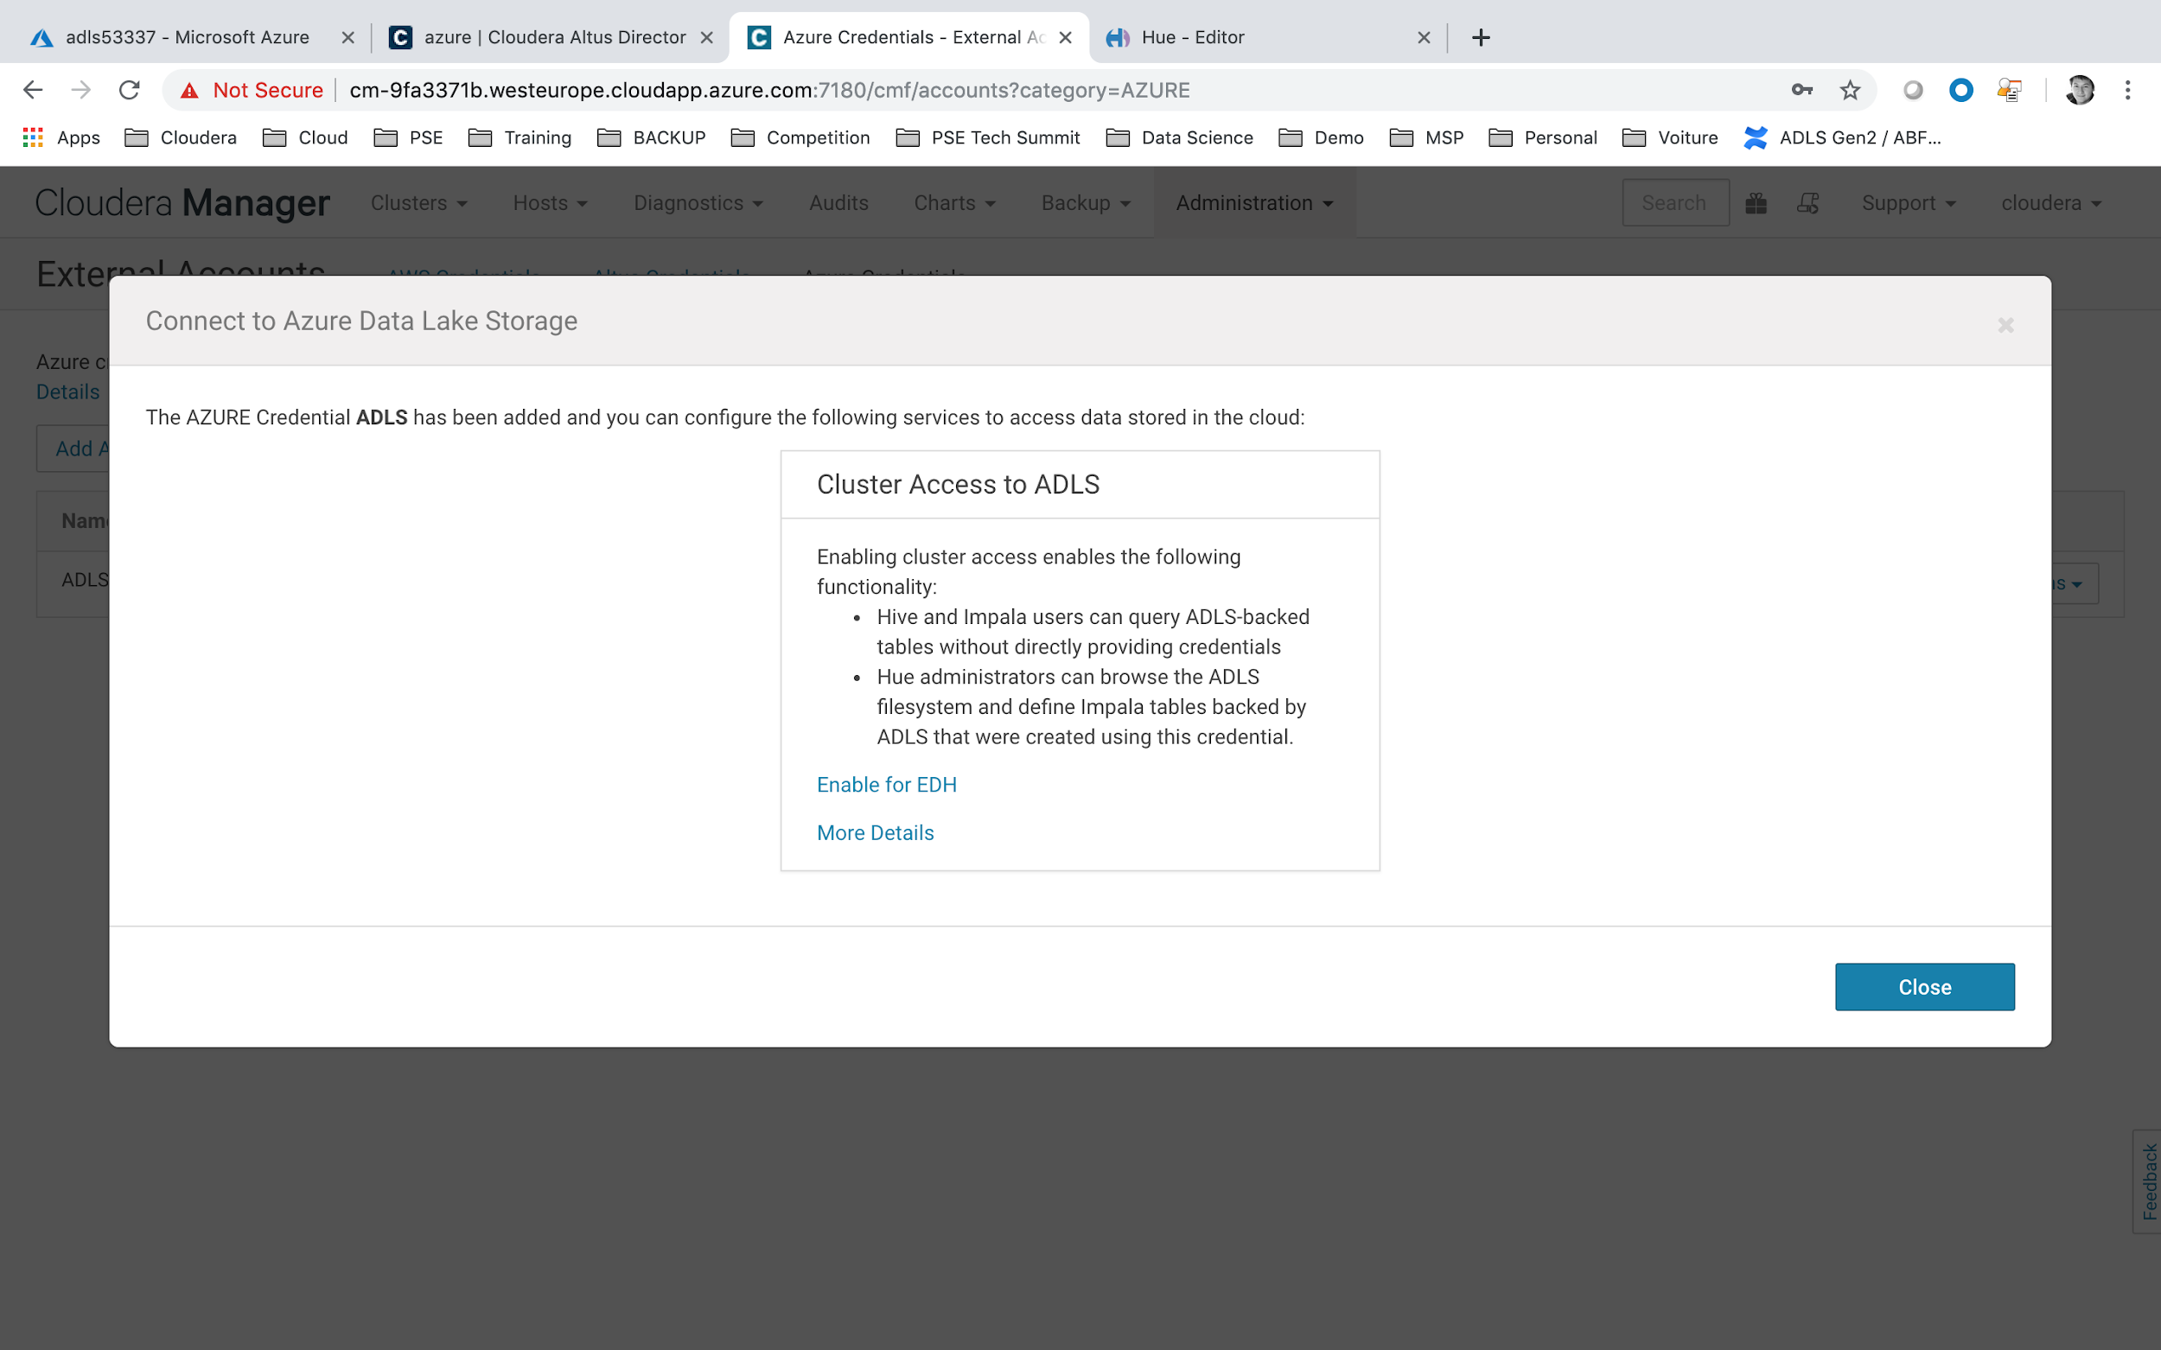

Click Enable Cluster Access to ADLS click on **Enable for EDH**.

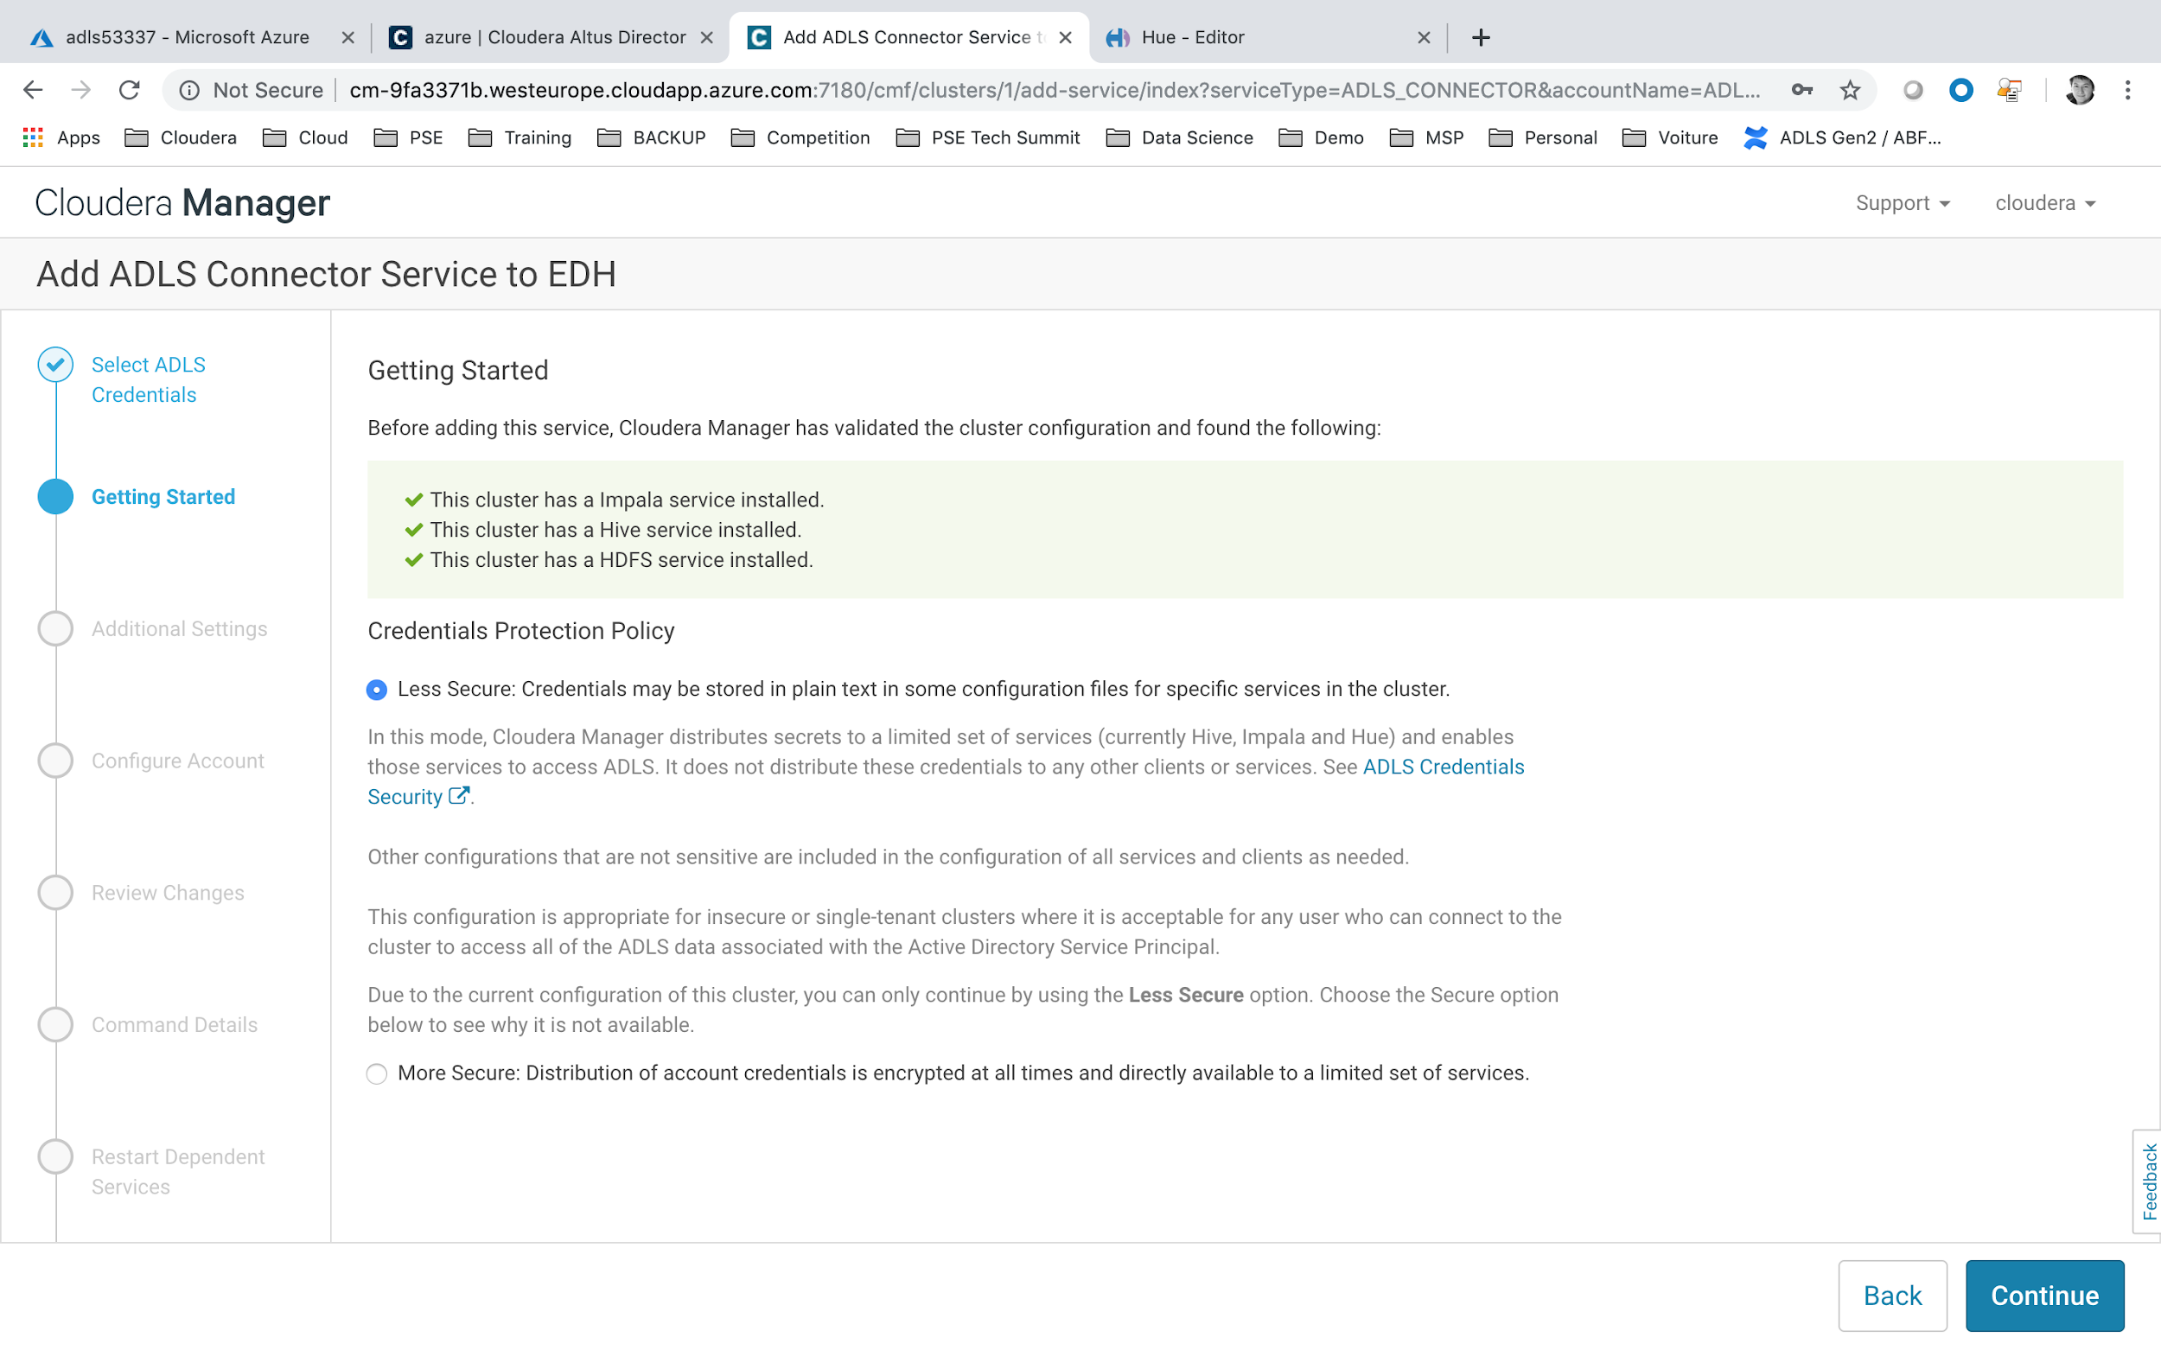

* click on Continue

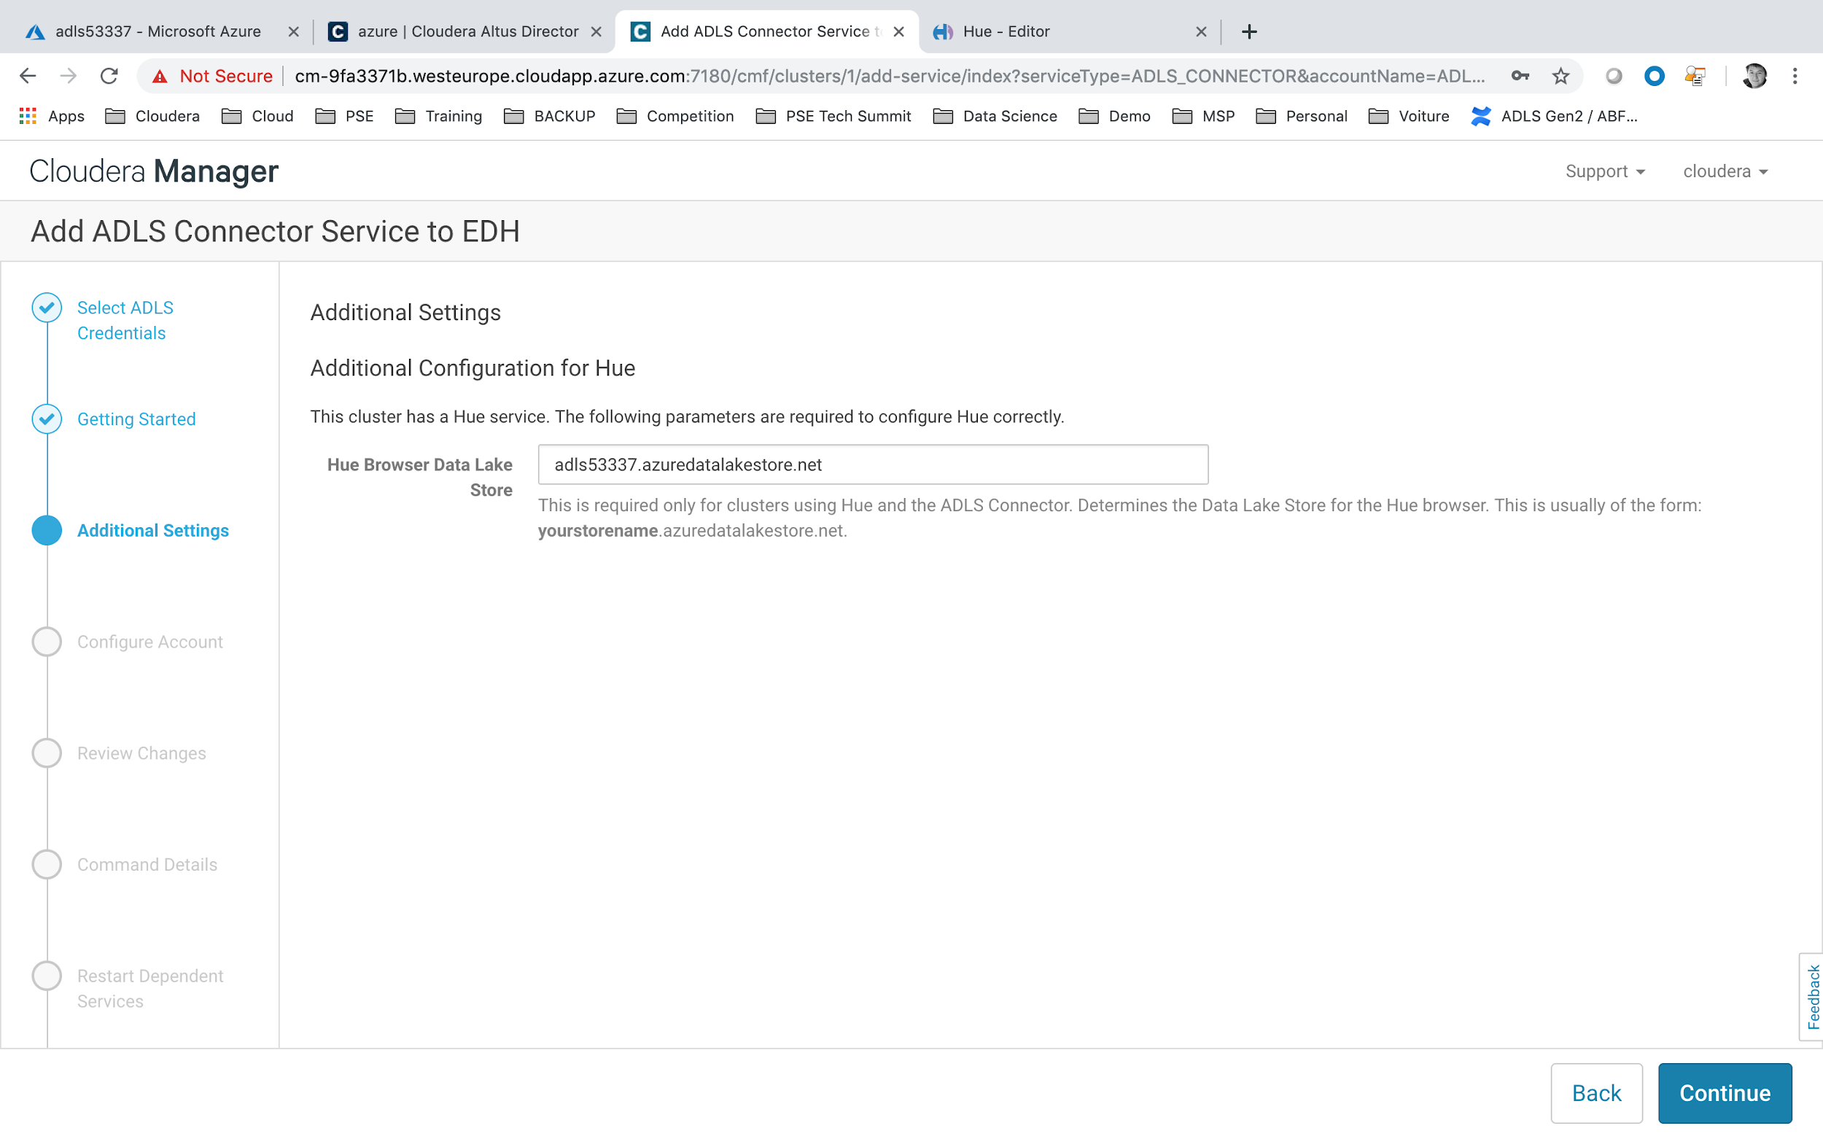

* Hue browser datalake Store = adls<USERID>.azuredatalakestore.net (for ex: adls53337.azuredatalakestore.net)

## 

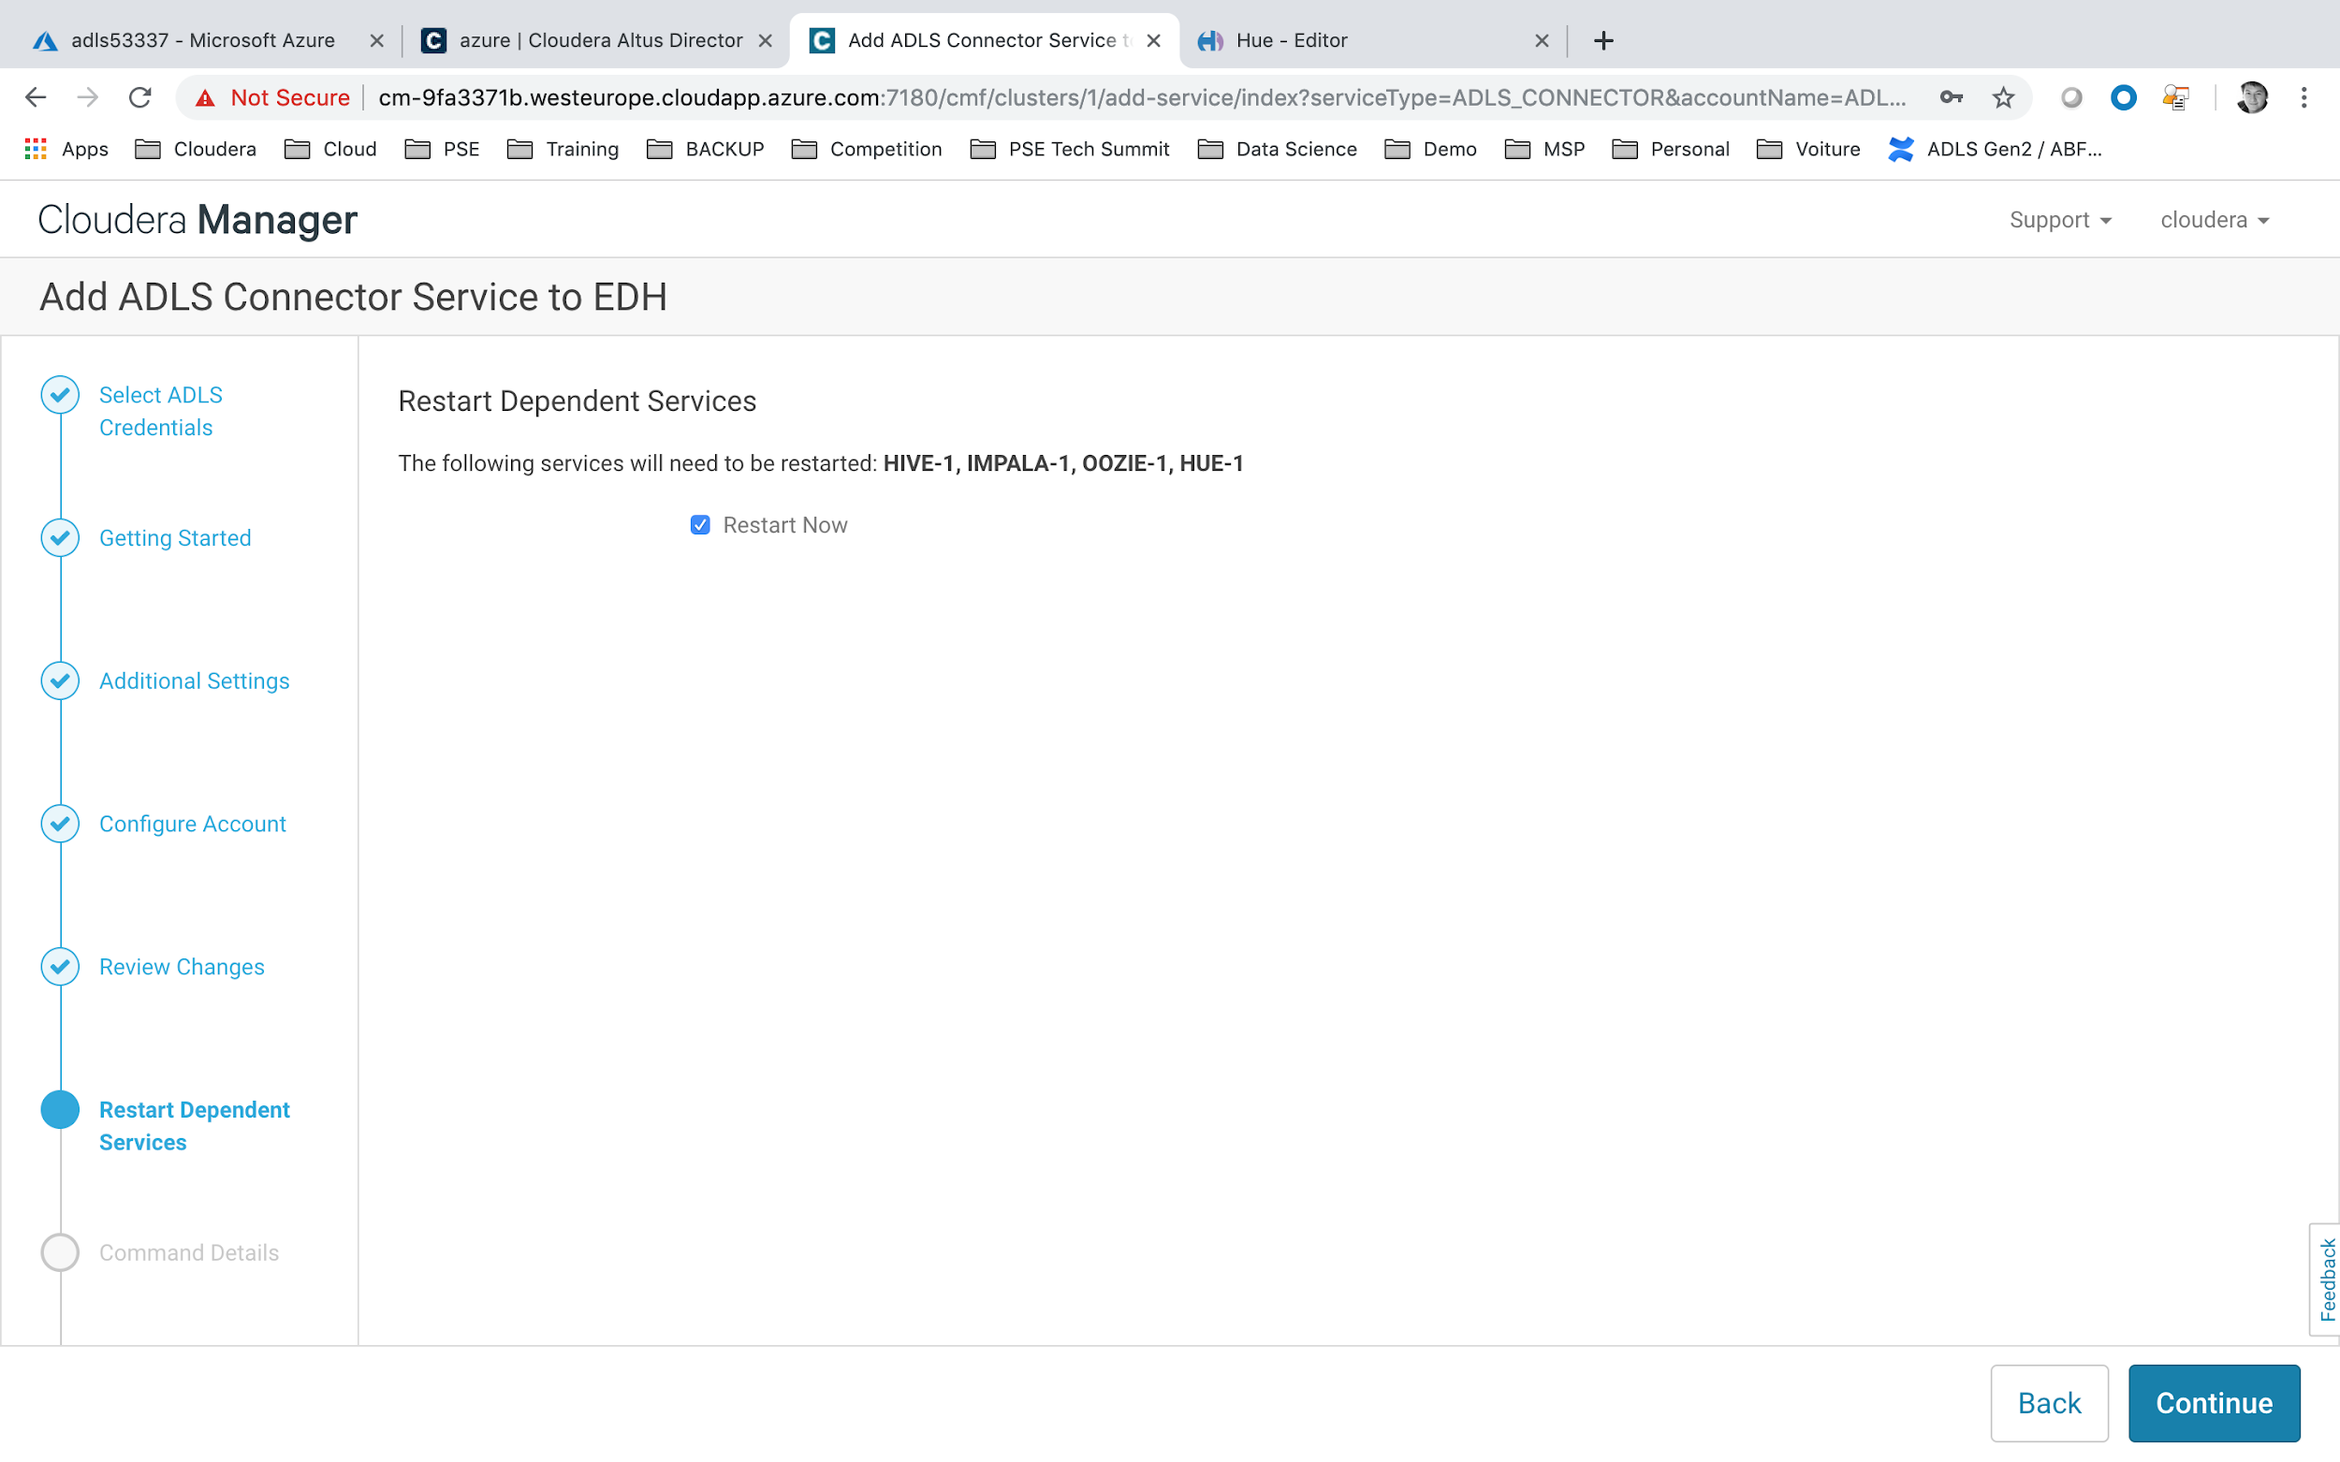

* Click on **Continue** to Restart The Cluster.

A Restart of Stalled services is maybe required for HUE.

## **Upload the DataSet on ADLS**

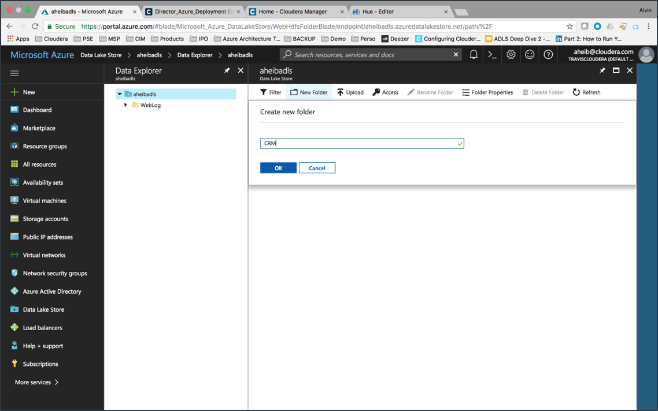

* Search for Azure Data Lake Store Gen 1 Services.
* Click on your created store called adls<USERID>.
* Click on Data Explorer icon.
* Create a Directory under path CRM.

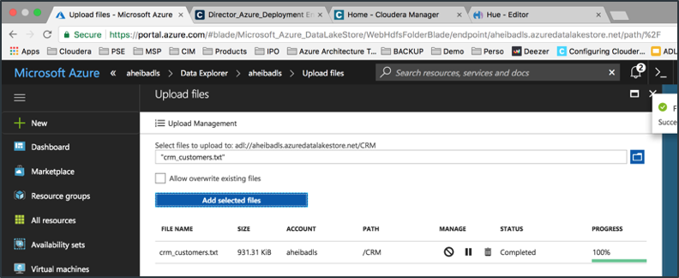

* Upload the crm_customers.txt file in that directory.

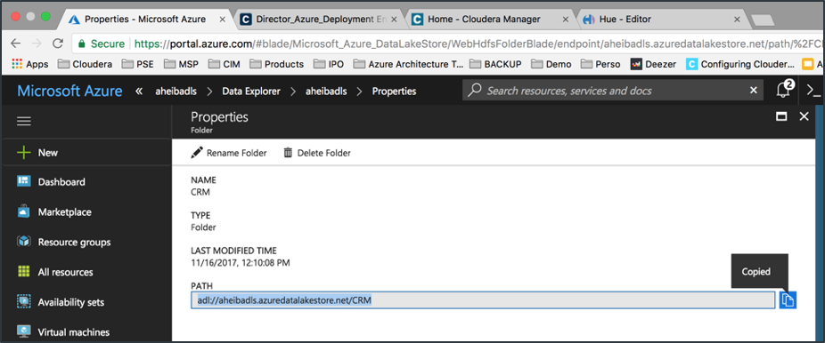

* Identify your file external URL : adl://adls<USERID>.azuredatalakestore.net/CRM

You could now check on HUE Services that your file has been correctly uploaded to ADLS.

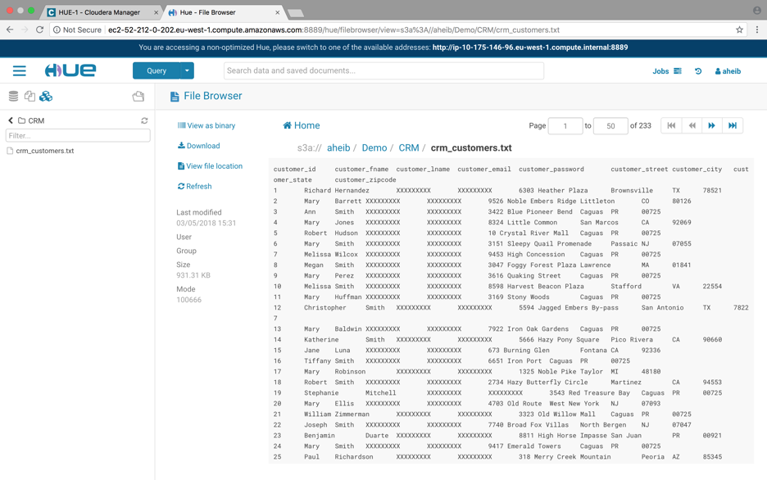

A refresh of the HUE browser will be needed to take into account this new storage.

Under HUE services, you could see 3 type of storage like Database / HDFS / Object Store ADLS.

Navigate to your **crm_customers.txt** file path and double click.

You will see on right panel the content of the file.

## **Impala Query on ADLS storage**

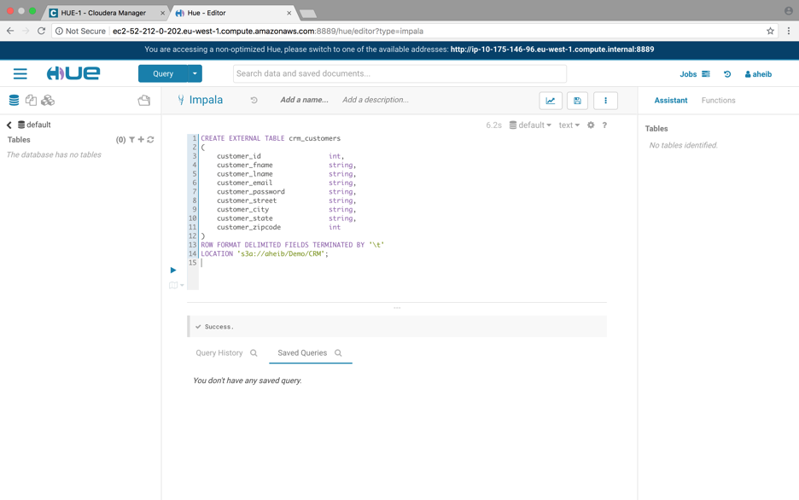

Select Query button, and Database storage.

In the Query field please enter below sql query and execute it.

|  |
| --- |
| CREATE EXTERNAL TABLE crm_customers_adls (  customer_id int,  customer_fname string,  customer_lname string,  customer_email string,  customer_password string,  customer_street string,  customer_city string,  customer_state string,  customer_zipcode int  )  ROW FORMAT DELIMITED FIELDS TERMINATED BY '\t'  LOCATION 'adl://adls<USERID>.azuredatalakestore.net/Demo/CRM'; |

A **crm_customer_adls** table will automatically be created.

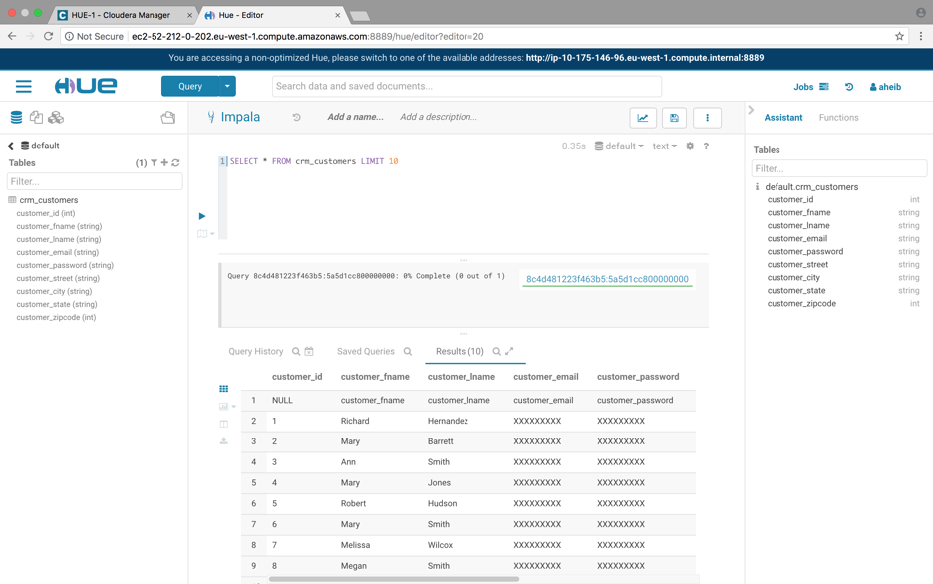

You could then start querying the **crm_customer_adls** table.

|  |
| --- |
| SELECT * FROM crm_customers LIMIT 10 |

You now have successfully ran Impala Query based on a crm database (txt file) stored on ADLS.

# LAB#8: INTEGRATING WITH POWER BI DESKTOP

## **Deploying the PowerBI Desktop Virtual Machine**

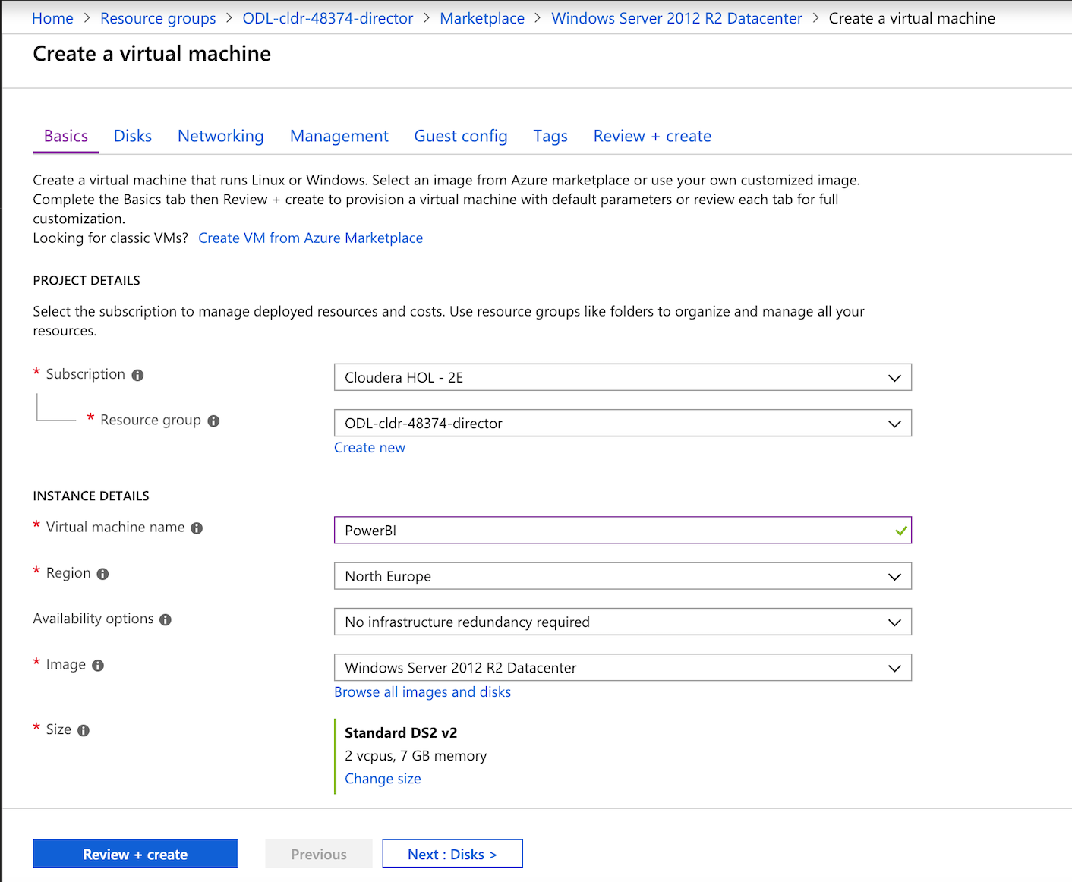

Select the **Create a Resource** menu and choose to deploy a **Windows Server 2012 R2 Datacenter** machine.

And update the informations as follow:

* Resource Group = **ODL-cldr-<USERID>-director**
* Virtual Machine name = **PowerBI**
* Region = Please make sure to choose the same region as the Resource Group that have been chosen by Spektra Systems. For example **westeurope**.
* Image = Windows Server 2012 R2 Datacenter
* Size = Standard DS2 v2
* Username = cloudera
* Password = Cloudera_123
* Click on **Networking** menu (on top of the screen)

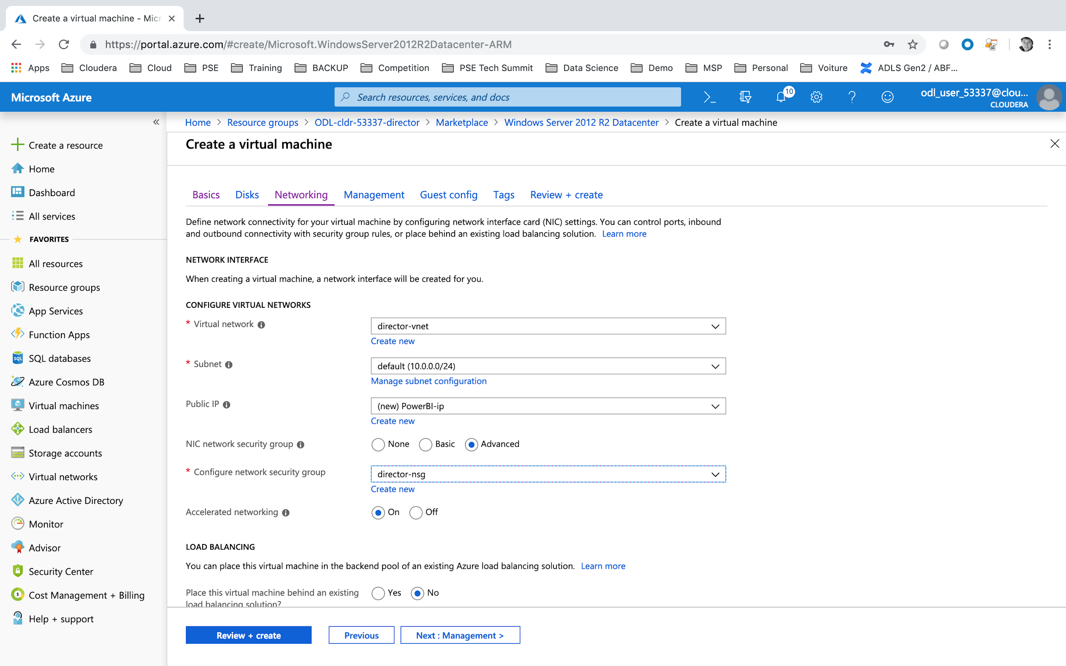

* Virtual network = **ODL-cldr-<USERID>-director-vnet**
* Subnet = **default (10.0.0.0/24)**
* Public IP = **PowerBI-ip**
* Network Security Group = **director-nsg**
* Click on **Review+create**.

## **Update the Power BI Virtual Machine DNS name**

Once the virtual machine is deployed, click on PowerBI IP Configuration menu.

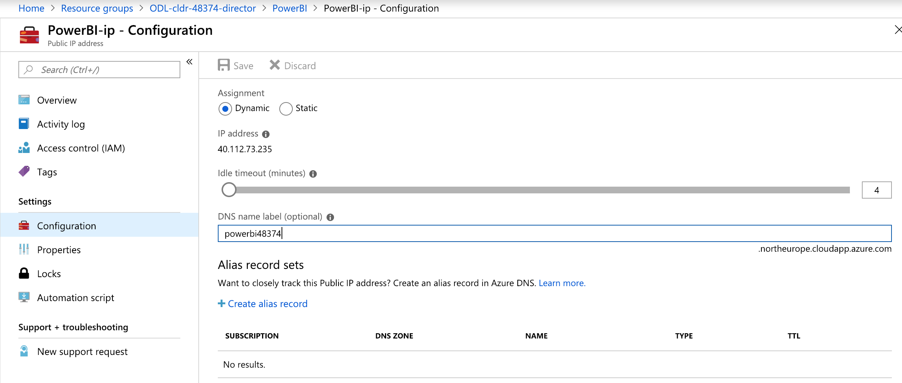

* DNS name label = **powerbi<USERID> .** And please note this shall be a unique identifier within the region (for ex: **westeurope.cloudapp.azure.com**).
* Click on Save.

## **Install Power BI Desktop on the Virtual Machine**

Please install Remote Desktop Protocol (RDP) tools.

* on mac: <https://docs.microsoft.com/en-us/windows-server/remote/remote-desktop-services/clients/remote-desktop-mac>
* on windows: <https://docs.microsoft.com/en-us/azure/virtual-machines/windows/connect-logon>

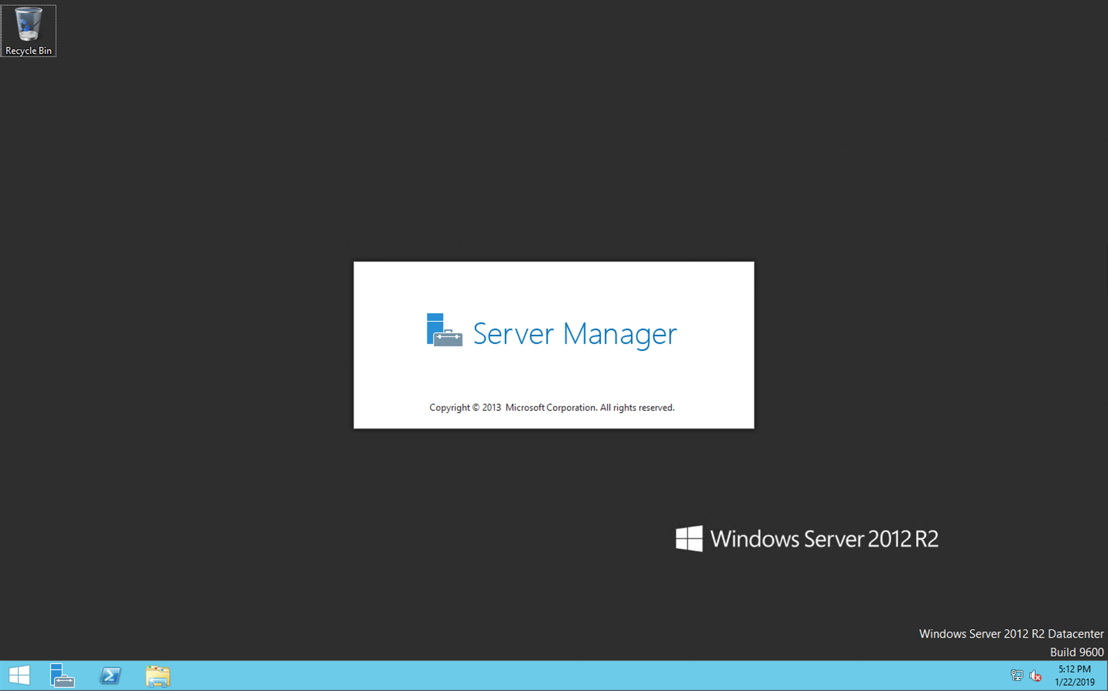

Connect through RDP with the below parameters:

* hostname: **powerbi<USERID>**.**westeurope.cloudapp.azure.com**
* user: cloudera
* password: Cloudera_123

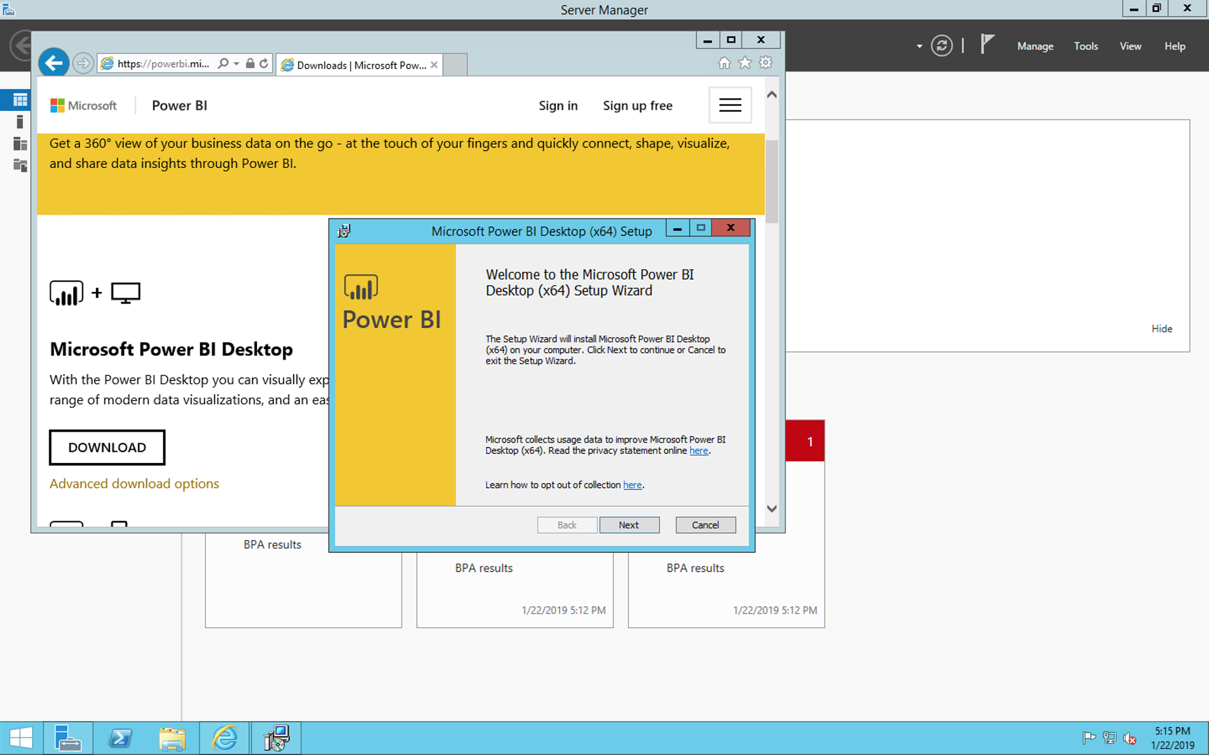

Within the Virtual Machine search on Internet Explorer, Power BI Desktop for windows. Download and install the executable.

* Download PowerBI : <https://powerbi.microsoft.com/en-us/downloads/>
* Install the executable.

## **Update the ODBC driver**

Within the Virtual Machine search on Internet Explorer, Impala ODBC Driver for windows. Download and install the executable.

<https://www.cloudera.com/downloads/connectors/impala/odbc/2-6-0.html>

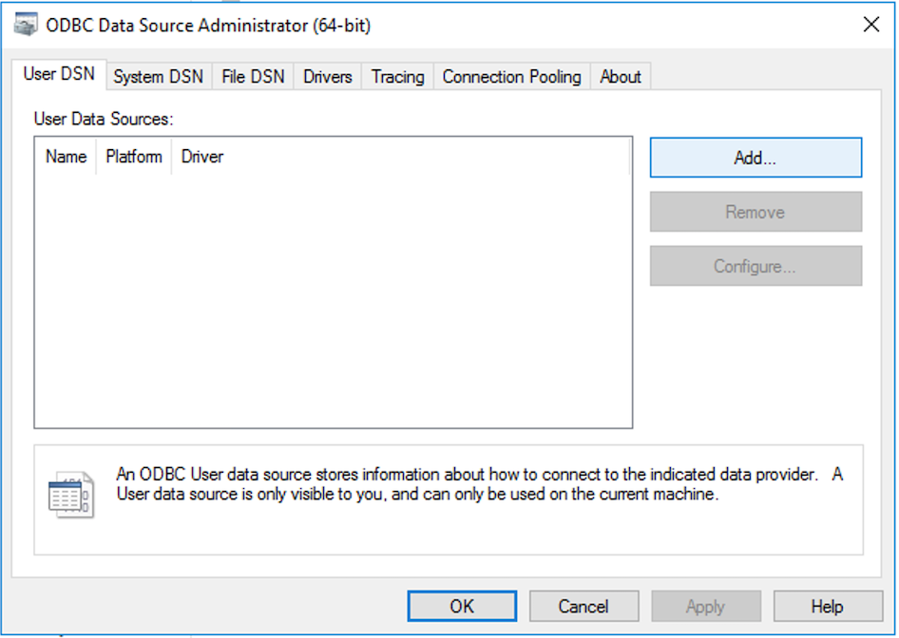

Within Windows system search for the ODBC Data Source Administrator (DSN). Add a new DNS.

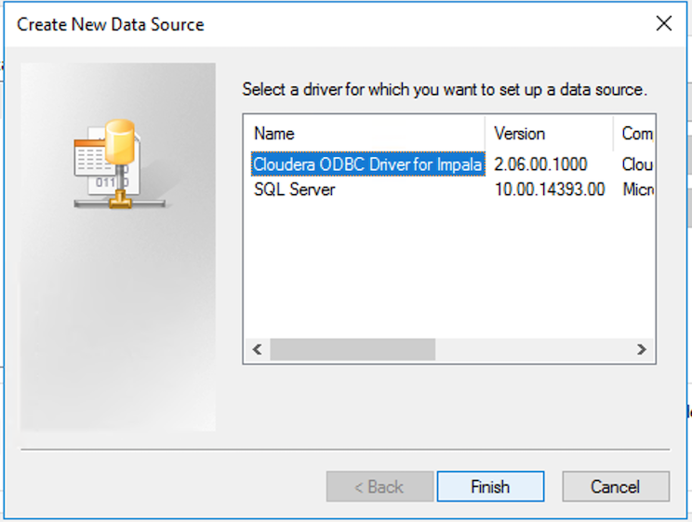

You should be able to find the Cloudera ODBC Driver for Impala in the list of options.

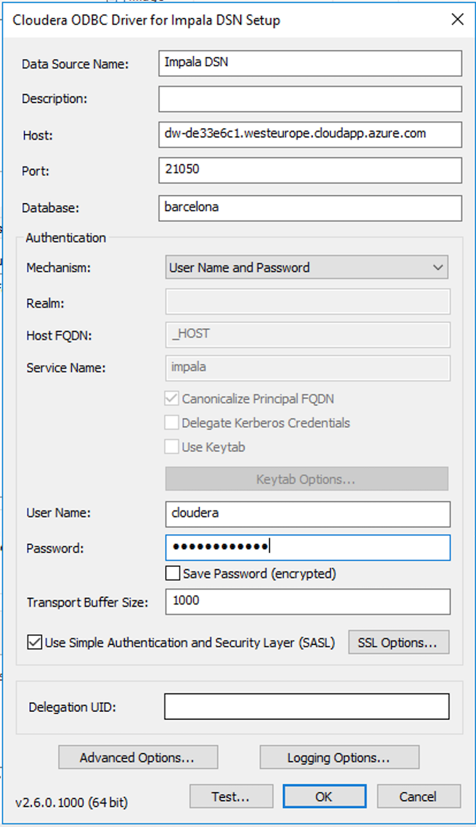

Update the informations as follow:

* Data Source Name = Impala DNS
* Host = masternode hostname.
* Port = 21050
* Database = sales
* Authentication Mechanism = User Name and Password
* Username = cloudera
* Password = Cloudera_123

You should now be able to Query Directly from Power BI to Cloudera Datawarehouse through Impala driver.

# LAB#9: AZURE ACTIVE DIRECTORY APPLICATION & SERVICE PRINCIPLE

At the end of the section we will have documented 4 variables that will be used throughout the Altus Director Deployment Through Azure Market section:

* [AZURE-SUBSCRIPTION-ID]
* [AZURE-AD-TENANT-ID]
* [AZURE-AD-CLIENT-ID]
* [AZURE-AD-CLIENT-SECRET]

The different steps are described in documentation here:

<https://docs.microsoft.com/en-us/azure/azure-resource-manager/resource-group-create-service-principal-portal>

## **Identify your AZURE-AD-TENANT-ID**

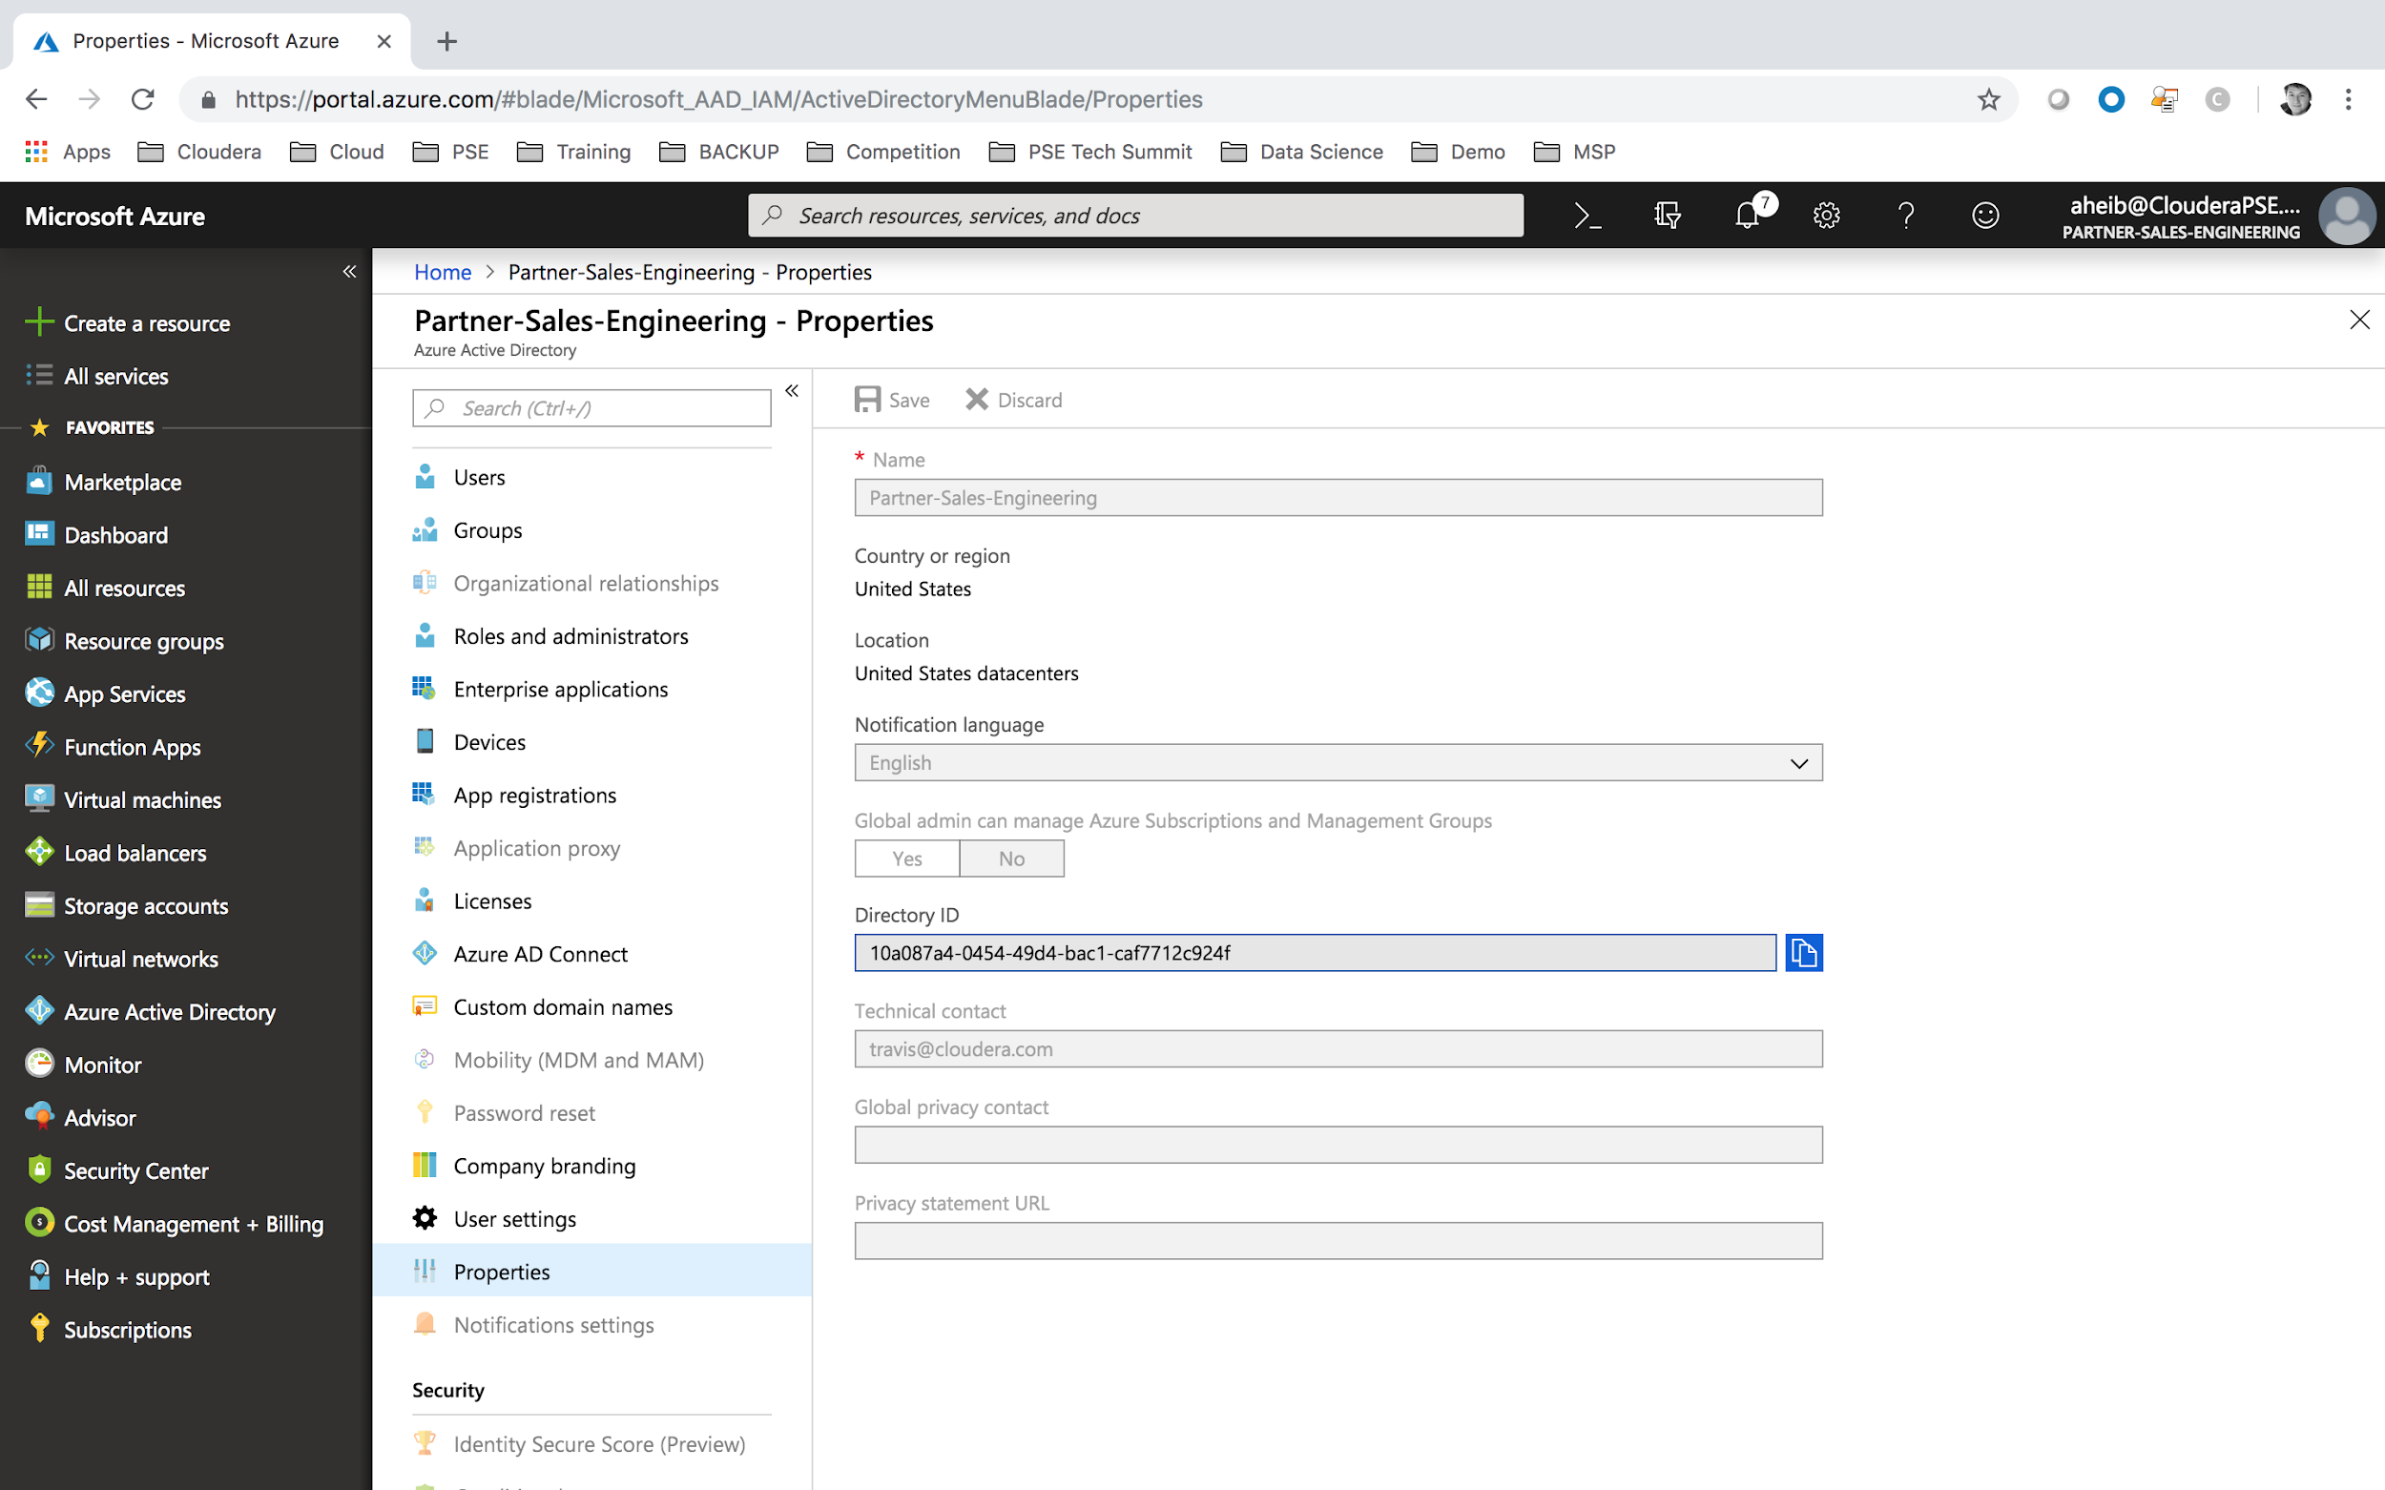

Click on All Services menu and select Azure Active Directory.

Within this Azure Active Directory Service, please select Properties.

If you have multiple subscriptions, please select the correct subscription you will be using for the labs.

Please note that you will be provided a Directory ID, and for our labs will be called Tenant ID:

* [AZURE-AD-TENANT-ID]: the tenant ID Provided by Azure (for ex: xxxxxxx-xxxx-xxxxxxx-xxxxxxxx)

## **Create your AD Application and retrieve your AZURE-AD-CLIENT-ID**

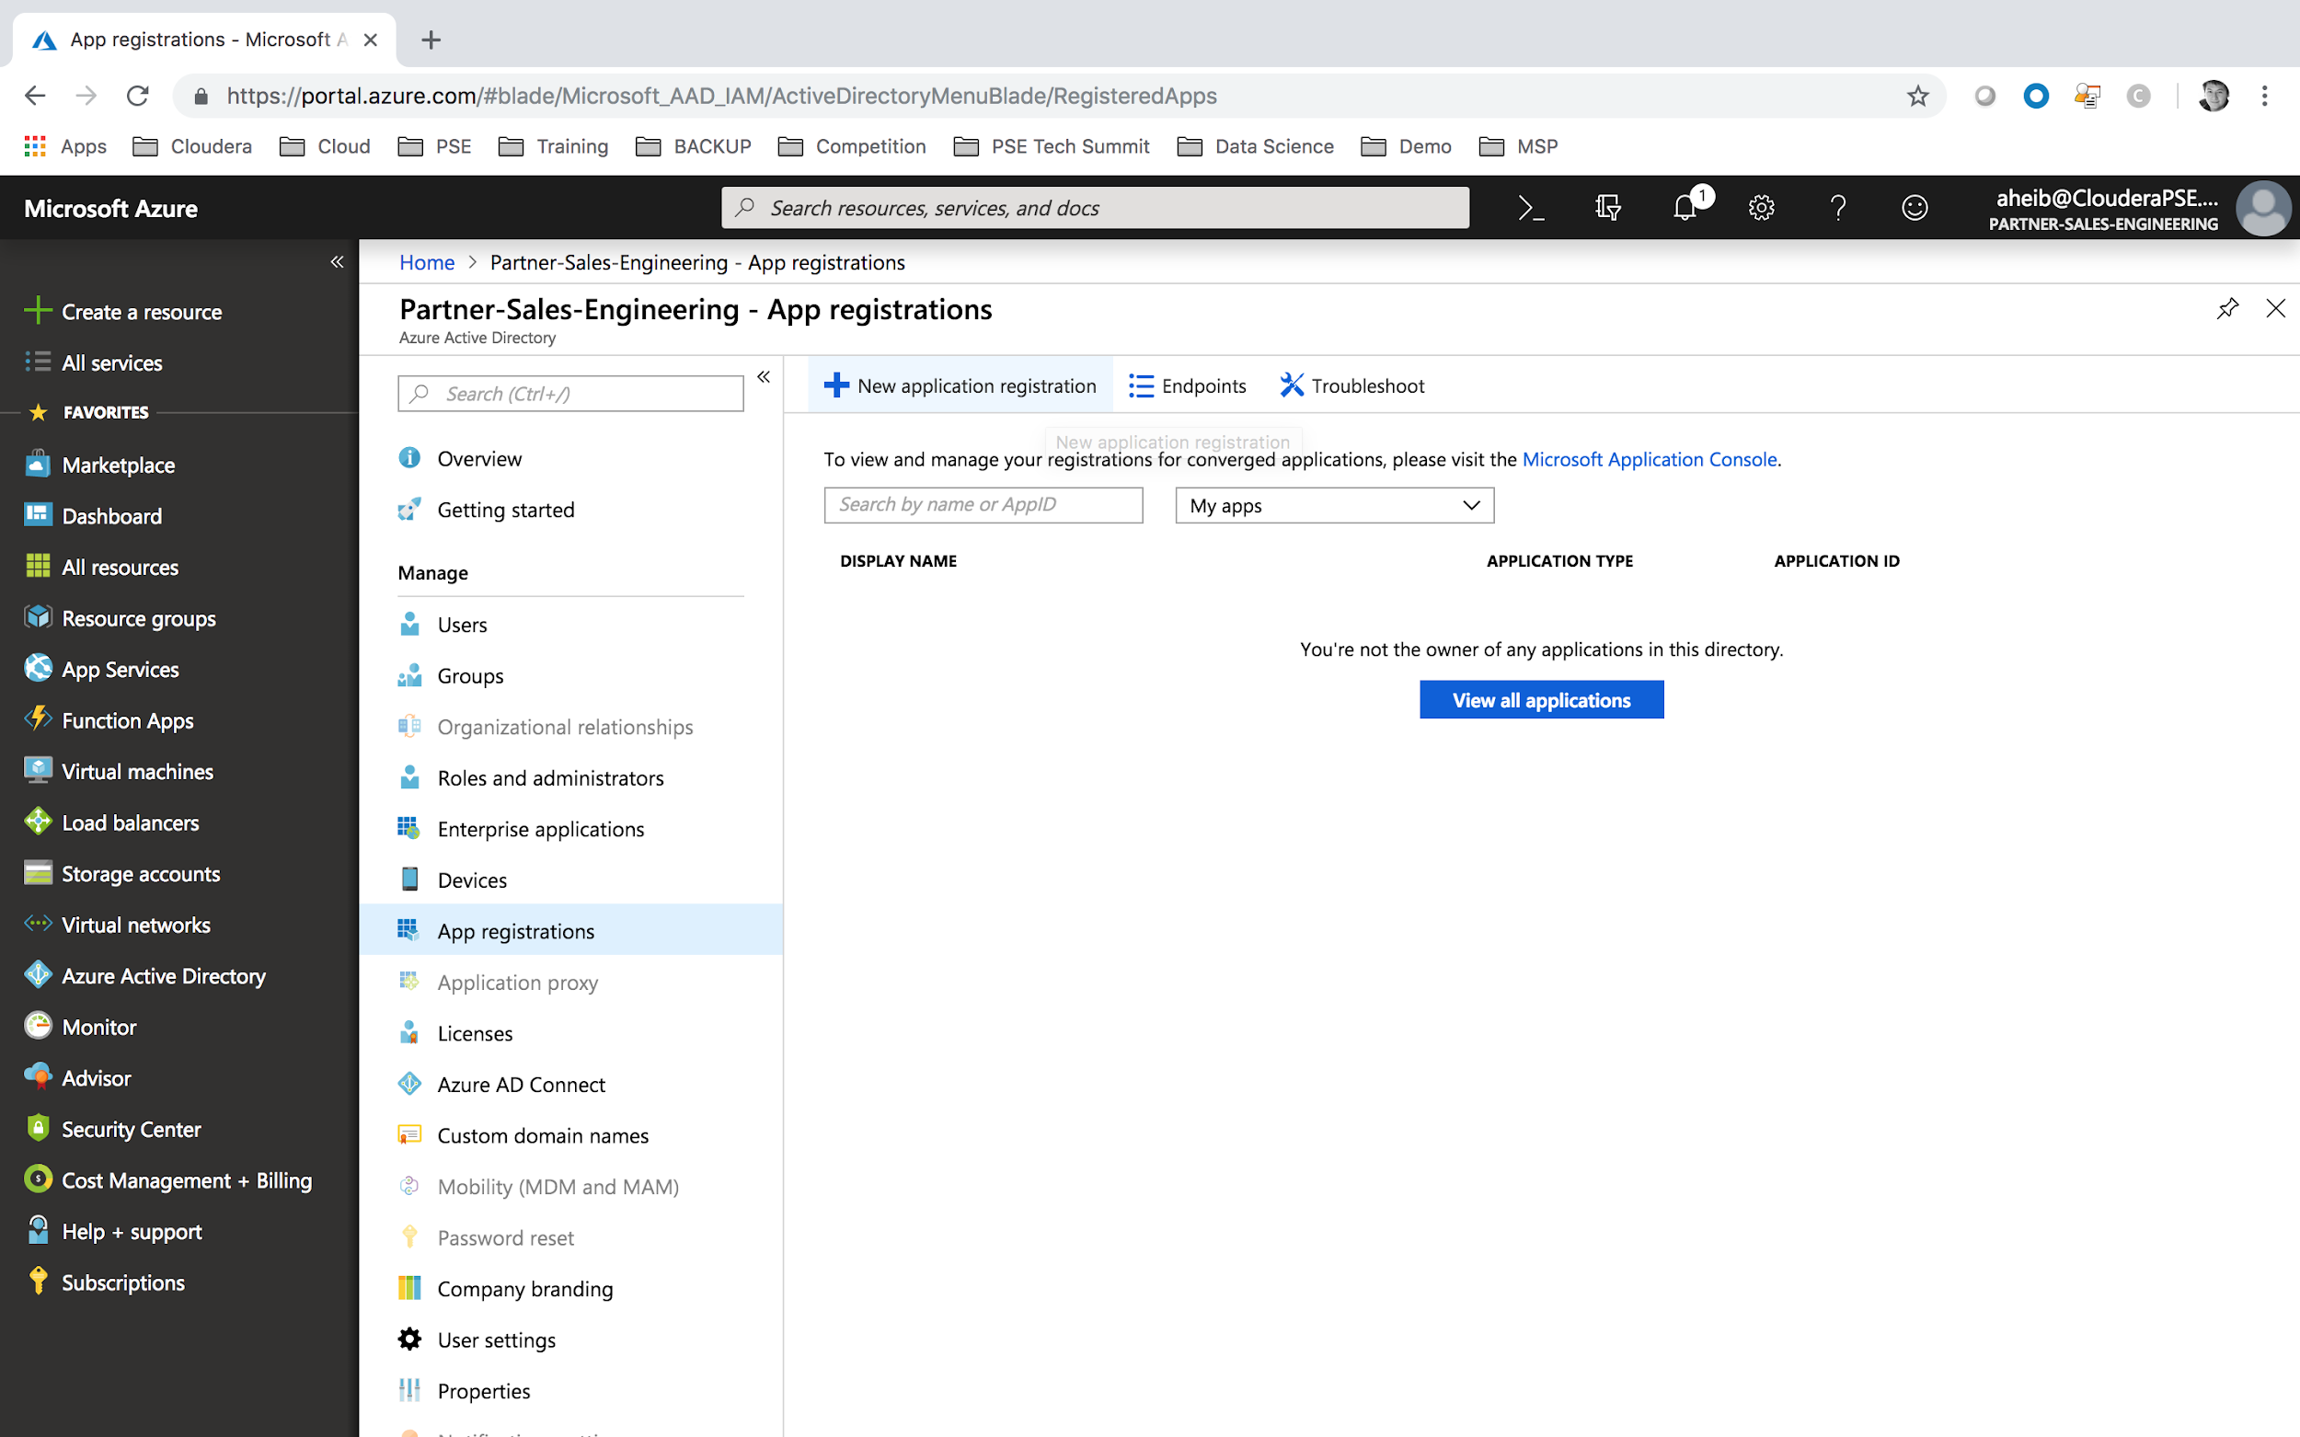

Click on All Services menu and select Azure Active Directory.

Now select App Registration and then on New application registration.

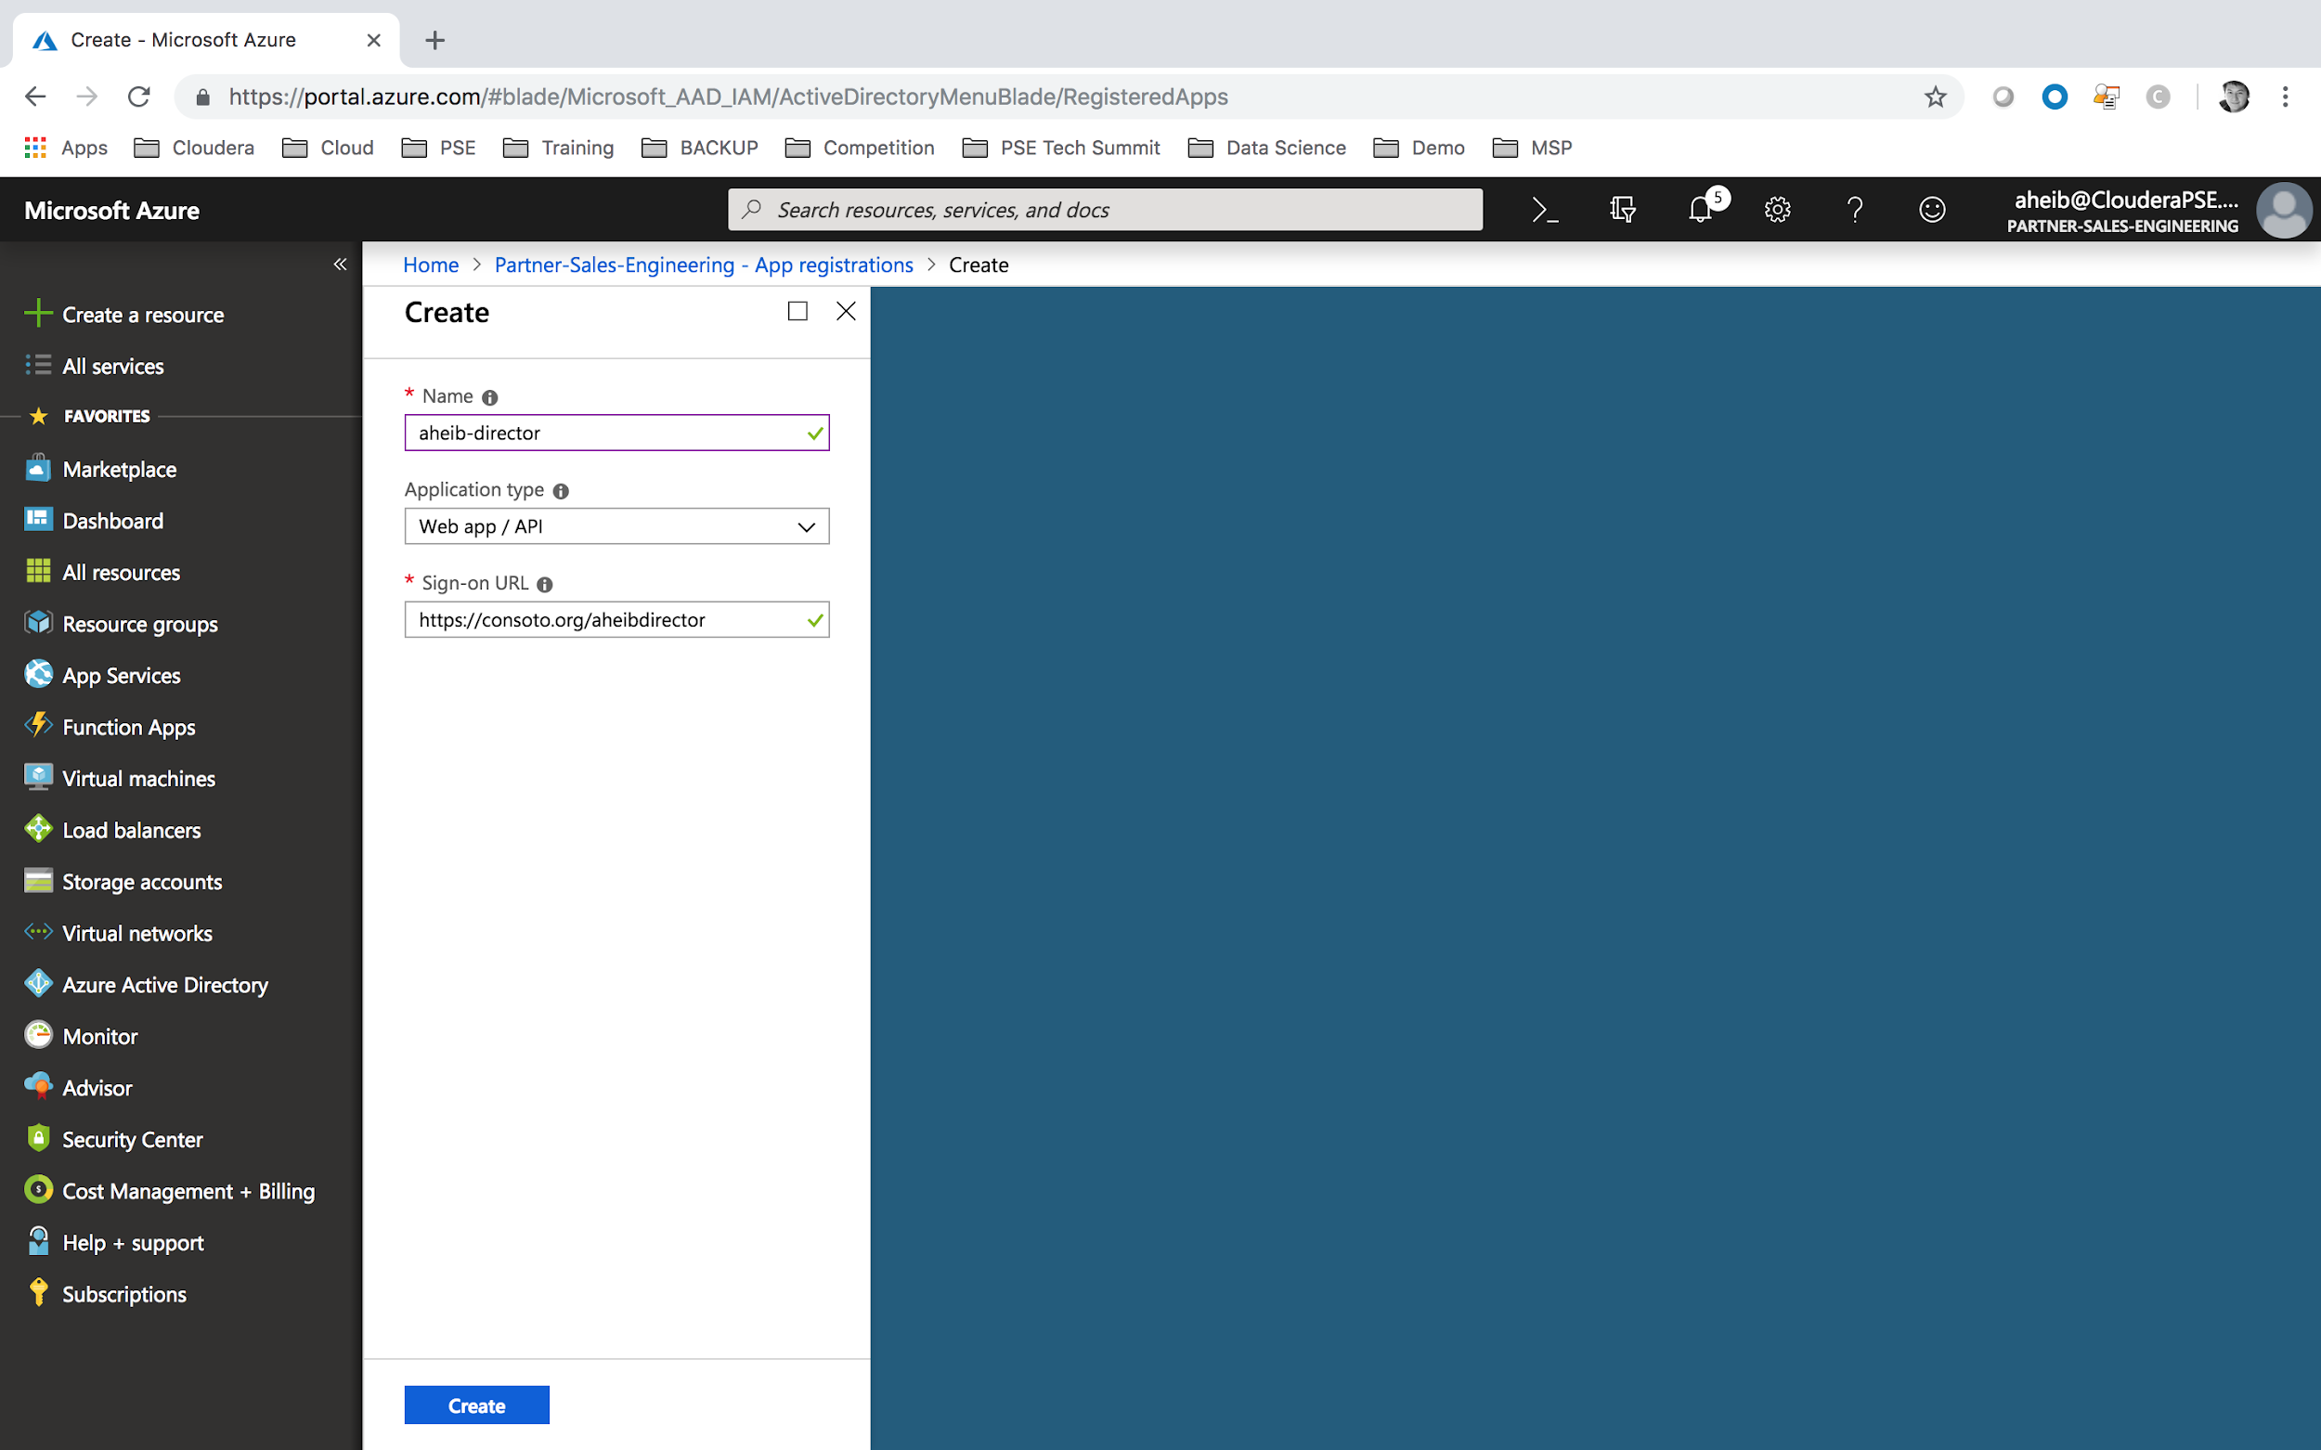

Please provide information for the Application and then Create.

* Name: your application name (for ex: aheib-director)
* Application Type: Web app / API
* Sign-On URL: URL to your application, which is unused (for ex: https://contoso.org/aheibdirector)

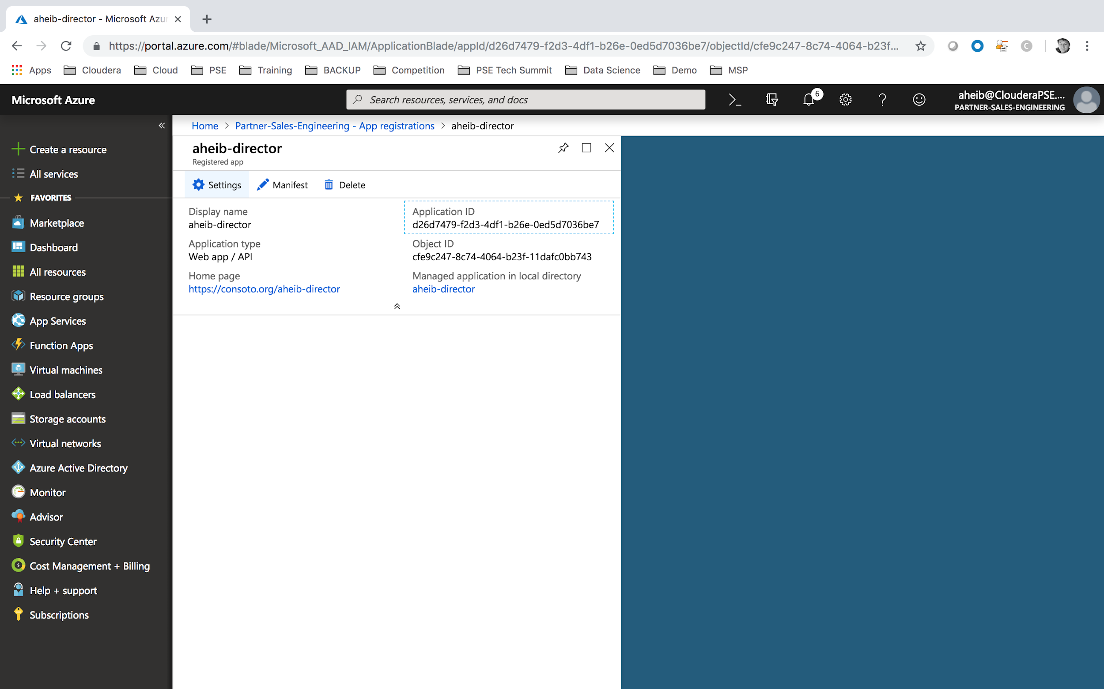

You now will have an Application ID provided by Azure. Please note that this Application ID will correspond to our [AZURE-AD-CLIENT-ID].

* [AZURE-AD-CLIENT-ID] = your Application ID (for ex: d26d7479-f2d3-4df1-b26e-0ed5d7036be7)

## **Create the AZURE-AD-CLIENT-SECRET**

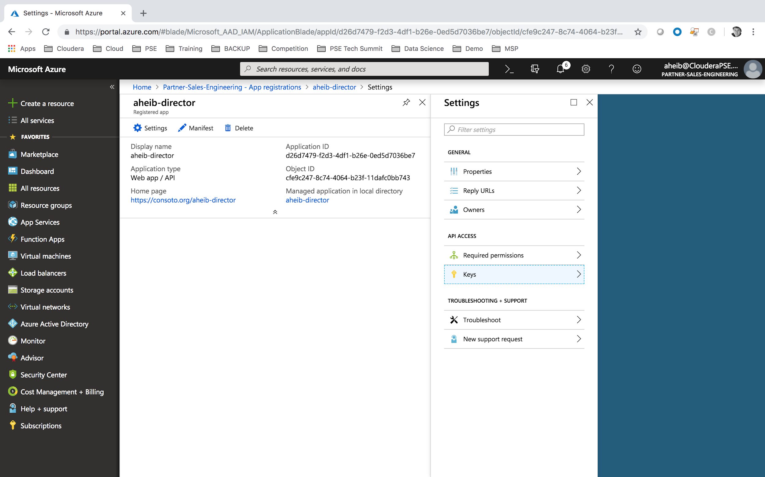

Click on the AD Application Settings.

And let’s create the Client Secret Keys.

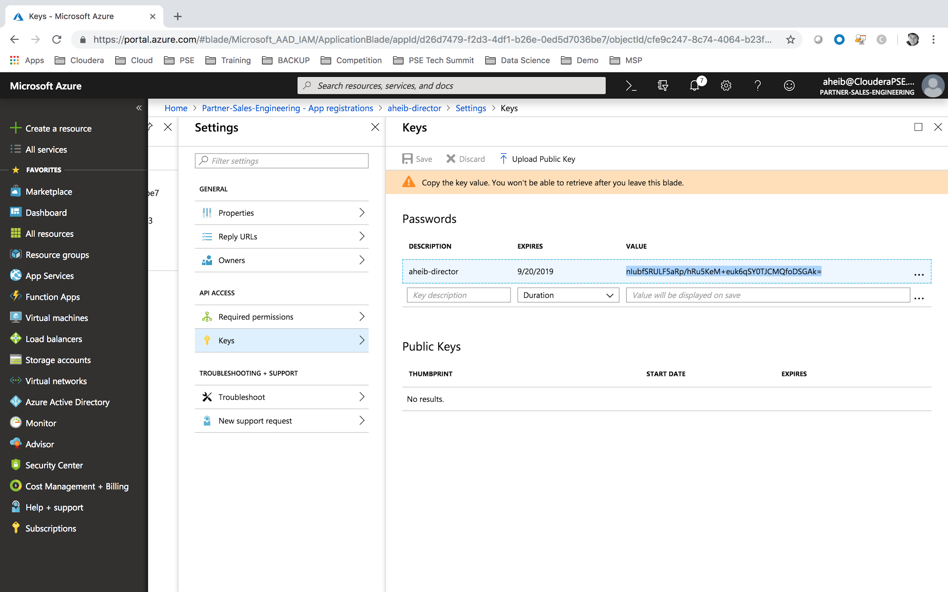

For Azure to be able to provide a Secret Key, you will need to provide these information’s. Once, the information provided, the secret key will be provided once you save your configurations.

* Description: your key description (for ex: aheib-director)
* Expires: select the key validity duration (for ex: 1 year)
* [AZURE-AD-CLIENT-SECRET] save your key (for ex: ubfSRULF5aRp/hRu5KeM+euk6qSY0TJCMQfoDSGAk=)

**Note:** This secret key is provided only once and cannot be retrieved. Please save it in a safe location.

## **Identify your AZURE-AD-SUBSCRIPTION-ID**

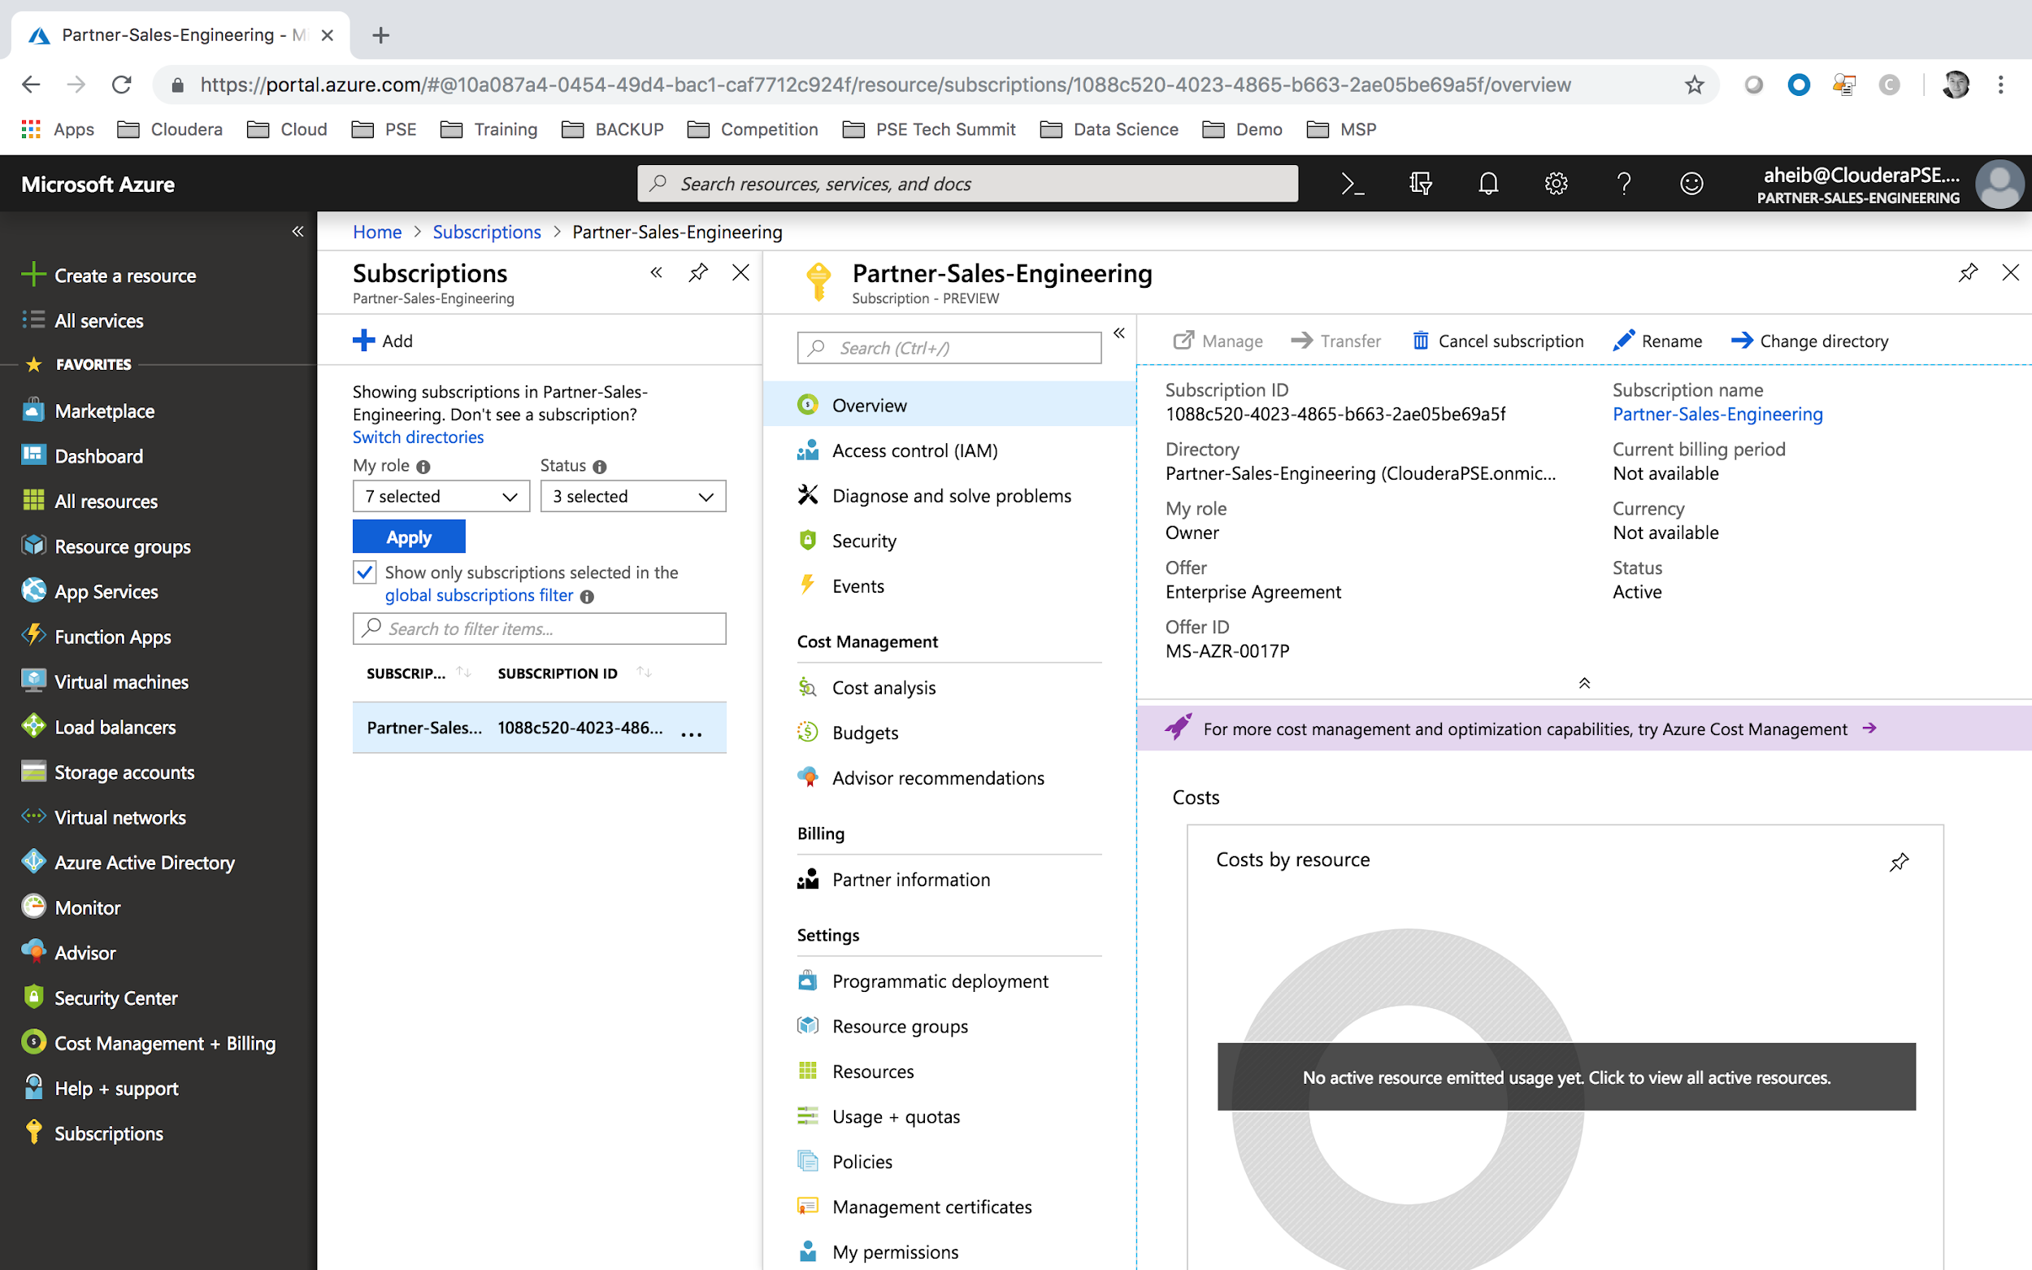

We will now retrieve the Subscription ID through the Subscriptions menu.

Then select the relevant subscription that will be used for this Hands-On.

On the Overview part you will be able to gather your Subscription ID:

* [AZURE-SUBSCRIPTION-ID]: linked to your subscription (for ex: xxxxx-xxxxx-xxxx-xxxx-xxxxxxxxxxx)

## **Grant Permissions to the AD Application**

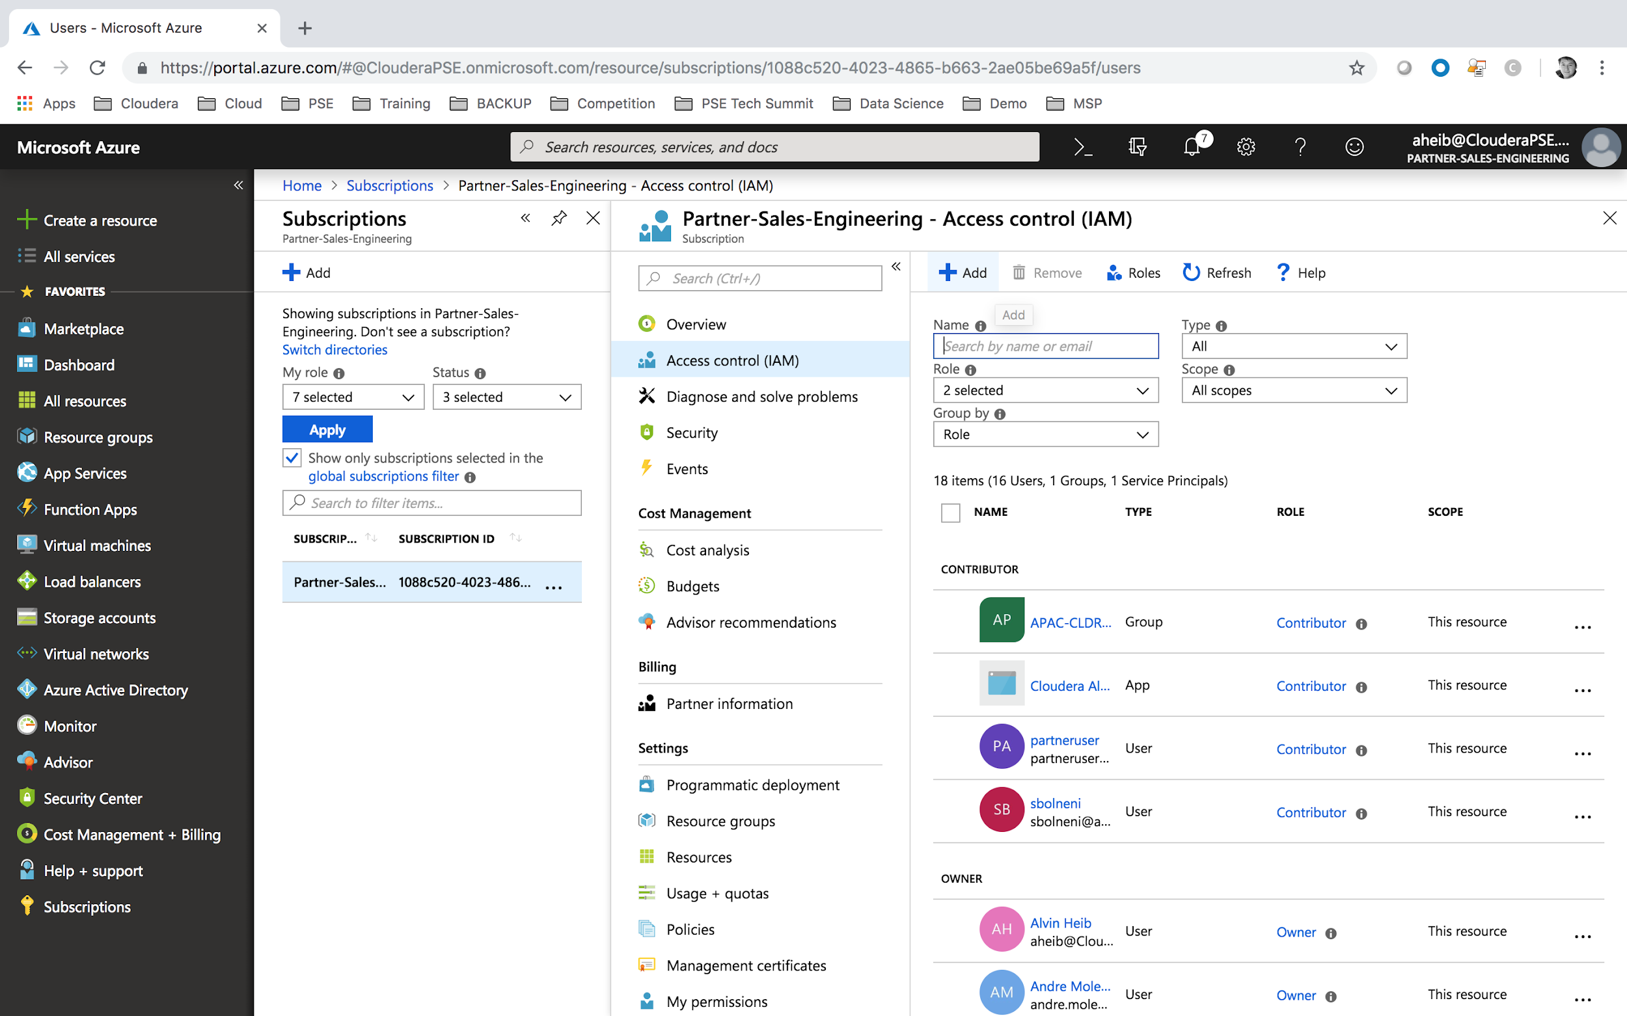

We will now add permission for the newly created Application.

Within the Subscriptions Services, please select Access Control (IAM) menu.

You will now be able to grant new permission by clicking on the Add button.

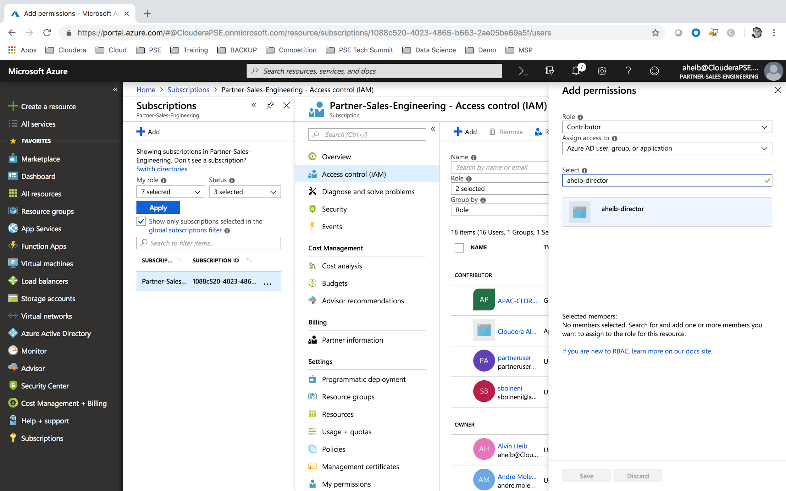

Please provide the below information, and save:

* Role: Contributor
* Assign access to: Azure AD user, group or application
* Select: your newly created AD Application (for ex: aheib-director)

# LAB#10: CREATE YOUR RESOURCE GROUP

## 

You should be able to skip section 3.1, since Spektra Systems has pre-created 3 ressources groups (adls, director and marketplace):

* ODL-cldr-<USERID>-adls
* ODL-cldr-<USERID>-director
* ODL-cldr-<USERID>-marketplace

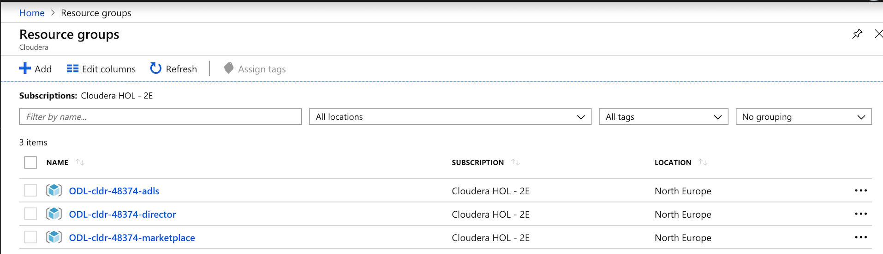

To create a new resource group, perform the following steps:

* In the left pane, click **Create a Resource**.
* Type resource group in the search box.
* Click **Resource Group** in the search result.
* Click **Create**.
* Type in a name for the resource group.

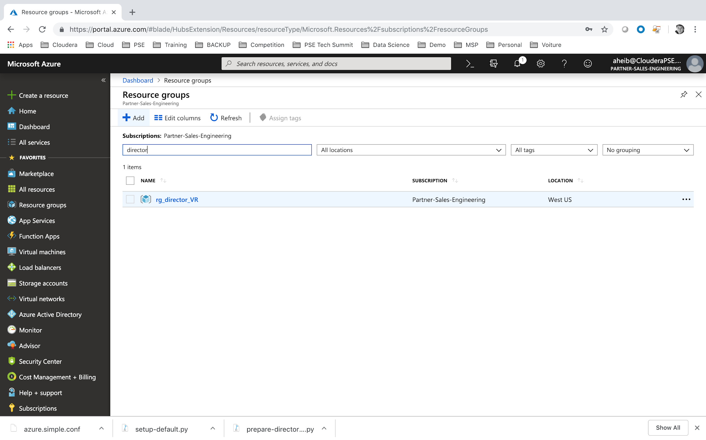

Under Resource Group menu. Click on **Add**.

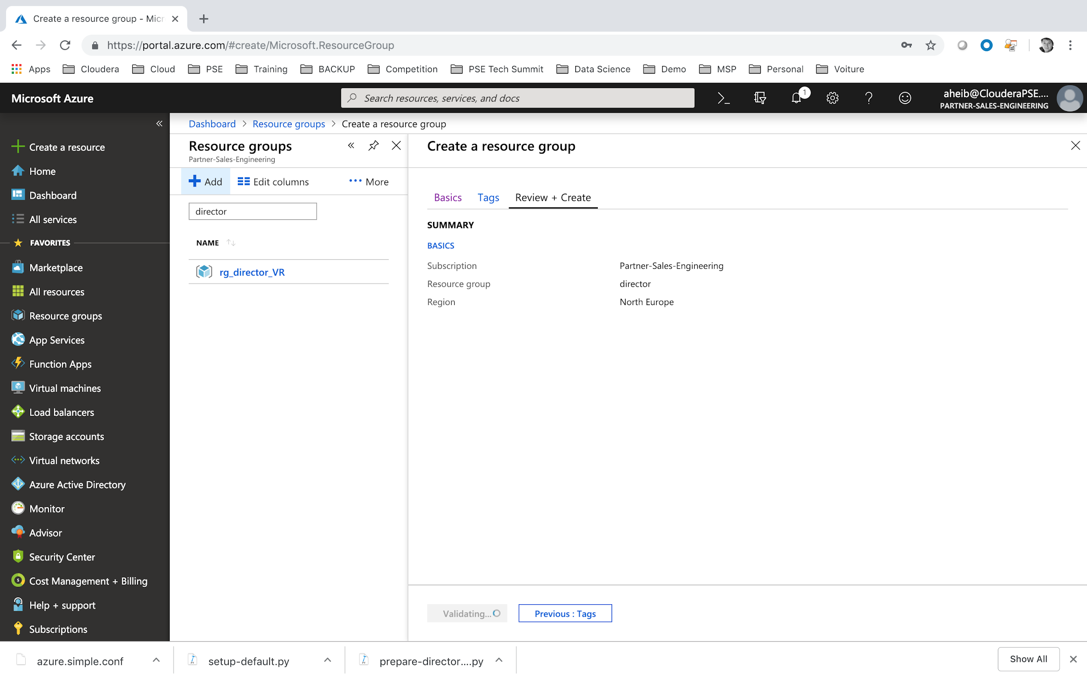

Provide a resource group name, for ex: director.

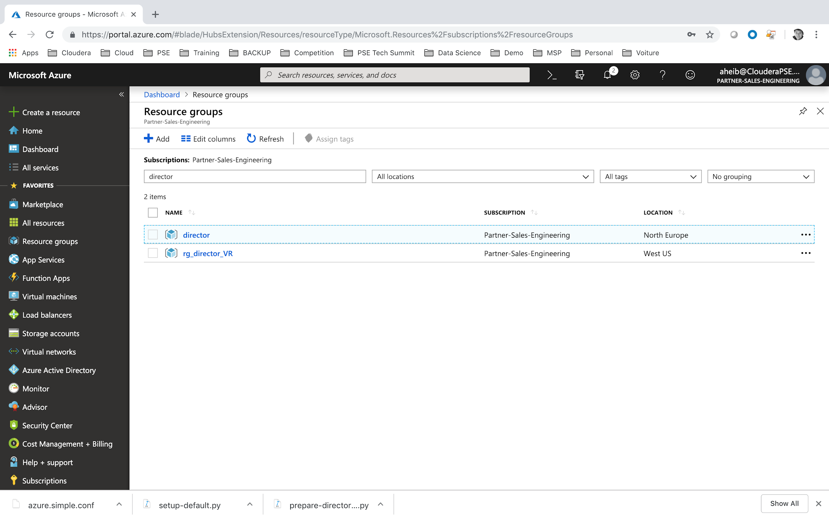

Repeat the operation for **adls** and **marketplace**.

# LAB#11: ENABLE PROGRAMMATIC DEPLOYMENT FOR CLOUDERA IMAGES

This step is required to be able to deploy Cloudera CentOS deployment programmatically. Altus Director will be in autonomy to deploy these types of images.

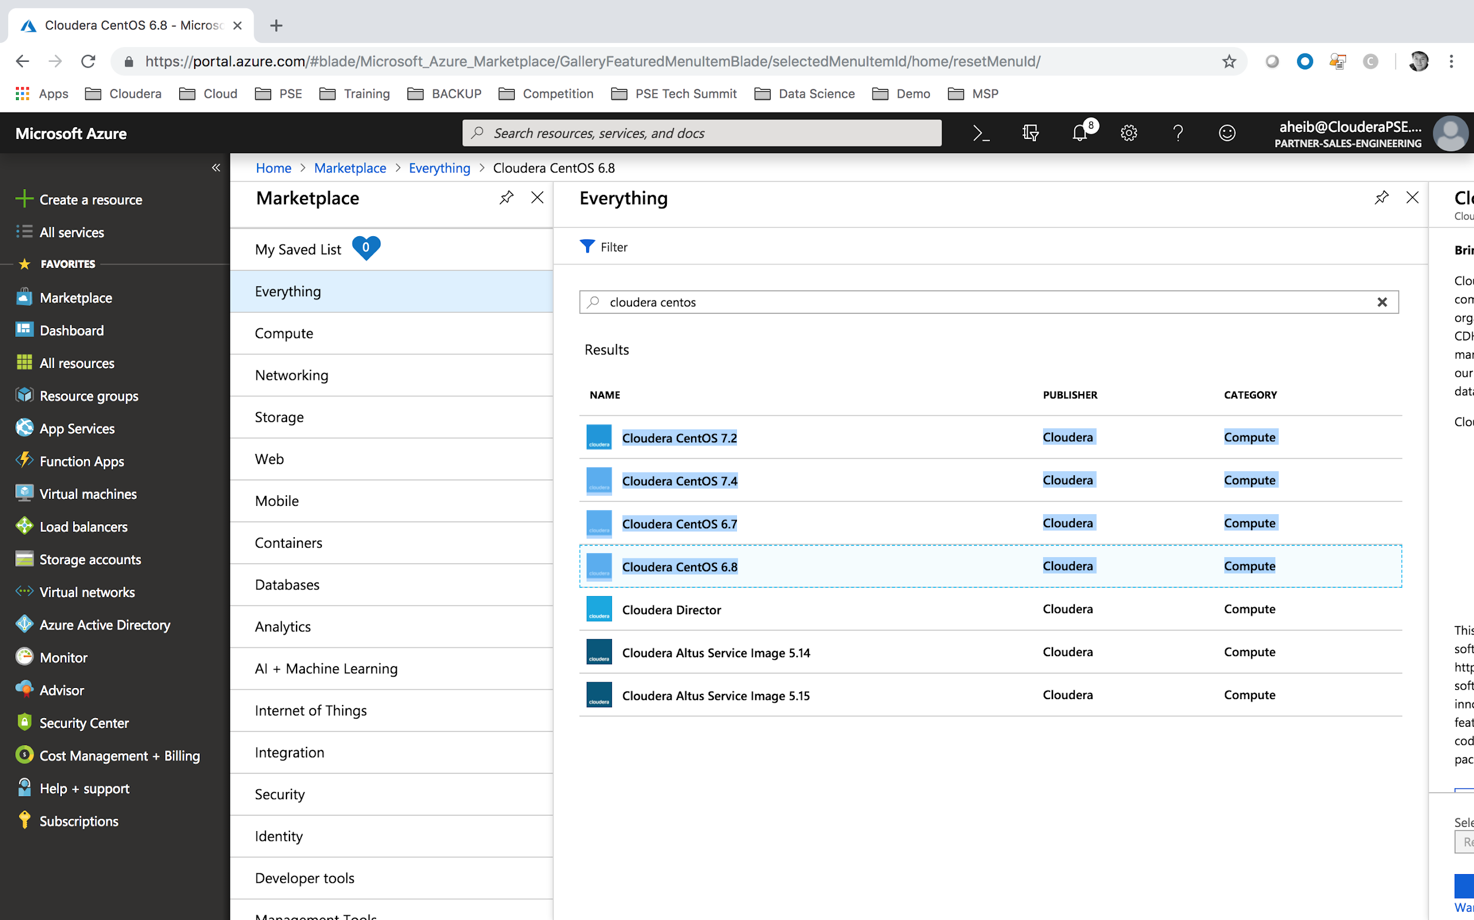

Select Marketplace Services and filter on Cloudera specific images. Select Cloudera CentOS 7.4.

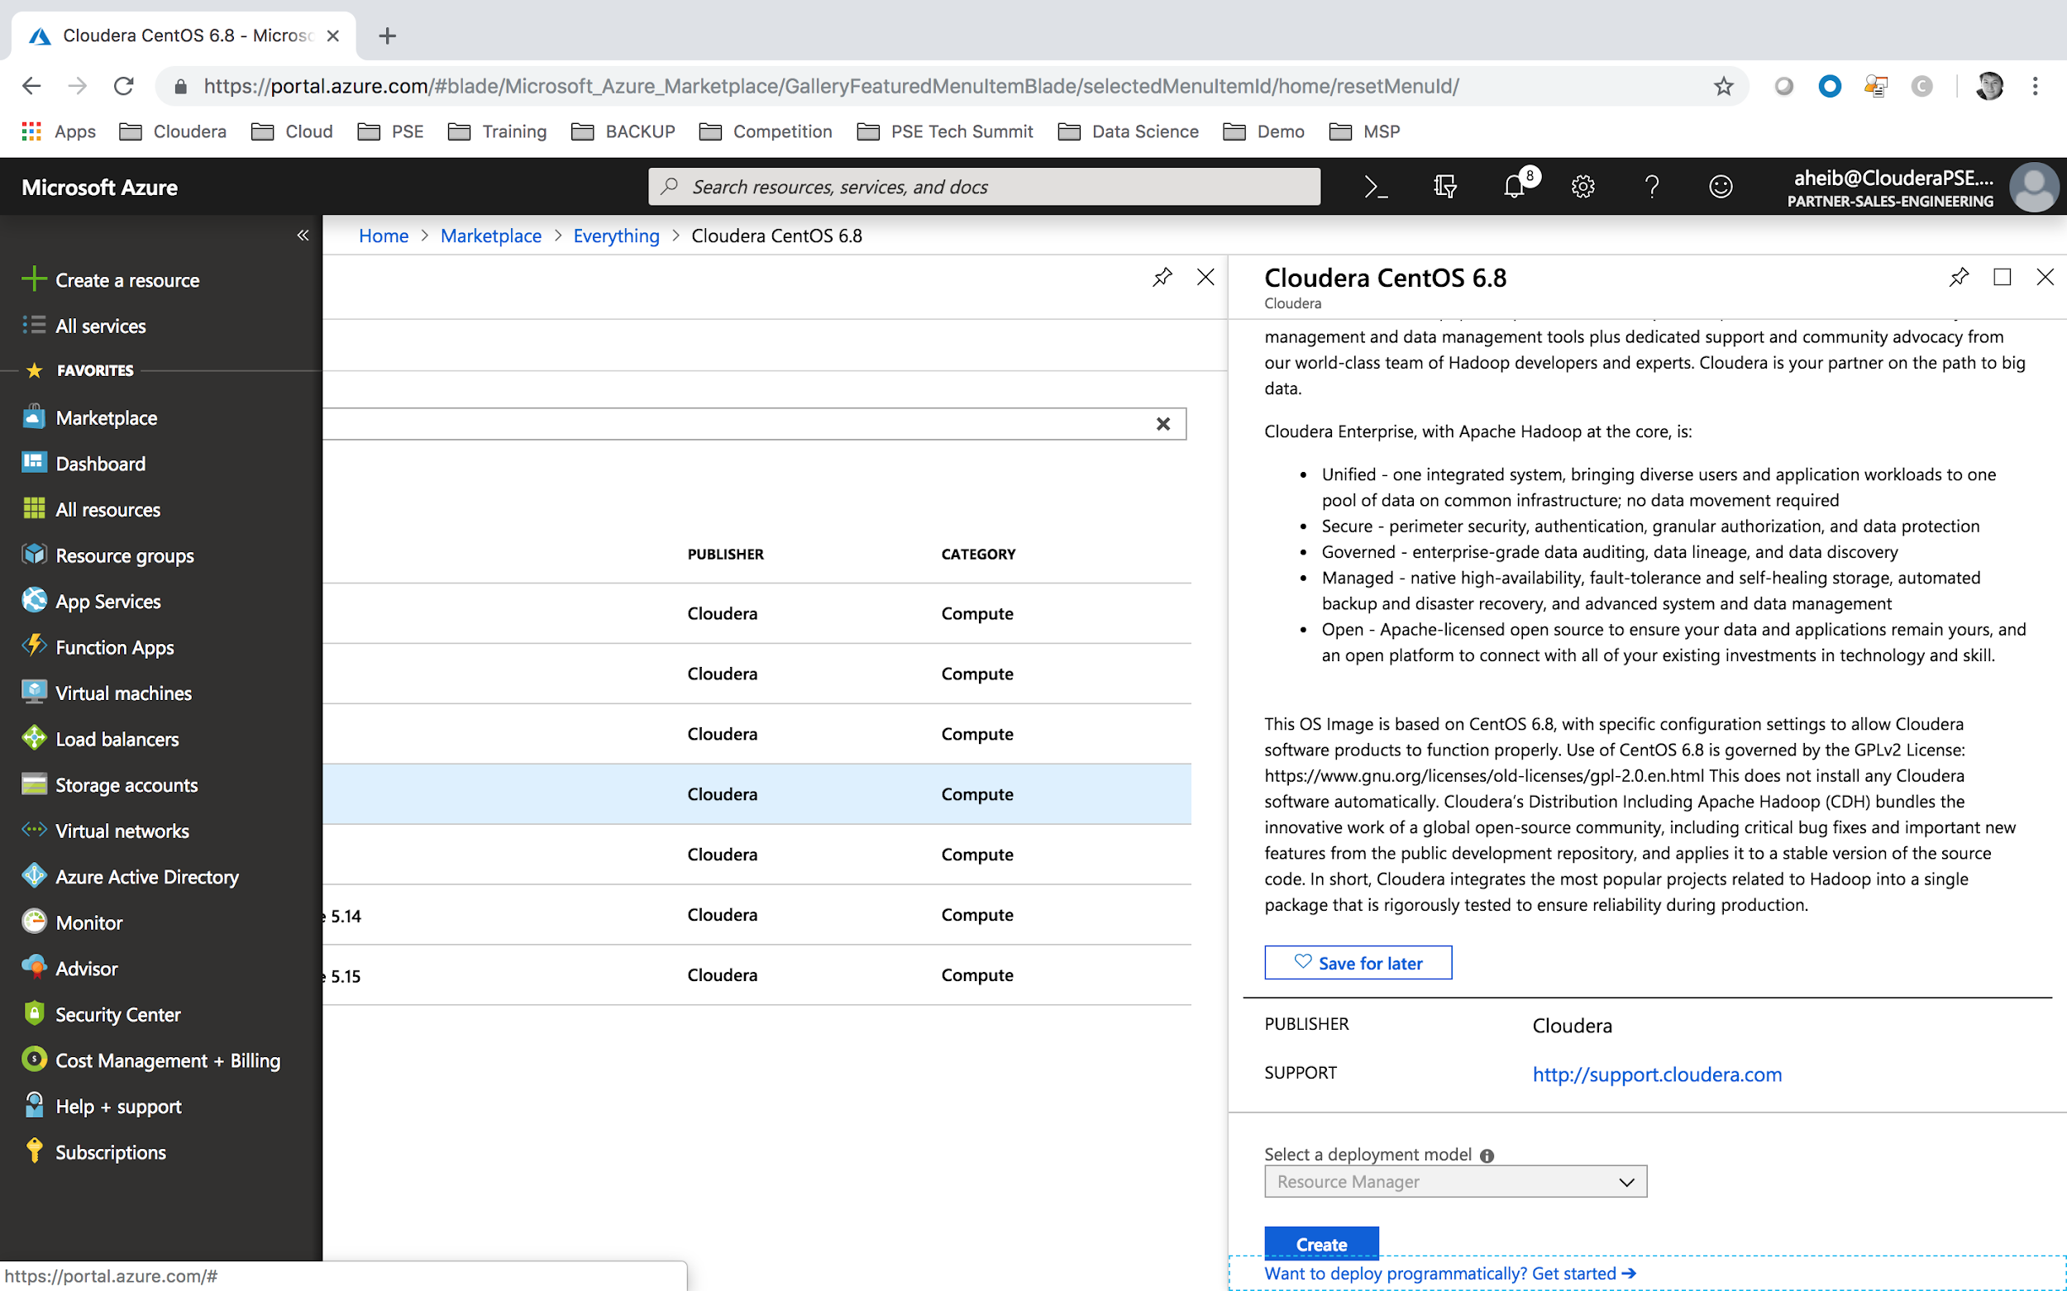

Select an image and scroll to the bottom to select “Want to deploy programmatically? Get started ->”

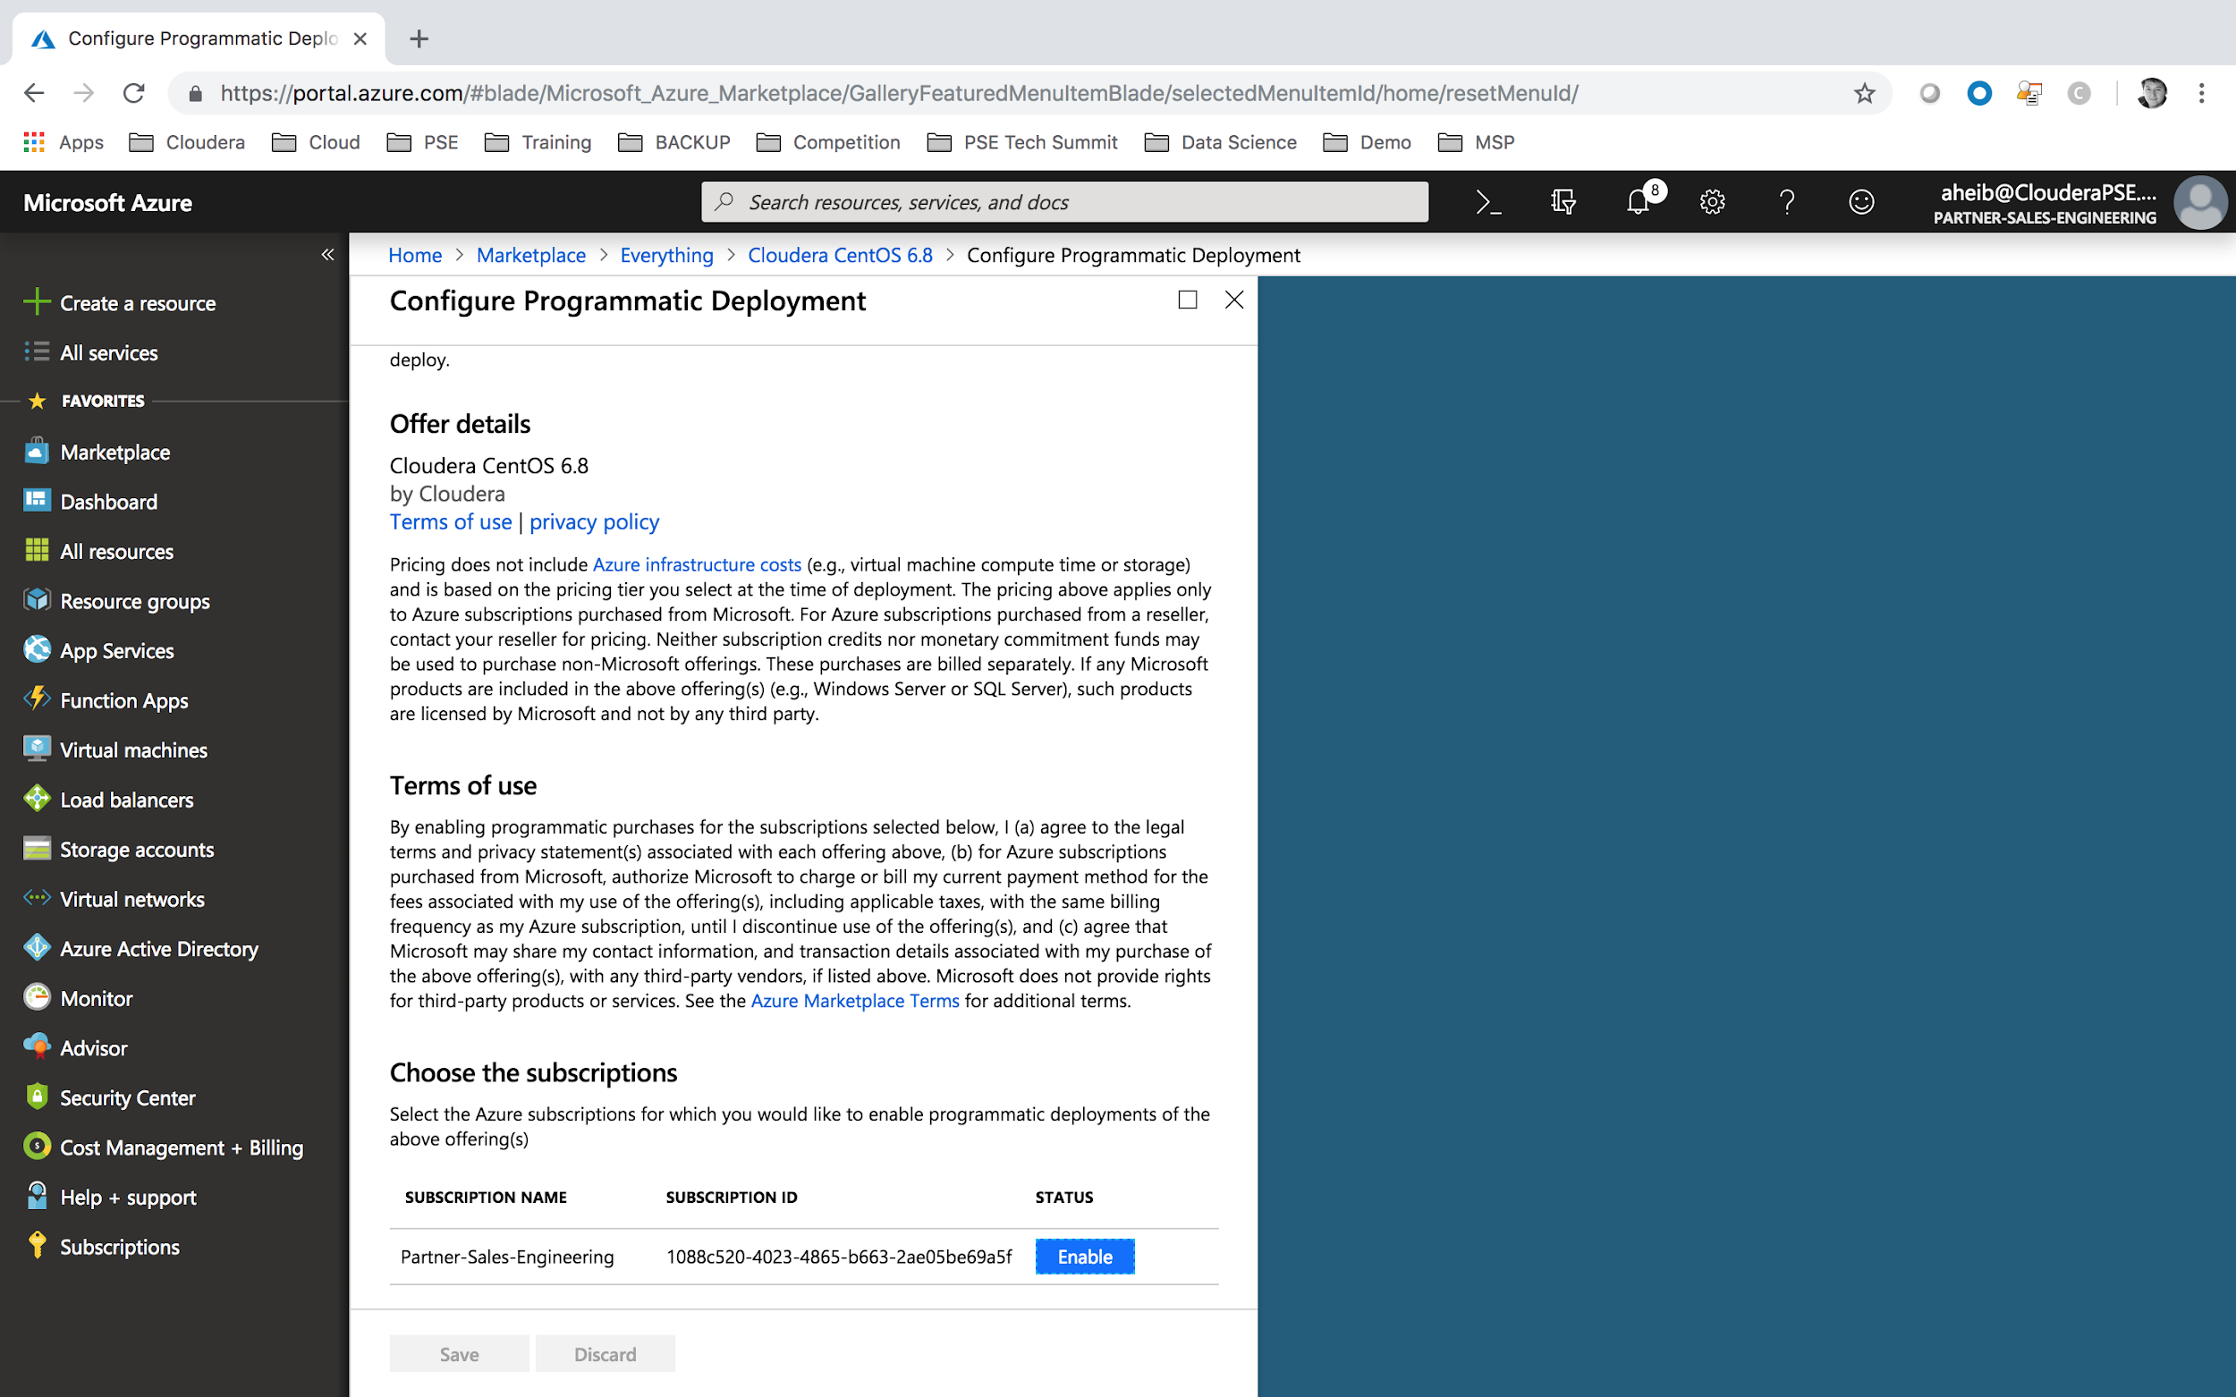

Once done, you will need to click on the button “Enable”.

# TROUBLESHOOTING

## **Cannot access to Cloudera Director Web UI**

This could happen due to multiple issues:

* please double check that you have correctly setup a security group rule for port 7180-7189 towards your laptop IP address. You maybe have moved location and your IP has changed. Please check Lab#4 Section#6.
* it could happen that your laptop, or company does not allow to access internet on port 80. And alternative is to use a mobile connection modem instead.
* Network Address Translation (NAT) could have been activated in your company (providing a unique Public IP for the company, and multiple private IP for laptops). In this case, you could try opening port 7180 - 7189 to all users (Lab#4 Section
  + Navigate to your **Home > Resource groups > ODL-cldr-<USERID>-director > director-nsg** network security group.
  + Click on Inbound security rules.
  + Destination = **Any**
  + Destination port range = **7180-7189** (opening port from 7180 to 7189)
  + Name = **Cloudera_Port**

## **Deploying Cloudera Manager - Cluster in a private network.**

You could avoid using Public IP for all Master / Worker / Edge nodes, for security reasons. In this case, we will create a SSH Tunneling for this purpose.

Secure Shell (SSH) tunneling connects a port on your local machine to a head node on HDInsight. Traffic sent to the local port is routed through an SSH connection to the head node. The request is resolved as if it originated on the head node. The response is then routed back through the tunnel to your workstation.

For mac users,

launch a SSH Tunnel to the Cloudera Director virtual machine:

|  |
| --- |
| ssh -i azure_rsa -CND 1080 cloudera@director<USERID>.westeurope.cloudapp.azure.com |

By default, Google Chrome uses system-wide proxy settings on a per-profile basis. To start Chrome without these settings, open Chrome through the command line and specify the following:

* The SOCKS proxy port. This must be the same port that you used when you started the proxy.
* The profile. This examples below create a new profile.

Use one of the following commands to create a profile and launch a new instance of Chrome that does not conflict with any currently running Chrome instances.

|  |
| --- |
| "/Applications/Google Chrome.app/Contents/MacOS/Google Chrome" \  --user-data-dir="$HOME/chrome-with-proxy" \  --proxy-server="socks5://localhost:1080" |

For windows users, please make use of Putty functionality. You could find more readings about this on this link: <https://docs.microsoft.com/en-us/azure/hdinsight/hdinsight-linux-ambari-ssh-tunnel>